**Program Review Committee Agenda**

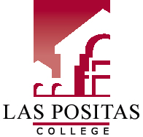

# LPC Mission Statement

Las Positas College is an inclusive learning-centered institution providing educational opportunities and support for completion of students’ transfer, degree, basic skills, career-technical, and retraining goals.

# LPC Planning Priorities

* Establish regular and ongoing processes to implement best practices to meet ACCJC standards.
* Provide necessary institutional support for curriculum development and maintenance.
* Develop processes to facilitate ongoing meaningful assessment of SLOs and integrate assessment of SLOs into college processes.
* Expand tutoring services to meet demand and support student success in Basic Skills, CTE, and Transfer courses.

# Meeting Name

**Members:**

March 13, 2019*| 3-4:30pm**|* Room 106

1. Approve minutes
2. Shared Governance Worksheet
3. Next year’s timeline
4. SLO Section
5. Update on Student Services areas
6. Program Review features checklist
7. Next year’s template

Spring 2019 PRC Meetings (2nd and 4th Wednesdays, 3-4:30, Room 106)

January 23

February 13

February 27

March 13

April 10

April 24

May 8