**Program Review Committee Agenda**

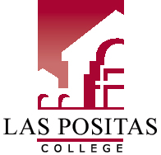

# LPC Mission Statement

Las Positas College is an inclusive learning-centered institution providing educational opportunities and support for completion of students’ transfer, degree, basic skills, career-technical, and retraining goals.

# LPC Planning Priorities

* Establish regular and ongoing processes to implement best practices to meet ACCJC standards.
* Provide necessary institutional support for curriculum development and maintenance.
* Develop processes to facilitate ongoing meaningful assessment of SLOs and integrate assessment of SLOs into college processes.
* Expand tutoring services to meet demand and support student success in Basic Skills, CTE, and Transfer courses.

# Meeting Name

**Members:**

Decebmber 12, 2018*| 3-4:30pm**|* Room 106

1. Reflection on Program Reviews and reading process
2. Plans for next semester

Fall 2018 PRC Meetings (2nd and 4th Wednesdays, 3-4:30, Room 106)

Remaining November 14