**Program Review Committee Agenda**

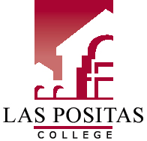

# LPC Mission Statement

Las Positas College is an inclusive learning-centered institution providing educational opportunities and support for completion of students’ transfer, degree, basic skills, career-technical, and retraining goals.

# LPC Planning Priorities

* Establish regular and ongoing processes to implement best practices to meet ACCJC standards.
* Provide necessary institutional support for curriculum development and maintenance.
* Develop processes to facilitate ongoing meaningful assessment of SLOs and integrate assessment of SLOs into college processes.
* Expand tutoring services to meet demand and support student success in Basic Skills, CTE, and Transfer courses.

# Meeting Name

**Members:**

August 24, 2016*| 3-4:30 pm |* Room 503

1. Introductions
2. Committee Charge
3. Committee Membership
4. Review Program Review Update form
5. Review timeline and reading process

Fall 2016 PRC Meetings (2nd and 4th Wednesdays, 3-4:30, Room 503)

August 24

September 14

September 28

October 12

October 26

November 9

December 14