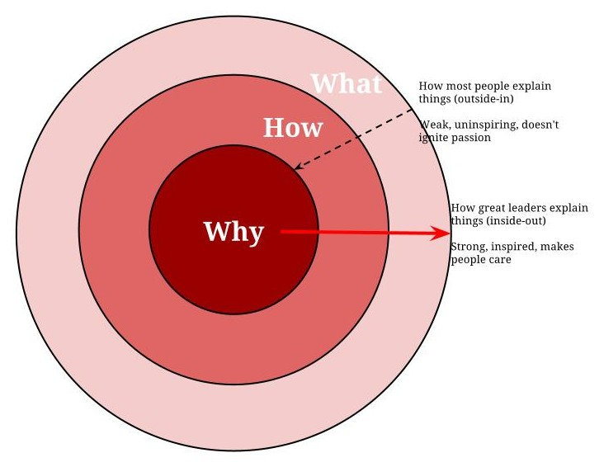

|  |
| --- |
| **Write your *why* here.** |
| ***How* (the process or way of providing your *why*)?** |
| **What is it that you are trying to create?** |

