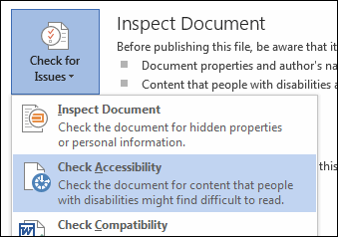
Formatting a Word document for Accessibility (H1)
The Accessibility Checker (H2)
The accessibility checker in Word might not indicate an error if you don’t use heading styles, but when your document is exported to an accessible PDF, a screen reader will have trouble with the reading order and navigating through the document without heading styles.

To locate the Accessibility Checker (H3)
- File
- Check for Issues
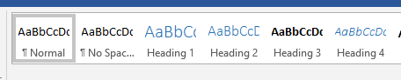
- Accessibility Checker.
Use of Heading Styles (H2)
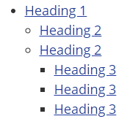
By using logical heading structures in your documents, you can create more usable and easier to digest information for all readers, as well as provide the structure needed for assistive technologies to navigate the content effectively.

Importance of headings (H3)
Thoughtful use of heading styles is especially valuable for individuals with disabilities who are using assistive technology to access and navigate the page content. Pages should be structured in a hierarchical manner:
- A Heading 1 is usually a page title or a main content heading. It is the most important heading, and there is generally just one.
- A Heading 2 is usually a major section heading.
- A Heading 3 is usually a sub-section of the Heading 2.
- A Heading 4 is usually a sub-section of the Heading 3, and so on, ending with Heading 6.
It is often not necessary to go beyond three levels of headings in most simple documents. Heading text can be used to quickly gain an understanding of the main points a document is talking about, and headings can be organized with a ranking hierarchy, to help define main topics and sub-topics.
Alternative Text (H2)
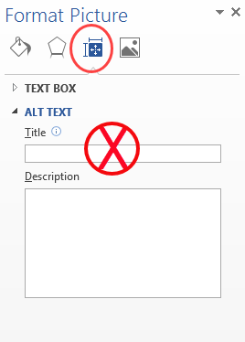
To add alt text to the image below, right-click the image, and choose Format Picture. In the Format Picture panel on the right, click the icon for Layout and Properties. Click Alt Text, and type your description in the Description box.
Do NOT type in the Title box. If you type in both the title and description boxes, the visually impaired student's screen reader will only read the title box.
Tables (H2)
To add headers to the table below, select the table by hovering over it and clicking the move handle on the top left of the table. Right-click the table, and choose Table Properties. In the Table Properties box, make sure the Row tab is selected, then check the box in front of Repeat as header row at the top of each page. Click OK.
Date | Topic | Read
September 2 | Personal Hygiene | Textbook, Chapter 1
September 9 | Diseases | Textbook, Chapter 2
September 16 | Healthy Breathing | Textbook, Chapter 2

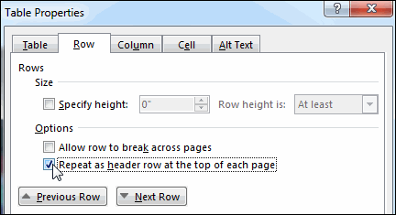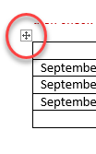Document Hyperlinks
Documents containing hyperlinks to websites or other online resources can be improved by including hyperlink text that is more descriptive and easily understood by the reader. Do not underline text for emphasis, this can be mistaken for a link. Bold, Italicize, or change the font style instead of underlining.
Using the full hyperlink URL may not make sense to the reader without some context. https://support.office.com/en-US/article/Make-your-Word-documents-accessible-D9BF3683-87AC-47EA-B91A-78DCACB3C66D#BKMK_WinTableHeaders
You can modify the text displayed in the document while retaining the hyperlink destination.
- Right-click on the hyperlink text in the document and choose Edit Hyperlink, or press Ctrl+K (Mac: Cmd+K).
- In the field "Display" (or "Text to Display" for MS Word for Windows) enter the desired on-screen text.
- Including both the text description and full URL can be helpful, particularly for when the document is printed.
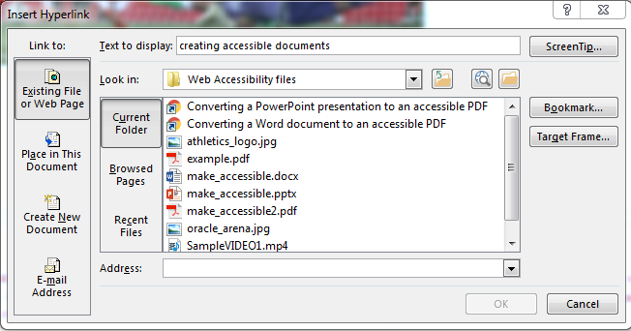

Save as an Accessible PDF
- File
- Save as Type
- Options
- Document structure tags for accessibility
