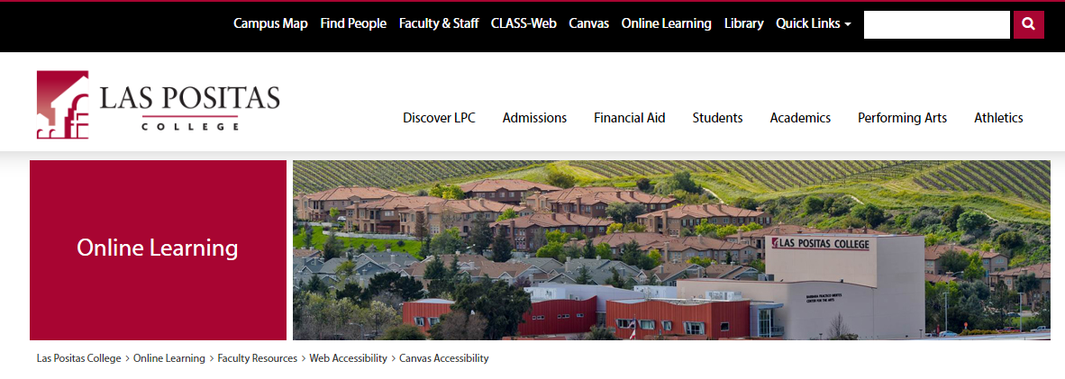
Canvas Accessibility
- Online Learning (2) Faculty Resources (3) Web Accessibility (4) Canvas Accessibility

Using Styles in Canvas
Make sure to utilize styles when adding text into Canvas' Rich Content Editor. Screen reader and other assistive technology users have the ability to navigate web pages by heading structure, assuming true headings are used (as opposed to text that is styled to be big and/or bold).
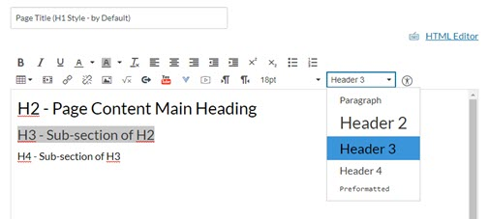
Canvas uses Header 1 for the Page Title, so your content heading will begin with a Header 2. Simply type your text, highlight it, then select the proper style. Your sub-headings will continue with Header 3 (child of H2).
Do not skip heading numbers. Meaning don’t follow a Heading 2 with a Heading 4 because you like that font size better. You can reduce the font size, bold or italics after applying the correct heading style.

Lists
- Use the bullet or numbered list tool, do not created list manually.

Links
Screen readers allow users to view a list of all links present on the page, using a keyboard shortcut. This is especially useful if they are searching for a particular link.
Good link text should not be overly general; don't use "click here" as a link. "Click here" says nothing about what is to be found if the link is followed. Instead of "click here", link text should be explanatory and indicate the nature of the link target.
Linked text should indicate to the users where the link will go if they choose that link. In the sentence below, users know that if they choose the link, they will go to the Strawberry Nutritional Guide.
Click the following link to see the Strawberry Nutritional Guide. (perfect example)
In poor examples, the linked text does not indicate where the link will go. In the sentence below, it is not clearly understood that the link will go to the Strawberry Nutritional Guide.
Click here to see the Strawberry Nutritional Guide (poor example)
Also, do not use web addresses https://nutritiondata.self.com/facts/fruits-and-fruit-juices/2064/2 as links because screen readers will read every character aloud, making for long, tedious, and sometimes nonsensical, listening for blind students.
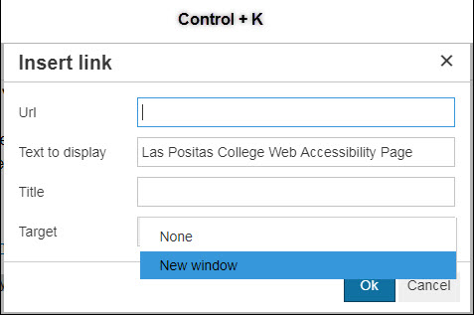
Finally, do not underline text that is not a link as means of emphasis, when students see a word(s) that is underlined, they will think it's a link. Instead use Bold or Italic to emphasize words within a paragraph.
- Set links to open in a new window.
  - A handy little trick to know when setting up your descriptive links is Ctrl+K (or Cmd+K, if you're on a Mac). It opens a dialogue box that allows you to set the link to open in a new window.

Tables
- Tables must have a header row, column, or both, and need a caption. Use the accessibility checker for help.
- Do not use tables for formatting or layout of content on a page.

Color
Learners who are blind, low-vision, or colorblind will not be able to differentiate between the content you are trying to emphasize or highlight if you use only color to convey meaning.
It's OK to use color to convey meaning as long as that meaning is indicated in some other way as well (ie…italics or bold)

Images
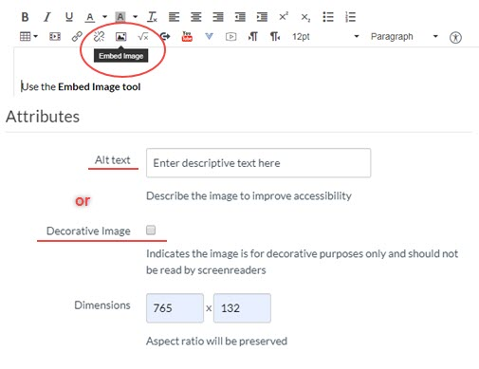
Visually impaired students need alt text to hear the description read to them via screen-reading technology. After uploading an image into Canvas, use the Embed Image icon in the Rich Content Editor to place the image where you desire. The content of the alt text needs to be relatively simple, and depending on the image, it should not require an extensive description.
Alt text should convey enough information so the visually impaired student has an equal amount of knowledge about the image as the sighted student.
Some other pointers for images:
- Don't copy text that students are reading and paste it in as alt text.
- Don't begin your alt text with "Image of ..." because the screen reader will already say that.
- Don't use the filename of the image as the alt text, particularly because it includes file extensions (.jpg, .gif, .png).
- If your image contains text, make sure to include those same words as alt text.
- Check the Decorative Image box if the image has no pedagogical value and is simply for decoration.

Video/Audio
All videos embed into Canvas or linked out to another source from Canvas must be correctly captioned. All audio files must be accompanied with a transcript.

