

**SHARED GOVERNANCE HANDBOOK**

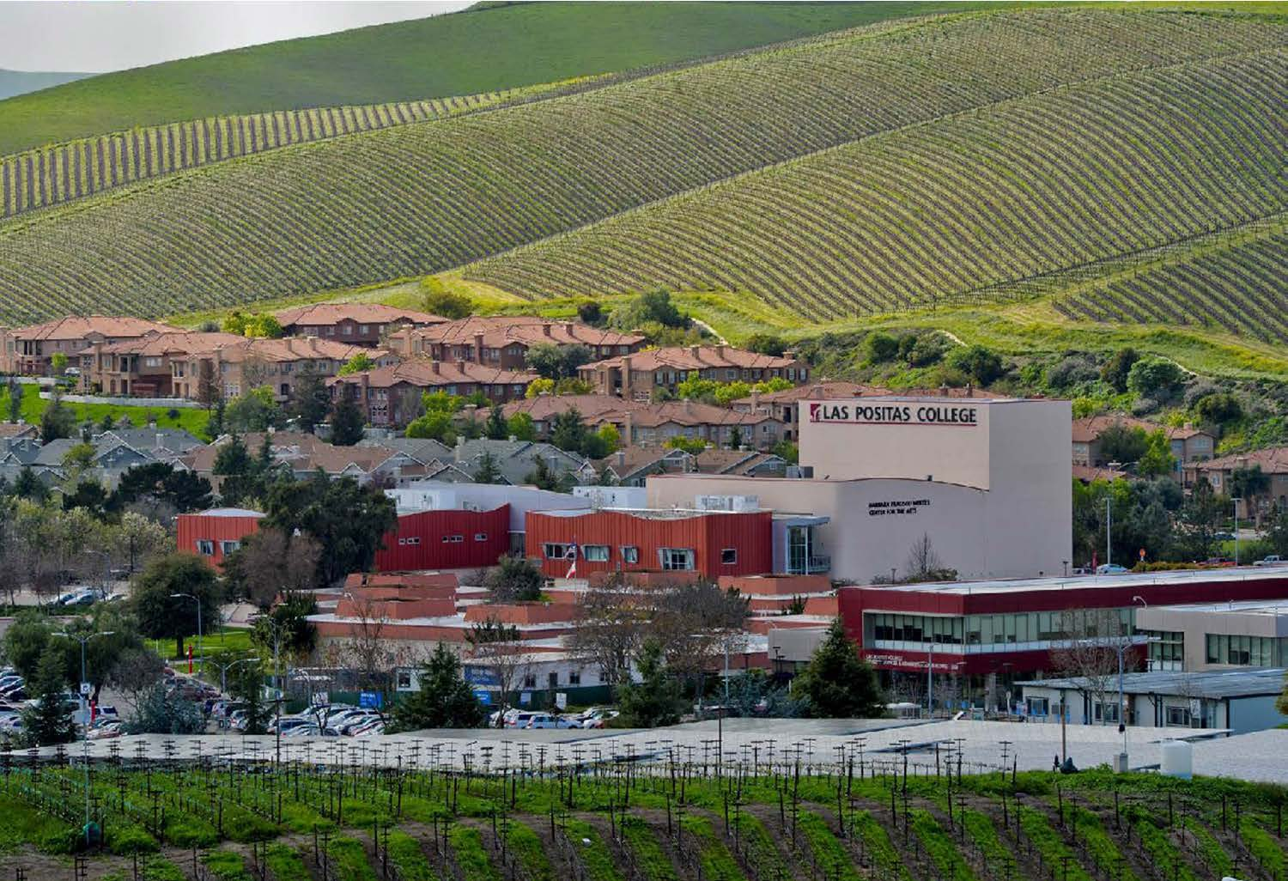

**Updated June 25, 2024**

**Accepted by Board: September 13, 2022**

**Updated/Approved by College Council: NEEDS TO BE FINALIZED September 26, 2024.**

Message from the President

Las Positas College takes great pride in fostering a collegial and shared governance approach to the planning and decision-making processes of the college. Shared governance is all groups participating in the varied parts of the process of decision-making. We have agreed together on the process and roles of administrators, faculty, and classified professionals and various interconnected functions across the campus. Our process allows for timely decision-making practices that are aligned with expertise and responsibility. Working together at shared governance has allowed us to balance maximum participation with clear accountability. It gives a voice to all constituencies, although, not final authority, for common concerns or specific concerns for all groups.

This Shared Governance Handbook serves as a resource to faculty, classified professionals, students, and administrators on all matters related to the leadership and governance process of the College. The handbook provides an overview of the college’s shared governance committee structure, operational guidelines for committees, committees reporting structure, useful forms and templates for committee members, and college planning processes. The college created this handbook to promote understanding and encourage participation on behalf of all members of the college community to serve on its various committees and councils. The institutional structures outlined in this handbook will ensure the continued advancement of Las Positas College and the success of our students.

We’ve updated the handbook to include the ACCJC, June 2024 Accreditation Standards for which each of the college governance committee supports, you will find this information in Appendix G. This handbook is reviewed and updated on an annual basis.

Many thanks to those who have shared in the revisions and updating of this version of our Shared Governance Handbook.

Sincerely,

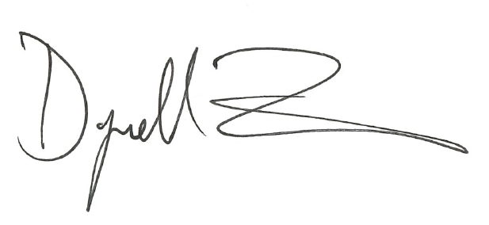

Dyrell Foster, Ed.D.

College President

Las Positas College

Table of Contents

Message from the President 2

SECTION I. 7

Institutional Principles 7

Mission Statement 8

Vision Statement 8

Values Statement 8

Education Master Plan Goals 2021-2026 10

SECTION II. 13

Overview of Shared Governance 13

Introduction 14

Purpose of the Shared Governance Process 14

Chabot-Las Positas Community College District (CLPCCD) – Relationship to LPC Shared Governance 15

Committee Structure 16

College Council 16

Committees 16

Sub-Committees 16

Advisory Groups 16

Task Forces/Work Groups 16

User Groups 16

LPC Committees and Reporting Structure 17

SECTION III. 18

Operational Guidelines for Committees 18

Committee Academic Year Timeline 19

Roles and Responsibilities 19

Committee Chair 19

Committee Member 20

Administrative Liaison 20

Support/Resource Staff 20

Terms of Service 21

Meeting Times and Location 21

Distribution of Documents 21

College Committee Changes, Creations or Deactivation 21

Committee Assignments 22

Decision Making 22

Quorum 22

By Vote of Consensus 22

Robert’s Rules of Order, Revised 22

Expectations and Engagement 23

Accountability 23

Communication and Collegiality 23

SECTION IV. 24

Committees Reporting to College Council or the President 24

College Council 25

College Enrollment Management Committee (CEMC) 36

Facilities and Sustainability Committee 38

Guided Pathways Steering Committee 40

Resource Allocation Committee (RAC) 46

Technology Committee 48

SECTION V. 50

Committees Reporting to Academic Senate 50

Curriculum Committee 51

Faculty Hiring Prioritization Committee (FHPC) 58

SECTION VI. 63

Committees Reporting to Academic Senate and Institutional Planning and Effectiveness Committee 63

Program Review Committee (PRC) 64

SECTION VII. 67

Committees Reporting to Academic Senate and College Council 67

Career Technical Education (CTE) 68

SECTION VIII. 70

Committees Reporting to Academic Senate and Classified Senate 70

Professional Development Committee (PDC) 71

SECTION IX. 73

Committees Reporting to Academic Senate and College Council via VPSS 73

Student Equity and Achievement Committee (SEA) 74

SECTION X. 76

Committees Reporting to Administrative Services 76

Health and Safety Committee 77

SECTION XI. 79

Sub-Committee Reporting to Student Equity & Achievement Committee 79

Math and Language Equity and Achievement (MLEA) 80

SECTION XII. 82

Task Forces and User Groups 82

Art on Campus Task Force 83

Student (Grade) Grievance Task Force 84

Student Grievance Task Force 85

UndocuAlly Task Force 86

SECTION XIII. 87

Forms and Templates 87

Description of Forms 88

Meeting Agenda 88

Meeting Minutes 88

Templates 89

Meeting Agenda Template 89

Meeting Minutes Template 90

Shared Governance Worksheet Template 91

SECTION XIV. 95

Appendices 95

Appendix A. Constituency Groups (Alphabetical) 96

Academic Senate 96

Administrative Team 97

Classified Senate 97

Faculty Association (FA) 98

SEIU Local 21 (Classified Union) 98

Student Government 98

Appendix B. LPC’s Integrated Planning and Budget Cycle 99

Appendix C. Sample Shared Governance Master Calendar 100

Appendix D. LPC Planning Documents 101

Appendix E. CLPCCD Board Policy 102

Administration 102

District Councils and Committees 103

Appendix G: Shared Governance Committees Providing Evidence to Accreditation Standards 106

SECTION I.

Institutional Principles

INSTITUTIONAL PRINCIPLES

**Las Positas College Mission, Vision, and Values Statements**

Adopted by LPC College Council on February 27, 2020, August 27, 2020, November 19, 2020

# Mission Statement

Las Positas College provides an inclusive, learning-centered, equity-focused environment that offers educational opportunities and support for completion of students’ transfer, degree, and career-technical goals while promoting life-long learning.

# Vision Statement

Las Positas College strives to support and empower students to develop the knowledge, skills, values, and abilities needed to become engaged participants and leaders in their local and global communities.

# Values Statement

Las Positas College thrives as a collaborative teaching and learning community committed to integrity and excellence by:

1. Encouraging and celebrating lifelong learning;
2. Responding to the needs of the ever-changing workplace and society;
3. Demonstrating civic, social and environmental responsibility;
4. Promoting ethical behavior, mutual trust, equity, and respect within our diverse community;
5. Fostering a climate of discovery, creativity, personal development, and physical and mental health;
6. Committing to anti-racist policies and practices;
7. Ensuring that Las Positas is a sanctuary campus for undocumented students;
8. Holding firm to the belief that each of us makes an astonishing difference.

*****

**Glossary of Selected Terms for College Mission Statement**

Adopted by College Council, May 11, 2023

The multiple meanings of selected terms used in the Mission Statement are below:

**Inclusive** - welcoming of a diverse group of students including but not limited to: all race-ethnicity groups, all ages, all genders, lesbian, gay, bisexual, transgender+, first generation, students with disabilities, veterans, students with children, all socio-economic backgrounds, including those from economically disadvantaged backgrounds, undocumented, international, multicultural, religious beliefs and practices—all with varying skill levels and learning styles.

**Learning-Centered** - refers to courses, programs, disciplines, modes of delivery, learning communities, accounting for varying skill levels and learning styles, creative and critical thinking, and having necessary and specialized facilities.

**Educational Opportunities** - include but are not limited to classroom and Distance Education (DE) instruction, athletics, field trips, guest speakers, student government, cultural opportunities, clubs, labs, internships, tutoring service, workshops, library research, career training, and mentoring.

**Support** - includes tutoring services, Reading and Writing Center, learning communities, student workshop opportunities, counseling, faculty office hours, Math Learning Center, supplemental instruction, Admissions and Records, advisory boards, Health and Wellness Services, financial aid, evening services, veteran services, learning management system, online courses, online counseling, online tutoring, technology support for online students, food pantry, cafeteria, bookstore, technology, appropriate pathways, assessment, Child Development Center, Library, Computer Center,  technical support, Student Services, programs for traditionally marginalized students, Administrative Services; all provided by a dedicated group of faculty, classified professionals, and administrators.

**Degree and Career-Technical -** include Associate of Arts (AA), Associate of Science (AS), Associate in Arts for Transfer (AAT), Associate in Science for Transfer (AST), Certificate of Achievement, Certificate of Competency, and Certificate of Completion.

**Equity Mission Statement –** Las Positas College will achieve equity by changing the impacts of structural racism, ableism, homophobia, and systematic poverty on student success and access to higher education, achieved through continuous evaluation and improvement of all services. We believe in a high-quality education focused on learning and an inclusive, culturally-relevant environment that meets the diverse needs of all our students.

**Equity Operational Definition –** equity is parity in student educational outcomes. It places student success and belonging for students of color and disproportionately impacted students at center focus.

# Education Master Plan Goals 2021-2026

Adopted by College Council, April 23, 2020

|  |  |
| --- | --- |
| **Goals** | **Strategies** |
| 1. **Educational Excellence**   Ensure excellence in student learning through quality academic programs and support services. | A1. Analyze and meet the educational needs of a diverse population and workforce through ongoing program support and innovation.  A2. Design course offerings, class schedules and modalities, and support services that are accessible and inclusive for all students and promote timely completion of transfer, degree, and career-technical goals.  A3. Comprehensively and equitably provide for the learning needs of underserved students and students with disabilities through proactive engagement and support.  A4. Provide students with the knowledge and skills necessary for career readiness and advancement.  A5. Institutionally support opportunities for students and the Las Positas community to engage critical issues related to ethics, social justice, globalization, and civic responsibility both inside and outside the classroom.  A6. Develop and institutionalize a comprehensive system of tutoring and other learning support services.  A7. Develop and promote practices and services that support student health, safety, and wellness.  A8. Engage in efforts to safeguard continuity of instruction in career education programs aligned with industry demands or designated as critical infrastructure programs. |
| 1. **Community Collaboration**   Ensure excellence in student learning by collaborating with community partners to provide educational opportunities that best serve the needs of our students and our community. | B1. Deepen engagement with local school districts to increase academic preparedness for high school students planning to enter Las Positas College and to promote the opportunities offered by the College.  B2. Develop and strengthen collaboration with community partners to better serve local, regional, national, and global workforce needs and to secure resources for program growth and innovation.  B3. Coordinate efforts to increase community awareness of the programs, services, and achievements of Las Positas College through a variety of approaches, especially social media, targeted outreach, and on-campus events.  B4. Increase community awareness of the college’s cultural wealth, including its status as a Hispanic Serving Institution (HSI) and a sanctuary campus. |
| 1. **Supportive Organizational Resources**   Ensure excellence in student learning by strengthening fiscal stability, providing appropriate staffing levels, meeting evolving technology needs, and expanding or updating facilities. | C1. Strategically pursue and support initiatives that strengthen the financial stability of Las Positas College, while institutionalizing support for programs and services that have demonstrated success.  C2. Develop processes and institutional supports to pursue, coordinate and manage alternative revenue sources.  C3. Evaluate and ensure staffing levels that support student needs and institutional effectiveness.  C4. Optimize the use of technology in college processes, practices, and facilities to meet student learning needs and support institutional effectiveness.  C5. Engage in advocacy with external stakeholders to ensure appropriate funding models that support students in our communities.  C6. Optimize and continually update facilities to address student and personnel needs. |
| 1. **Organizational Effectiveness**   Ensure excellence in student learning by improving organizational processes, promoting safety and wellness, and fostering professional development. | D1. Improve and communicate existing processes for students and personnel through streamlining, integration, standardization, and appropriate use of technology.  D2. Nurture and support inclusive, transparent, and accountable decision-making processes, in order to ensure broader participation and leadership development amongst full-time and part-time faculty, classified professionals, students, and administrators.  D3. Ensure equitable access to relevant professional development opportunities for all college personnel in support of student learning, equity, anti-racism, accessibility, organizational readiness, and institutional effectiveness.  D4. Provide ongoing training and support to promote the design of distance education courses and support services that are user-friendly, accessible, equitable, inclusive, and pedagogically excellent.  D5. Continually assess and analyze student data in order to develop and implement plans for institutional improvement.  D6. Expand practices and processes that promote safety and wellness for all members of the campus community in response to ongoing and emerging community needs.  D7. Develop communication strategies with our students that are technologically-current and equity-informed, especially for students accessing courses and services remotely. |
| 1. **Equity and Anti-Racism**   Ensure excellence in student learning by prioritizing equity and anti-racism. | E1. Establish Las Positas College as a destination campus for Black students and other students of color by nurturing culturally-informed and equity-focused curriculum, strengthening access to student support services, and creating physical and virtual cultural centers.  E2. Analyze data to take urgent action to eliminate student opportunity gaps associated with systemic racism and investigate the effects of other structural inequities.  E3. Identify, assess and work to eliminate inequities associated with racism and implicit bias in hiring, promotions, and employee experience.  E4. Nurture a campus-wide culture of rigorous attention to equity and anti-racist practices. |

**Las Positas College Planning Priorities**

Updated September 26, 2024

Based on the work of the Integrated Planning Committee, College Planning Priorities provide guidance about key issues that need to be addressed by the campus community.

It is hoped that all committees and shared governance groups will keep these in mind when prioritizing and accomplishing their work. Sample agenda and minutes templates are in the addendum for use with the priorities noted.

LPC Planning Priorities 2024-25

* Establish a knowledge base and an appreciation for equity; create a sense of urgency about moving toward equity; institutionalize equity in decision-making, assessment, and accountability; and build capacity to resolve inequities.
* Increase student success and completion through change in college practices and processes: coordinating needed academic support, removing barriers, and supporting focused professional development across the campus.
* Health & Wellness: Establish a knowledge base and appreciation for health and wellness in the workplace; create a sense of urgency about wellness; prioritize wellness in decision-making, assessment and accountability; and build capacity to support wellness.

**Graduated College Planning Priorities**

Graduated College Planning Priorities are priorities that have been determined by the Institutional Planning and Effectiveness Committee to have “graduated” to a sustainable college process. The following College Planning Priority has graduated:

* Coordinate resource and provide professional development for effective online instruction and remote delivery of student support services and college processes, to advance equitable student outcomes. (Graduated Spring 2021)
* Implement the integration of all ACCJC standards throughout campus structure and processes. (Graduated Spring 2021)
* Develop processes to facilitate ongoing meaningful assessment of SLOs/SAOs and integrate assessment of SLOs/SAOs into college processes. (Graduated Spring 2017)
* Provide necessary institutional support for curriculum development and maintenance. (Graduated Spring 2019)
* Expand tutoring services to meet demand and support student success in Basic Skills, CTE, and Transfer courses. (Graduated Spring 2019)
* Coordinate available resources to address current and future professional development needs of faculty, classified professionals, and administrators in support of educational master plan goals. (Graduated Spring 2019)

**[2024-25 LPC Strategic Priorities](https://www.laspositascollege.edu/president/priorities.php)**

* Excellence & Equity in Student Success & completion
* Strategic Enrollment Management: access & Retention
* Budget: Efficiencies & Revenue
* Professional Development: Centering Diversity, Equity, Inclusion, and Accessibility (DEIA)
* Health and Wellness in the Workplace

SECTION II.

Overview of   
Shared Governance

OVERVIEW OF SHARED GOVERNANCE AT LAS POSITAS COLLEGE

# Introduction

The shared governance structure of Las Positas College is reflective of an institutional decision-making process that includes representation from all constituents (students, classified professionals, faculty, and administrators) in recommending policies and/or procedures (exclusive of collective bargaining issues) to the President, Chancellor, and Board of Trustees.

The shared governance process is based upon the mutual belief and tradition that the development of College policies, procedures, and recommendations is made by consensus and built upon campus-wide involvement of students, faculty, classified professionals, and administrators. This belief is founded on the premise that, while each group has unique responsibilities and authority, many issues – because of their effect on the operation of the College as a whole – are not exclusive. Through the active engagement and participation of all constituency groups on campus, there is strong commitment to the successful implementation of policy decisions resulting from college-wide recommendations.

This process is in concurrence with the recognition by the Board of Governors of the California Community College System and the CLPCCD Board of Trustees (Policies 2015, 2016, 2017, and 2018) that all key parties participate in college and district governance in accordance with Title V (§ 51023.5, 51023.7, 53200, 53201, 53203, and 53204).

All members of the Las Positas College campus community are invited and encouraged to attend committee meetings. Although there are specified voting and non-voting members for each committee, the college encourages any interested faculty, classified professional, student or administrator in attending any committee meeting based on their interest.

# Purpose of the Shared Governance Process

The purpose of the Las Positas College shared governance process is to develop a method for collegial consultation that appropriately involves staff, faculty, and students in the planning and operation of the College. This inclusion brings with it the responsibility and obligation on the part of all members of the campus community to fully participate in and be open to the collegial process. This means willingness on the part of all groups to actively contribute to the decision-making process and to accept ownership for the development and creation of a College environment based on these decisions.

These procedures attempt to guide appropriate representation and authority for each constituency group and to delineate committee responsibilities and reporting relationships. It is a purposefully fluid process that will be reviewed and refined on an annual basis, or sooner when needed, with the goal of enhancing and improving collegial consultation.

The Board of Trustees has delegated-authority, through the Chancellor to the President, who will – as appropriate – share that authority through this collegial consultation process. Final authority for governance of Las Positas College rests with the Board of Trustees.

# Chabot-Las Positas Community College District (CLPCCD) – Relationship to LPC Shared Governance

The CLPCCD (District) reviews and endorses this Shared Governance Handbook upon each revision.

Note that the District has committees which assist the two Colleges’ committees with their work and which have members from each College.

The District committees are listed below and their membership and charge information are on the District webpage at  [http://districtazure.clpccd.org/committees/index.php.](http://www.clpccd.org/board/DistrictwideCommittees.php)

These committees’ meeting dates are usually on Fridays.

* District Facilities Committee
* District Planning and Budget Committee (District PBC)
* District Technology Coordinating (TCC) Committee
* District Enrollment Management Committee (DEMC)

# Committee Structure

The vehicle by which the consultation process shall function and be organized is the shared governance structure, made up of the College Council, Committees, Sub-Committees, Advisory Groups, Task Forces, and User Groups (for vendor relations). These governance bodies are designed to provide expertise and formalize the collegial process, facilitate communication, develop plans and processes, and provide input for the effective planning and operation of the College. Agendas will be made available prior to the meetings and minutes for committees and sub-committees will be taken at all meetings and distributed through e-mail and posted in appropriate locations. Term lengths do not preclude members from serving additional terms.

## College Council

The College Council is the body that reports information and makes recommendations directly to the President of the College via the shared governance structure. The College Council is charged with a scope of responsibility that is institutional and broad in nature and/or particularly significant. All executive leadership and constituency groups are represented and members serve as representatives of these groups. See the Committee Chart following this section.

## Committees

Committees report and make recommendations to the College Council or a Committee which reports to the College Council, or committees report to a governance group, such as the Faculty Association, SEIU, or Academic Senate. Committees have significant scope and meet regularly on an on-going basis.

Chairs for College Committees do not vote at their committee level, unless a vote is needed to break a tie. Chairs for Academic Senate Committees may or may not vote, as the Senate decides, and these are noted on each committee page in the Committee section.

## Sub-Committees

Sub-committees serve committees with a specific role or focus. They are on-going and may meet regularly. They work from an agenda and have informal minutes. They have a member from the parent committee, and they each report to their parent committee. Their work may come to College Council through the parent committee they serve. They are formed or disbanded by their parent committee.

## **Advisory Groups**

An advisory Group is a collection of individuals who bring unique knowledge, skills, and expertise to provide strategic advice or recommendations to an entity, such as the LPC President, Executive Team, Academic Senate, Classified Senate, etc. An Advisory Group may be standing (or ongoing) or ad hoc (one-time) in nature.

## Task Forces/Work Groups

Task Forces/Work Groups are groups that accomplish limited tasks (such as an event) or initiatives (such as a grant). Appointments to Task Forces/Work Groups are made based on the duties of members necessary to accomplish the task. They are not required to keep an agenda or take minutes.

User Groups

User Groups work with the vendors of the bookstore, food services, or other areas. They recommend policies and general procedures involving the vendor-operated areas and work with vendors to solve service situations or problems and to make improvements. Meetings are called as needed by the Administrator in charge.

LPC Committees and Reporting Structure

(Does not include District Committees)

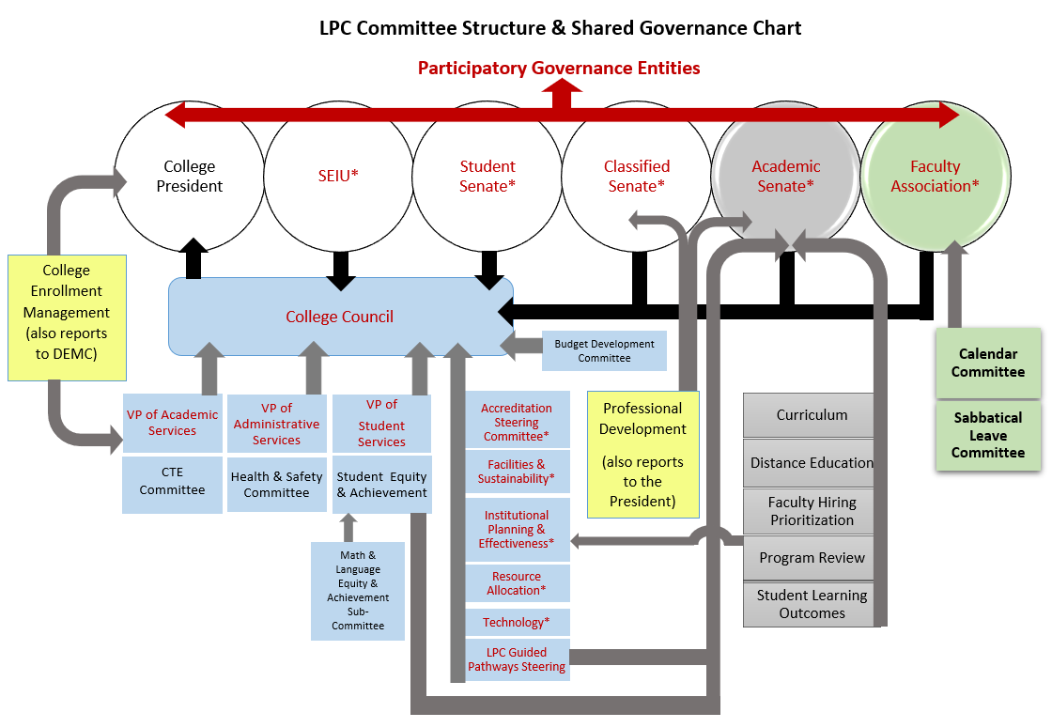

*Reports to College Council

SECTION III.

Operational Guidelines for Committees

Operational Guidelines for Committees

# Committee Academic Year Timeline

|  |  |
| --- | --- |
| **Month** | **Activity** |
| February | * Committees discuss and finalize committee changes and/or structure. * Chair completes Governance Worksheet with or without changes and signs on behalf of the committee. |
| March | * Governance Worksheet goes forward to Academic Senate (if appropriate). * Governance Worksheet goes forward to College Council for approval. * College Council Meeting – Approvals of Governance Committee Changes. * If there are significant changes, Committee Chair or Designee must attend the Council Meeting. |
| April | * Shared Governance Participants’ Document and Governance Handbook updated with committee changes. * President’s Office sends reminder to Academic and Student Services Divisions, Classified Senate, and Administrators to update membership. * Student Services Division Meeting agenda item: committee memberships. * Admin Staff Meeting agenda item: committee memberships. * Classified Senate Meeting agenda item: committee memberships. * Academic Divisions Meeting agenda item: committee memberships. |
| May | * Admin Staff finalizes committee memberships. * Student Services Division finalizes committee memberships. * Classified Senate finalizes committee memberships. * Academic Divisions finalizes committee memberships. * Academic Divisions, Student Services Divisions, Classified Senate, and Admin Staff sends committee representation to President’s Office. |
| August | * President’s Office posts DRAFT Governance Participants on website. |
| September | * Faculty Association sends list of appointments. * LPCSG sends list of appointments to President’s Office. * Committees send President’s Office Committee Chair selection. * President’s Office posts FINAL Governance Participants on website. * Committee Chair/Support updates committee webpage with changes and committee representation. |

# Roles and Responsibilities

## Committee Chair

When chairs of the College Committees are chosen, they become non-voting members of the committee. In the event of a tie, the Chair may vote to break the tie if they wish. Other ways to make the decision include consensus or, if not a time-critical matter, continued discussion and consensus of voting later or holding the topic over to a future meeting agenda.

**The Shared Governance Group that the chair comes from may choose to replace the voting member from their Senate/Union/Division (as applicable) and notify the President’s Office of this replacement.**

Chairs are chosen to guide the agenda, discussion, and votes for the good of the whole campus. They are expected to be well-versed in parliamentary procedures in order to be able to effect efficient and collegial discussions.

* If committee reports to College Council or Academic Senate, be prepared to attend those meetings (i.e., prepare one’s schedule in advance to accommodate attendance).
* Understand the committee’s charge, membership, connections, and reporting relationships to other governance groups.
* Be familiar with relevant accreditation standards and make requested reports.
* Be prepared for meetings.
* Encourage participation of committee members and elicit feedback.
* Ensure that all voices have an opportunity to be heard before decisions are finalized.
* Utilize time management for discussions and meeting time.
* Facilitate dialogue and keep discussions “on track.”
* If the governance group does not have support/resource staff, the Chair is responsible for sending out and posting meeting materials.
* Keep the membership list up-to-date and inform the committee or College Council support person of changes.
* At the end of each meeting, summarize key decisions and next steps for members.
* As soon as possible after meetings, send out Message Points to the committee, Deans, VPs, and constituent groups to assist in Division discussions and to inform other committees which may need to coordinate topics.
* Work collaboratively with Administrative Liaison and support/resource staff (if provided) to develop agenda and meeting materials.
* If new members join the committee mid-way through the semester, provide them with an “orientation” on the group’s charge, membership, and schedule as well as brief overview of the issues addressed to date.

## Committee Member

* When signing up for committees, note the terms and responsibilities and arrange one’s schedule to accommodate the needed work.
* Attend all meetings of the governance group; if a scheduling conflict should arise, identify a proxy to attend the meeting in your place, and when possible, notify the Committee Chair in advance.
* Be prepared for meeting: review materials in advance; be ready to discuss and/or provide feedback; take notes to report back to the constituency group.
* Follow through on seeking feedback from and/or communicating information to constituents
* Adhere to key dates and deadlines for meetings, submitting votes, and follow-up items.
* Lend your voice/perspective to discussions and decisions – remember that you are there to represent your respective constituency group; participation in the dialogue and decision-making is your individual and collective opportunity to weigh in on institutional issues; when in doubt, ask questions.

## Administrative Liaison

* Working collaboratively with the Chair and/or the Administrator, provides information and support to the committee.
* The Administrator is often a long-standing member of the committee who can provide history, background, and context for committee discussions and decisions.
* Assists Chair with development of the meeting agenda.

## Support/Resource Staff

* Takes notes; types/prepares minutes and agenda.
* Posts documents online; maintains current and accurate committee information on the College website.
* Assists Chair and Administrative Liaison with meeting materials and logistics.
* Maintains the archive of committee processes, actions and decisions.
* Functions as the “conduit” for the committee with materials and announcements (e.g. agenda, handouts, votes, etc.) flowing to/through the support staff.

# Terms of Service

* Unless otherwise stated, members will serve a term of two years on each committee to which they have been appointed as a representative.
* To the extent possible – and to maintain continuity of membership and committee history/decision-making – only half of the representatives will be replaced each year.

# Meeting Times and Location

The Master Calendar of College meetings is managed through the President’s Office. If a governance group wishes to change the time, day, or location of its meetings, the request (including rationale) must be submitted in writing to the President’s Office. The request will be reviewed and evaluated with regard to processes, room availability, and potential impact on other meetings and constituents.

# Distribution of Documents

Chairpersons or the committee administrative support person should assure that:

* A campus-wide email regarding the meeting time is sent prior to the meeting.
* Include the agenda with the campus-wide email, if possible.
* For committees subject to the Brown Act (i.e. Academic Senate, Classified Senate, Student Senate, and Curriculum Committee), agendas must be sent at least 72 hours prior to the meeting.
* When possible, send draft minutes to members within 5 working days after meeting; asking for edits.
* When possible, post approved minutes within 5 working days.

# College Committee Changes, Creations or Deactivation

The process for creating or deactivating a committee that reports to College Council follows the Robert’s Rules of Order and the philosophy of LPC Shared Governance.

Should a new committee be deemed necessary (such as Sustainability in 2010 or Integrated Planning in 2013), the matter should be placed on a College Council agenda under New Business. Reasons for the new committee will be presented and discussed and well as providing a Shared Governance Worksheet for the new committee. If prior research has taken place or the new committee has been championed by a certain group or committee, it may be presented at this time. If no research has been done yet, a task force may be created to research the pros and cons.

When fully researched, as with all shared governance matters, the College Council will hear the recommendation and then if agreed upon, shall send it to all constituent Council members (Senates, Unions, Administration) for discussion and voting. The Constituent groups may be asked to provide a one-month turn-around for the decision, if necessary, for accreditation or other needs.

When the Constituent votes return to College Council, the decision will be recorded in the minutes and new arrangements will begin to be made for creating or deactivating the college committee. On applicable committees, should the Academic Senate decide to reduce or increase the number of its representatives, the Classified Senate would like to match the number of its representatives to the faculty number automatically. This will be discussed in College Council.

# Committee Assignments

Committee assignment will take place through the President, Vice Presidents, Deans, Academic Senate, Classified Senate, Student Senate, SEIU, and Faculty Association processes prior to the start of committee meetings each fall.

# Decision Making

# 

## Quorum

A quorum must be present at a meeting in order for governance group action items and recommendations to be considered official. For the purposes of the College governance system, a quorum is determined to be a simple majority (i.e., 50% +1) of the committee’s voting members. An un-appointed seat does not count when determining a quorum (i.e., if your governance entity cannot fill all the seats).

## By Vote of Consensus

LPC committees use Robert’s Rules of Order, Revised for parliamentary rules.

For items requiring an official, recorded decision by the committee, action may be taken by achieving consensus or by taking a vote (verbally, with show of hands, or via email). To maintain consistency, each committee group should agree (ideally at its first meeting of the fall semester) on the decision-making method it will use throughout the year.

Helpful guidelines for achieving consensus:

* Clarify the problem/issue/question;
* Outline the criteria/parameters (effect on students, equity impact, use of tangible and intangible resources, etc.);
* Explore alternate solutions;
* Consensus does not mean unanimity (a few members opposed to the motion do not prohibit consensus, as long as the majority accepts the decision).

## Robert’s Rules of Order, Revised

The situations below apply for these common circumstances:

* No quorum to approve agenda:
  + If no quorum at beginning of meeting, agenda cannot be approved;
  + If quorum occurs during meeting, can approve agenda and discuss and vote on any action items.
* No quorum later in meeting:
  + If a quorum fails to be maintained during the meeting, no further votes or action items may be taken.
* Approval of past minutes:
  + Any member may vote on approval of minutes whether or not they were in attendance at that meeting;
  + The vote can be seen as confidence in the secretary to the committee.

(For reference on Robert’s Rules of Order, see Q&A on: <http://www.robertsrules.com/faq.html#1>)

# Expectations and Engagement

## Accountability

* Attend all meetings.
* Represent your respective constituency group but always maintain a focus on what is in the best interest of students and the institution.
* Adhere to key dates and deadlines for meetings, submitting votes/feedback, and follow-up items; any delay in communicating the necessary information back to the committee/Chair can impact the group’s effectiveness and ability to carry out its charge.
* Stay engaged in meeting discussions, through participation and/or active listening.
* Lend your voice/perspective to discussions and decisions.
* If a committee member is absent from three or more meetings during the course of the semester without sending an alternate representative, the Chair, Administrative Liaison, or Resource Staff should contact the appointing body to identify a replacement (or to determine if naming a replacement is necessary/appropriate).
  + If notified of a member’s absence in advance – and if an alternate is not available or appropriate – the Chair (or Support/Resource Staff) can attempt to have the member to participate via phone or teleconference; contact the Technology Department for these arrangements.
* All committee meetings are open, and all members of the campus community are welcome and encouraged to attend.

## Communication and Collegiality

* Maintain a professional and collegial environment; attack the issue – not the person.
* Remember that as members of the campus community, we’re all on the same team – and ‘we don’t tackle someone wearing the same jersey’.
* “Step up, step down” – share the floor with the other committee members; feel comfortable to speak your mind and share your perspective, but avoid dominating the discussion; make sure there are opportunities for others to join in the dialogue.
* Stay engaged in meeting discussions through participation and active listening; avoid sidebars/private conversations, use of smartphones/tablets/laptops to check messages and surf the web, and other activities (e.g., grading assignments or doing homework) as this may be viewed as a distraction or disrespectful to your fellow committee members.
* Have a “culture of veto” – Decisions by consensus allows the work of the committee/College to move forward; won’t be stuck at a standstill because of one person won’t agree.
* All are equal members of the committee; open communication shall take place without fear of reprisal.
* Although committee decisions/discussions may be communicated broadly or informally by the Chair, Administrative Liaison, and others, it is the primary responsibility of each member to keep their respective constituents informed of committee actions.

SECTION IV.

Committees Reporting to College Council or the President

College Council & Committees Reporting to

College Council and Administration

# College Council

College Council Approved April 25, 2024

**Charge:**

The College Council facilitates communication and coordination to provide direction through appropriate involvement among all constituent groups of the college community. Responsibilities include, but are not limited to:

* Formulating, reviewing, and revising College institutional principles, including the Mission Statement, Vision, Values, and Educational Master Plan Goals with accompanying strategies;
* Reviewing and evaluating the participatory Governance system, including committee structure, making recommendations for revisions on a regular basis and when necessary;
* Providing review, direction, and accountability for the Accreditation Steering Committee;
* Supporting institutional and strategic planning efforts for the College;
* Reviewing Budget Development Committee’s recommendations and processes;
* Assessing the degree of integration of planning, budget, and allocation;
* Operating as a channel for College issues going forward to the District including review and recommendations for policy and procedural changes as appropriate;
* Functioning in a leadership role for various College-wide projects as appropriate;
* Reviewing, documenting, and reporting on accreditation standards linked to committee’s charge.

|  |  |
| --- | --- |
| COMMITTEE: | COLLEGE COUNCIL |
| **Reporting Relationship** | College President |
| **Chairperson:** | College President |
| **Voting Member:** | Only in the event of a tie |
| **Serves on College Council:** | Yes |
|  |  |
| **MEMBERS:** |  |
| **Voting:** | Vice President of Academic Services |
|  | Vice President of Administrative Services |
|  | Vice President of Student Services |
|  | Chair, Accreditation Steering Committee |
|  | Chair, Budget Development committee |
|  | Chair, Facilities and Sustainability Committee |
|  | Chair, Institutional Planning and Effectiveness Committee |
|  | Chair, Resource Allocation Committee |
|  | Chair, Technology Committee |
|  | Coordinator, Guided Pathways Committee |
|  | Career Technical Education Liaison |
|  | Academic Senate President or designee |
|  | Academic Senate Vice President |
|  | Classified Senate President or designee |
|  | Classified Senate Vice President |
|  | LPC Association Site Vice President of CLPFA |
|  | LPC Site Vice President SEIU |
|  | LPCSG President or designee |
|  | LPCSG Vice President |
|  | Director of Student Success & Equity |
|  | Director of Marketing & Communication |
|  |  |
| **Non-Voting:** | n/a |
|  |  |
| **Term:** | 2 years |
|  |  |
| **Quorum:** | 21 Voting Members; Quorum = 11 |
|  |  |

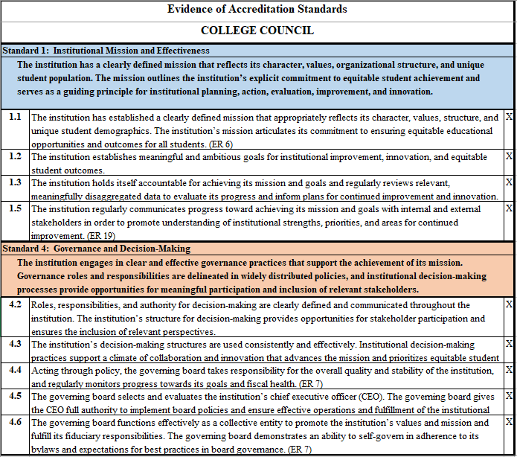

**Accreditation Steering Committee**

College Council Approved September 26, 2024

**Charge:**

The Accreditation Steering Committee (Steering Committee) is a standing committee of the College Council. The Steering Committee will provide leadership and management of the College’s accreditation and ACCJC related matters, and the College Council will provide review, direction, and accountability.

Responsibilities include, but are not limited to:

* Recommending timelines to College Council and Expanded Steering Committees;
* Attending and disseminating information from ACCJC workshops and training;
* Monitoring progress and identifying completion/compliance of accreditation work;
* Regularly updating the campus community on accreditation progress;
* Working with Staff Development to provide technical assistance and training;
* Assisting committees that have accreditation elements in their charge;
* Identifying and advising areas of campus work that need focused attention as related to the accreditation standards;
* Reporting regularly to the Academic Senate and College Council;
* Interpreting the accreditation standards and mapping them to the work of the college;
* Working collaboratively with stakeholders to assign responsibility;
* Monitor and report progress of Quality Focus Essay (QFE) to College Council;
* Recommend timelines to College Council regarding QFE reporting.

|  |  |
| --- | --- |
| COMMITTEE: | ACCREDITATION STEERING COMMITTEE |
| **Reporting Relationship:** | College Council |
| **Chairperson:** | Accreditation Liaison Officer (ALO) appointed by President and one Committee Member |
| **Voting Member:** | Only in the event of a tie |
| **Serves on College Council:** | Yes |
|  |  |
| **MEMBERS:** |  |
| **Voting:** | Faculty Lead (Recommended by ALO/Appointed by Academic Senate) |
|  | Director of Research, Planning and Institutional Effectiveness |
|  | Faculty Member |
|  | Document/Archivist |
|  | Executive Assistant to Vice President of Academic Services |
|  | Dean or other Administrator |
|  | Classified Professional |
|  | Student Services Representative |
|  |  |
| **Quorum:** | 8 Voting Members; Quorum = 5 |
|  |  |
| **Non-Voting:** | Student Representative |
|  |  |
| **Expanded Steering Committee** | Membership to the Accreditation Expanded Steering Committee is recommended by the Accreditation Steering Committee and approved by College Council. All members of the Expanded Steering Committee may vote. |
|  | Administrator (8) |
|  | Faculty (8) |
|  | Classified (8) |
|  |  |
| **Quorum:** | 24 Voting Members; Quorum = 13 |
|  |  |
|  |  |
| **Term:** | Once selected for the Steering Committee, the term expires after the next Self-Evaluation Report and/or Site Visit is complete. |
|  | Once selected for the Expanded Steering Committee, the term expires after the next Self-Evaluation Report and/or Site Visit is complete |

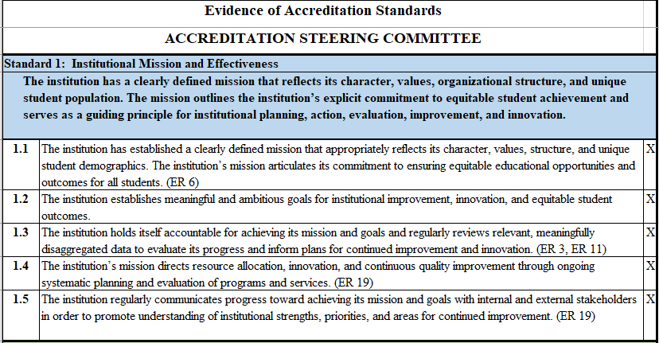

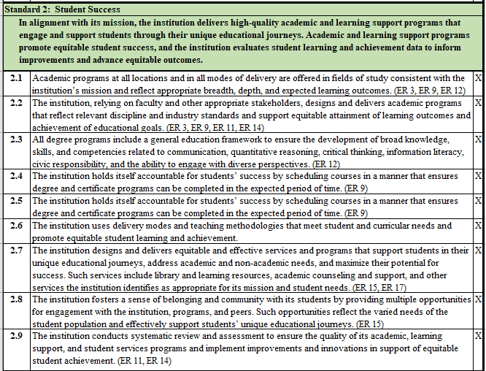

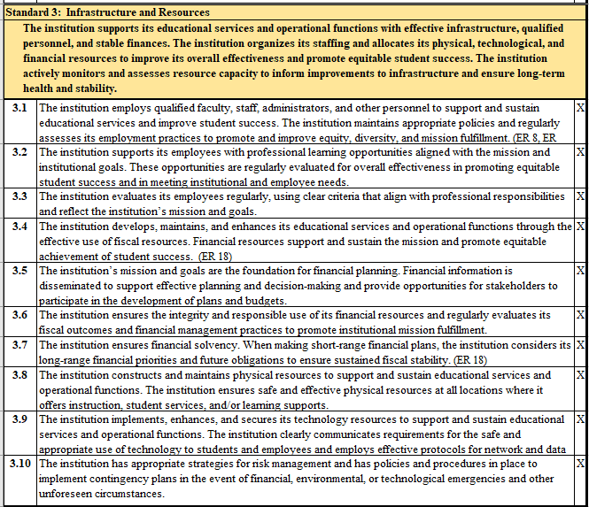

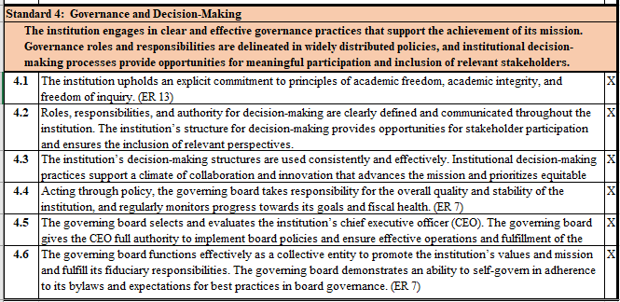

**Budget Development Sub-Committee**

College Council Approved August 24, 2023

**Charge:**

The mission of the Budget Development Committee is to ensure that the college maintains fiscal stability and that financial resources are allocated in accordance with agreed upon Las Positas College established priorities.

The Budget Development Committee accomplishes its mission by:

* Review long-term and short-term financial plans that are aligned with Las Positas College’s Education Master Plan and College Planning Priorities and provide feedback;
* Recommending annual operating budget to College Council;
* Monitoring the college operating budget on a quarterly basis and recommending corrective actions if necessary;
* Ensuring that both long-term and short-term budget activities are integrated into LPC College Council’s Calendar;
* Communicate to the allocating committees with respect to funding available for instructional equipment, staffing levels of faculty, classified staff and administrators per fiscal year;
* Act as a liaison to PBC while establishing regular communications with the campus community regarding college budget matters and budget deadlines;
* Review State, District, and College budget information;
* Evaluate current SCFF metrics and make recommendations as to maximizing SCFF revenue;
* Evaluate cost effectiveness of programs or proposals at the request of College Council;
* Assessing on an annual basis the effectiveness of the Budget Development Committee.

|  |  |
| --- | --- |
| SUBCOMMITTEE: | BUDGET DEVELOPMENT SUBCOMMITTEE |
| **Reporting Relationship:** | College Council |
| **Chairperson:** | Vice President of Administrative Services |
| **Voting Member:** | Only in the event of a tie |
| **MEMBERS:** |  |
| **Voting:** | Administrator, At Large (2) |
|  | Faculty, At Large (2) |
|  | Faculty (appointed by F/A) |
|  | Classified Professional (2) |
|  | SEIU Representative |
|  | LPCSG Representative |
|  | PBC Member (5) |
|  |  |
| **Non-Voting:** | LPC Administrative Services Officer |
|  |  |
| **Term:** |  |
|  |  |
| **Quorum:** | 14 voting members; Quorum = 8 |

|  |  |  |
| --- | --- | --- |
| **Standard 1: Institutional Mission and Effectiveness** | |  |
| **The institution has a clearly defined mission that reflects its character, values, organizational structure, and unique student population. The mission outlines the institution’s explicit commitment to equitable student achievement and serves as a guiding principle for institutional planning, action, evaluation, improvement, and innovation.** | |  |
| **1.4** | The institution’s mission directs resource allocation, innovation, and continuous quality improvement through ongoing systematic planning and evaluation of programs and services. (ER 19) | X |

|  |  |  |
| --- | --- | --- |
| **Standard 3: Infrastructure and Resources** | |  |
| **The institution supports its educational services and operational functions with effective infrastructure, qualified personnel, and stable finances. The institution organizes its staffing and allocates its physical, technological, and financial resources to improve its overall effectiveness and promote equitable student success. The institution actively monitors and assesses resource capacity to inform improvements to infrastructure and ensure long-term health and stability.** | |  |
| **3.4** | The institution develops, maintains, and enhances its educational services and operational functions through the effective use of fiscal resources. Financial resources support and sustain the mission and promote equitable achievement of student success. (ER 18) | |
| **3.5** | The institution’s mission and goals are the foundation for financial planning. Financial information is disseminated to support effective planning and decision-making and provide opportunities for stakeholders to participate in the development of plans and budgets. | |
| **3.6** | The institution ensures the integrity and responsible use of its financial resources and regularly evaluates its fiscal outcomes and financial management practices to promote institutional mission fulfillment. | |
| **3.7** | The institution ensures financial solvency. When making short-range financial plans, the institution considers its long-range financial priorities and future obligations to ensure sustained fiscal stability. (ER 18) | |

|  |  |  |
| --- | --- | --- |
| **Standard 4: Governance and Decision-Making** | |  |
| **The institution engages in clear and effective governance practices that support the achievement of its mission. Governance roles and responsibilities are delineated in widely distributed policies, and institutional decision-making processes provide opportunities for meaningful participation and inclusion of relevant stakeholders.** | |  |
| **4.3** | The institution’s decision-making structures are used consistently and effectively. Institutional decision-making practices support a climate of collaboration and innovation that advances the mission and prioritizes equitable student outcomes. | X |

# College Enrollment Management Committee (CEMC)

College Council Approved April 25, 2024

**Charge:**

In accordance with Article 26E of the CLPCCD/CLPFA collective bargaining agreement, the CEMC is responsible for recommending annual WSCH/FTEF goals for each of the disciplines or grouping of disciplines and the workload goals for other services in order for the college to attain the overall assigned workload goals.

The role of CEMC is to coordinate and facilitate the development of discipline plans that enable the College to meet or exceed annual WSCH/FTEF targets established by the District Enrollment Management Committee (DEMC). The CEMC works in consultation and collaboration with faculty and administrators to allocate FTEF and set productivity targets. The CEMC provides enrollment data and other supporting information to enable faculty in each discipline to develop discipline plans that correspond to the College's productivity/enrollment targets. The CEMC targets and maximizes student success, access, and equity. CEMC evaluates and makes recommendations on increasing/decreasing FTEF allocations to disciplines to meet enrollment and productivity goals. The CEMC evaluates discipline plans and recommends them to appropriate Vice President for approval and scheduling.

|  |  |
| --- | --- |
| COMMITTEE: | COLLEGE ENROLLMENT MANAGEMENT COMMITTEE (CEMC) |
| **Reporting Relationship:** | College President, VP Academic Services, and DEMC |
| **Chairperson:** | Faculty Member and 1 of the appointees of the College President |
| **Voting Member:** | Only in the event of a tie |
| **Serves on College Council:** | Yes |
|  |  |
| **MEMBERS:** |  |
| **Voting:** | Vice President, Academic Services |
|  | Dean, Academic (2) |
|  | Dean of Enrollment Services |
|  | Counseling Faculty (1) |
|  | Faculty (4) |
|  |  |
| **Non-Voting:** | Vice President, Administrative Services |
|  | Vice President, Student Services |
|  | Academic Dean (2) |
|  | Dean of Student Services |
|  | Director of Institutional Research, Planning, and Institutional Effectiveness |
|  | Executive Assistant to the Vice President of Academic Services |
|  | Classified Professional |
|  | LPCSG Representative |
|  | Committee Co-Chairs (vote only in the event of a tie) |
|  |  |
| **Term:** | 2 years |
|  |  |
| **Quorum:** | 9 Voting Members; Quorum = 5 |
|  |  |

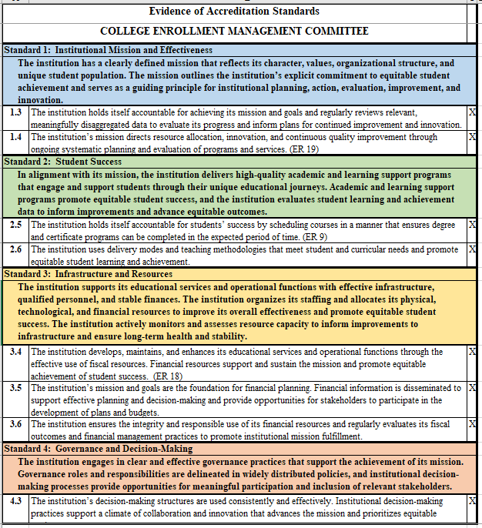

# Facilities and Sustainability Committee

College Council Approved May 11, 2023

**Charge:**

To elicit broad perspectives and advice regarding facility and sustainability needs of the College in order to serve the constituency groups and college by:

* Providing input and reviewing plans for utilization, maintenance, construction or renovation of facilities in concert with the District and the District Facilities Committee;
* Encouraging progress towards more sustainable use of energy, water, open space and other resources by promoting reduced consumption, reuse, recycling, and composting of these resources;
* Providing input, reviewing, and encouraging transportation and campus access strategies that encourage use of public transportation, ride-sharing, bicycle, and pedestrian access.

The Committee will provide an advisory linkage to the President through College Council on all matters pertaining to Facilities and Sustainability in the implementation of Strategic Goals, the College President’s Climate Commitment, the Climate Action Plan, the Educational Master Plan, the Facilities Master Plan, the Scheduled Maintenance Plan, and Ad Hoc Facilities and Sustainability Projects as needed.

The Facilities and Sustainability Committee meeting provides a forum to discuss physical projects on campus and provide input.

The committee will maintain an informational website concerning sustainability:

<http://www.laspositascollege.edu/green/index.php>

|  |  |
| --- | --- |
| COMMITTEE: | FACILITIES AND SUSTAINABILITY COMMITTEE |
| **Reporting Relationship:** | College Council |
| **Chairperson:** | Selected by committee vote |
| **Voting Member:** | Only in the event of a tie |
| **Serves on College Council:** | Yes |
|  |  |
| **MEMBERS:** |  |
| **Voting:** | Vice President of Academic Services |
|  | Vice President of Administrative Services |
|  | Vice President of Student Services |
|  | Academic Dean |
|  | Administrator |
|  | Faculty A&H |
|  | Faculty, PATH |
|  | Faculty, BSSL |
|  | Faculty, STEM |
|  | Faculty, Student Services |
|  | Classified Professional (4) |
|  | LPCSG Representative |
|  |  |
|  |  |
| **Non-Voting:** | Vice Chancellor of Facilities and Bond Program |
|  | Director of Maintenance & Operations |
|  | LPC Project Planner/Manager |
|  | Climate Fellow |
|  |  |
| **Term:** | 2 years |
|  |  |
| **Quorum:** | 15 Voting Members; Quorum = 8 |

|  |  |  |
| --- | --- | --- |
| **Standard 3: Infrastructure and Resources** | |  |
| **The institution supports its educational services and operational functions with effective infrastructure, qualified personnel, and stable finances. The institution organizes its staffing and allocates its physical, technological, and financial resources to improve its overall effectiveness and promote equitable student success. The institution actively monitors and assesses resource capacity to inform improvements to infrastructure and ensure long-term health and stability.** | |  |
| **3.8** | The institution constructs and maintains physical resources to support and sustain educational services and operational functions. The institution ensures safe and effective physical resources at all locations where it offers instruction, student services, and/or learning supports. |  |

# Guided Pathways Steering Committee

College Council Approved April 25, 2024

**Charge:**

The LPC Guided Pathways Steering Committee is a standing committee of the College Council. The goal of Guided Pathways is to increase student success and completion through continuous improvement in college practices and processes: coordinating needed academic support, removing barriers, and supporting equity-infused practices and holistic support along the student journey.  The Steering Committee’s focus is to guide the work and infrastructure to support student success teams. The Steering Committee is a cross-functional team that provides overall guidance to the college with regard to the inquiry, design, and implementation of Guided Pathways.

Responsibilities include, but are not limited to:

* Coordinate the development of the annual Guided Pathways Work Plan and budget
* Monitor progress of the Guided Pathways Work Plan including coordinating the annual assessment of key elements
* Develop, initiate, participate in, and evaluate activities that relate to Guided Pathways
* Create, lead, monitor, and advise work groups
* Lead the conversation about Guided Pathways with constituent groups throughout the College; as appropriate, coordinate with Guided Pathways efforts across the District
* Provide guidance upon on our Academic and Career Pathways’ structure and function
* Identify and recommend projects related to Guided Pathways, including technology and communication, that require the attention of the campus and across the District
* Work with the Professional Development Committee to recommend professional development opportunities
* Regularly collaborating on Guided Pathways to the College Council, Student Equity and Achievement Committee, Institutional Planning and Effectiveness Committee, Academic and Classified Senates, Student Government, Administrative Staff and other relevant committees/groups.
* Review, document, and report on accreditation standards linked to the committee’s charge.

|  |  |
| --- | --- |
| COMMITTEE: | LPC GUIDED PATHWAYS STEERING COMMITTEE |
| **Reporting Relationship:** | College Council |
| **Chairperson:** | Tri-Chair Model: Instructional Faculty, Student Services or Instructional Faculty, Classified Professional |
| **Voting Member:** | Only in the event of a tie |
| **Serves on College Council:** | Yes |
|  |  |
| **MEMBERS:** |  |
| **Voting:** | Vice President appointed by President |
|  | Administrator (2) |
|  | Faculty, A&H |
|  | Faculty, PATH |
|  | Faculty, BSSL |
|  | Faculty, STEM |
|  | Faculty, Student Services |
|  | Faculty, At-Large (1) |
|  | Classified Professional (4) |
|  | Students (2) – student government or recruited by Chairs |
|  |  |
| **Non-Voting:** | Tri-Chairs: 1 Academic Faculty, 1 Student Services Faculty, 1 Classified Professional (except in event of tie) |
|  | VP Academic Services/Student Services |
|  | Director of Student Equity and Achievement or designee |
|  |  |
| **Term:** | 2 years |
|  |  |
| **Quorum:** | 16 Voting Members; Quorum = 9 |

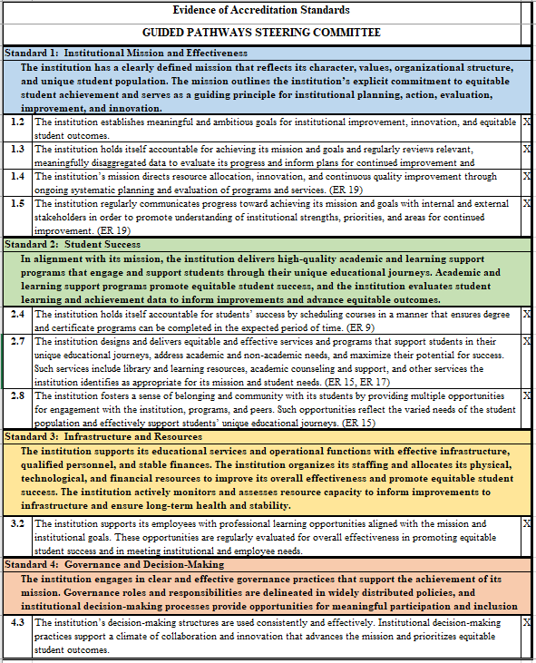

**Institutional Planning and Effectiveness Committee (IPEC)**

College Council Approved May 17, 2024

**Charge:**

The Institutional Planning and Effectiveness Committee (IPEC) provides institutional-level planning priority recommendations to the College President. In addition, IPEC evaluates key college processes and metrics in order to make recommendations or share information to improve student learning and institutional outcomes.

The responsibilities of IPEC will include, but are not limited to:

1. Creating planning priorities by primarily utilizing the College’s Mission, Vision and Values Statements, Strategic Plans, Program Reviews, SLOs/SAO, institutional research, Student Success Team data, and accreditation documents. In addition, planning priorities are informed by a variety of sources, including district priorities, and State, Federal, and Accreditation Commission for Community and Junior Colleges (ACCJC) mandates as required;
2. Guiding the institutional and strategic planning efforts by recommending planning priorities;
3. Reviewing institutional responses to State, Federal and accreditation mandates to ensure incorporation into institutional planning;
4. Identifying, reviewing, and revising, as necessary, processes for:
   1. Integrating the College strategic planning documents, including SLO/SAO and Program Review documents, into planning;
   2. Integrating and communicating the planning priorities to committees for allocation purposes;
5. Evaluating key college processes and metrics and integrating the findings into the planning process;
6. Providing direction to the Institutional Research Office to generate the data and analysis necessary for the planning efforts needed by the college;
7. Communicating adopted planning priorities and the rationale behind them to the College and College Council;
8. Reviewing, documenting, and reporting on accreditation standards linked to IPEC’s charge;
9. Evaluating IPEC’s charge, tasks and membership on a regular basis.

*ACCJC = Accreditation Commission for Community and Junior Colleges

|  |  |
| --- | --- |
| COMMITTEE: | INSTITUTIONAL PLANNING AND EFFECTIVENESS COMMITTEE (IPEC) |
| **Reporting Relationship:** | College Council |
| **Chairperson:** | Selected by committee vote; can be faculty, classified, or administrator |
| **Voting Member:** | Only in the event of a tie |
| **Serves on College Council:** | Yes |
|  |  |
| **MEMBERS:** |  |
| **Voting:** | Vice President of Academic Services |
|  | Vice President of Administrative Services |
|  | Vice President of Student Services |
|  | Researcher |
|  | Faculty, A&H * |
|  | Faculty, PATH * |
|  | Faculty, BSSL * |
|  | Faculty, STEM * |
|  | Faculty, Student Services |
|  | Classified Professional (5) (all at-large) |
|  | LPCSG Representative (2) |
|  |  |
|  | *Academic Divisions Faculty – preferably 1 from a CTE Discipline |
|  |  |
| **Non-Voting:** | College President |
|  | Chair sits on College Council (can be faculty, classified, or administrator) |
|  | Academic Senate President* |
|  | Chair, Program Review Committee* |
|  | Chair, Student Learning Outcomes Committee* |
|  | Classified Senate President/Co-President* |
|  | Faculty Association (FA) Representative* |
|  | SEIU Representative* |
|  | LPCSG President* |
|  |  |
|  | *Can double as voting Division/Senate representative |
|  |  |
| **Term:** | 2 years |
|  | This committee's responsibilities are seen to be complex, taking quite some time to learn the inter-relationships and requirements of the many mandates and agencies. |
|  |  |
| **Quorum:** | 16 Voting Members; Quorum = 9 |

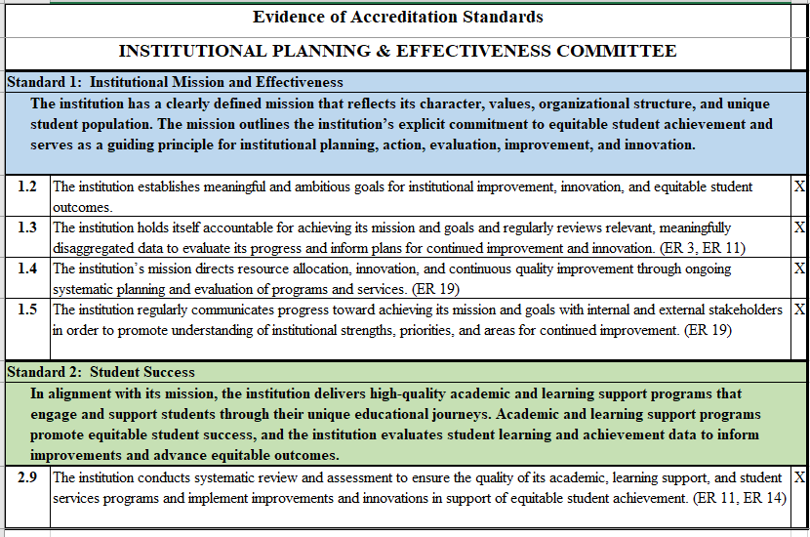

# Resource Allocation Committee (RAC)

College Council Approved April 25, 2024

**Charge:**

Considering the planning priorities and educational master plan, and using the College mission statement, this committee will guide the institutional allocation processes of the College. Responsibilities include, but are not limited to:

* Developing, documenting, evaluating, and recommending resource allocation processes and decisions in relation to the college goals and priorities;
* Identifying, prioritizing, and recommending 1) instructional equipment and 2) classified and administrative hiring priorities.

This committee will make recommendations to the College President.

|  |  |
| --- | --- |
| COMMITTEE: | RESOURCE ALLOCATION COMMITTEE (RAC) |
| **Reporting Relationship:** | College Council |
| **Chairperson:** | Selected by committee vote |
| **Voting Member:** | Only in the event of a tie |
| **Serves on College Council:** | Yes |
|  |  |
| **MEMBERS:** |  |
| **Voting:** | Vice President of Academic Services |
|  | Vice President of Administrative Services |
|  | Vice President of Student Services |
|  | Academic Dean |
|  | Dean, Student Services |
|  | Faculty, A&H |
|  | Faculty, BSSL |
|  | Faculty, PATH |
|  | Faculty, STEM |
|  | Faculty, Student Services |
|  | Classified Professional (5) |
|  | LPCSG Representative |
|  |  |
| **Non-Voting:** | n/a |
|  |  |
| **Term:** | 2 years |
|  |  |
| **Quorum:** | 16 Voting Members; Quorum = 9 |

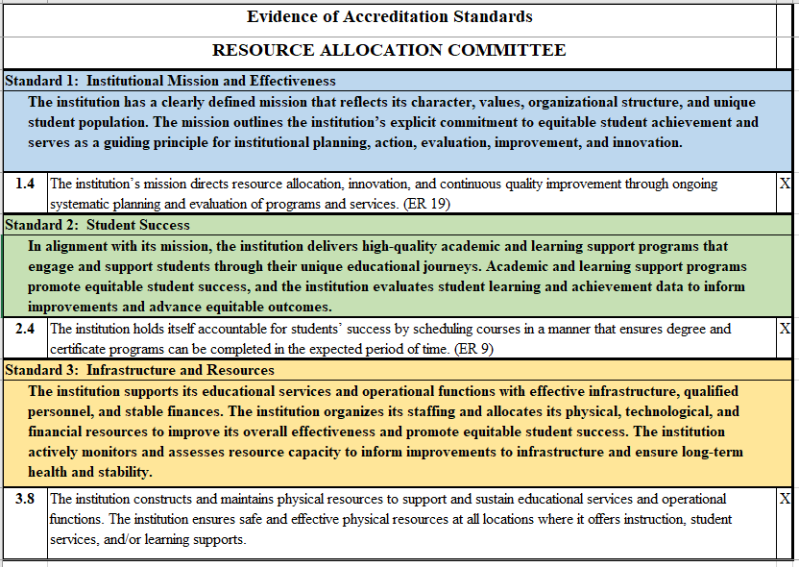

# Technology Committee

College Council Approved April 25, 2024

**Charge:**

The Technology Committee is responsible for:

* Assessing faculty, student, and staff technological needs for Las Positas College using various vehicles including reports and survey data;
* Researching and analyzing options for campus-wide technology;
* Reviewing and evaluating resources and additional technology needs as they arise, using the College Mission, Vision, Values and Priorities as guidelines;
* Communicating on current and upcoming technology projects and collaborating with the District ITS regarding District-wide projects and issues;
* Reviewing and making recommendations on LPC Technology Master Plan, Accreditation, and relevant District-wide Master Plans;
* Making recommendations for solutions in the following areas:
* Access
* Staff development and training

Support

The Technology Committee will coordinate with other committees impacted by technology related recommendations.

|  |  |
| --- | --- |
| COMMITTEE: | TECHNOLOGY COMMITTEE |
| **Reporting Relationship:** | College Council |
| **Chairperson:** | Selected by committee vote |
| **Voting Member:** | Only in the event of a tie |
| **Serves on College Council:** | Yes |
|  |  |
| **MEMBERS:** |  |
| **Voting:** | Vice President of Administrative Services |
|  | Dean |
|  | Faculty, A&H |
|  | Faculty, BSSL |
|  | Faculty, PATH |
|  | Faculty, STEM |
|  | Faculty, Student Services |
|  | Librarian |
|  | Classified Professional (5) |
|  | LPCSG Representative |
|  |  |
| **Non-Voting:** | Instructional Technology Coordinator* |
|  | Manager, College Technology Services* |
|  | Telecommunications Coordinator* |
|  | Webmaster* |
|  | CLPCCD Chief Technology Officer |
|  |  |
|  | *Non-voting college classified may be appointed by the Technology Committee to fill any vacant voting classified professional position |
|  |  |
| **Term:** | 2 years |
|  |  |
| **Quorum:** | 15 Voting Members; Quorum = 8 |

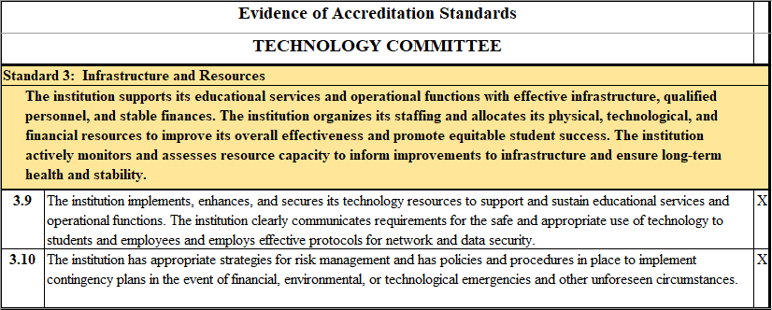

SECTION V.

Committees Reporting to Academic Senate

Committees Reporting to Academic Senate

# Curriculum Committee

College Council Approved May 17, 2024

**Overview:**

Responsible for reviewing curriculum, establishing prerequisites, placing courses in disciplines, assigning course identifiers, degree, and certificate requirements, developing process and timelines for review of academic programs, grading policies, maintaining and updating the discipline list, promoting equity in curriculum, and making recommendations to the President for action by the Board of Trustees. All new courses and programs, as well as changes in current course and program content, structure, or credit, must be reviewed by this committee.

**Charge:**

The Curriculum Committee (hereafter referred to as “the Committee”) is responsible for ensuring and preserving the academic integrity and quality of all courses and programs offered by Las Positas College. The Committee’s primary responsibilities lie in five major areas, as specified by Title V [Title 5 §53200]:

* Curriculum
* Degree and certificate requirements
* Grading policies
* Educational program development
* Standards or policies regarding student preparation and success

As a sub-committee of the Academic Senate, the Committee reports its recommendations for approval in the areas of Curriculum and Educational Programs to the Senate as informational items and forwards its recommendations in these areas to the Office of the Vice President of Academic Services. That office prepares the recommendations for presentation to the Board of Trustees by way of the President’s Office at the College. The Board of Trustees is the sole authority for approval of all curriculum recommendations in the areas of Curriculum and Educational Programs.

In the area of Degree and Certificate Requirements, it is the duty of the Committee to formulate policies for approving degree and certificate requirements for presentation to the Senate. It is not the role of the Senate to change these recommendations. However, it is appropriate for the Senate to review the policies and procedures used [Title V §53203(a)] and call attention to any irregularities which might require a recommendation to be returned to the Committee for reconsideration. Changes to the General Education pattern for the Associate degree may be recommended by the Committee but must be agreed upon through collegial consultation with the Curriculum Committees and Academic Senates of both colleges and approved by the Board of Trustees.

The Committee’s duties and responsibilities in each of the areas are defined as follows:

1. **Curriculum**

In the area of curriculum, the Committee’s duties include, but are not limited to, approval of:

* New and revised course outlines of record for degree-applicable credit courses, non-degree credit courses, and non-credit courses;
* Pre-requisites, co-requisites, and advisories for courses;
* Limitations on the number of times a course may be repeated;
* Courses to be taught in distance education modes;
* Courses for inclusion in the requirements for the Associate degree (AA or AS);
* Courses for transfer to CSU;
* Courses for which credit may be earned through prior learning;
* Discontinuation of existing courses or programs;
* Placement of courses within disciplines;
* Assigning course identifiers;
* Maintaining and updating the discipline list.

1. **Degree and Certificate Requirements**

In this area, the Committee’s duties include, but are not limited to, the following:

* Recommendations for changes to the General Education pattern for the Associate degree;
* Definition of criteria for placement of courses within General Education areas;
* Periodic review for appropriateness and relevancy of the courses listed within a specific General Education area.

1. **Grading Policies**

In this area, the Committee’s duties include, but are not limited to, the following:

* Review of grading policies for individual courses (e.g., whether the course is grade only);
* Review of coursework required of students (as specified in the course outline of record), to ensure that coursework meets rigorous academic standards.

1. **Educational Programs**

Educational programs are initiated and developed within appropriate areas or disciplines. In this area, the Committee’s duties include, but are not limited to, the approval of:

* Educational (degree and certificate) programs and requirements for such programs;
* Pre-requisites, co-requisites, and advisories for new and revised programs.

1. **Standards or Policies Regarding Student Preparation and Success**

The Committee’s role in this area is related to its charge to approve course outlines and pre-requisites. The Committee must ensure that pre-requisites, co-requisites, and advisories are appropriately selected in such a way as to ensure students are adequately prepared for a course and will have the skills necessary to succeed in the course. The Committee must also ensure that pre-requisites, co-requisites, and advisories do not act as a barrier to students seeking to complete coursework or programs.

|  |  |
| --- | --- |
| COMMITTEE: | CURRICULUM COMMITTEE |
| **Reporting Relationship:** | Academic Senate |
| **Chairperson:** | Selected by Academic Senate |
| **Voting Member:** | Only in the event of a tie |
| **Serves on College Council:** | No |
|  |  |
| **MEMBERS:** |  |
| **Voting:** | Dean |
|  | Faculty, A&H (2) |
|  | Faculty, BSSL (2) |
|  | Faculty, PATH (2) |
|  | Faculty, STEM (2) |
|  | Faculty, Student Services (2) |
|  | Faculty, Library |
|  | Articulation Officer |
|  |  |
| **Non-Voting:** | Vice President of Academic Services |
|  | Dean |
|  | Classified Professional, Academic Services (2) |
|  | Classified Professional, Admission and Records |
|  | LPCSG Representative |
|  |  |
| **Appointments by:** | Academic Senate; College President; Student Senate |
|  |  |
| **Term:** | It is hoped that voting members will serve for a minimum of two years and should be allowed to serve longer if so selected by their constituency in order to preserve valuable expertise amongst the committee members. At the same time, it is important to bring new members onto the committee within any two-year cycle in order to develop curriculum expertise amongst all faculty members. |
|  | The term of office for the position of Chair is two years. The Chair may serve for more than one term and may serve consecutive terms. |
|  |  |
| **Quorum:** | 13 Voting Members; Quorum = 7 |

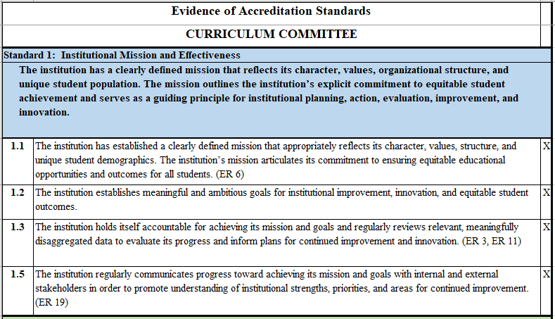

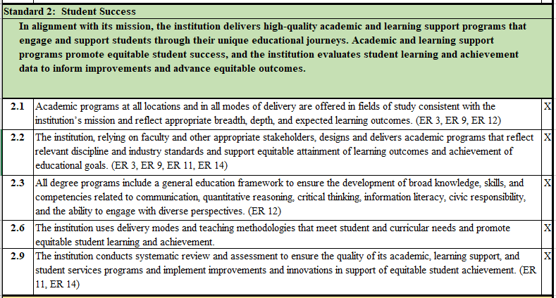

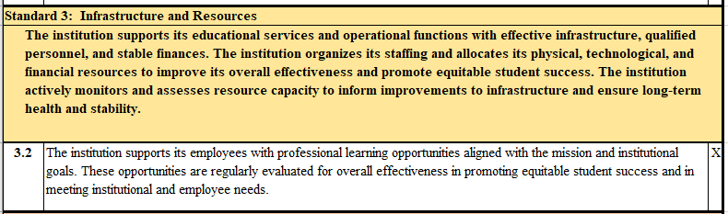

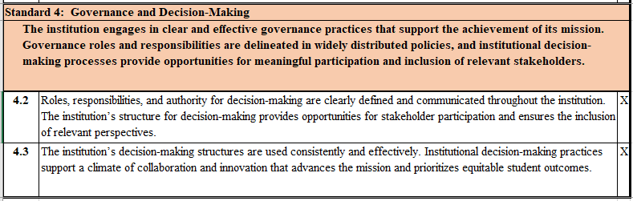

**Distance Education Committee (DE)**

College Council Approved April 25, 2024

**Charge:**

The Distance Education Committee (DE) will explore and recommend policies, procedures, and tools to enhance student learning and services in the delivery of distance education offered through Las Positas College. To review distance education courses and provide feedback to instructors on how to align their courses to quality course design standards in addition to legal and accreditation requirements.

|  |  |
| --- | --- |
| COMMITTEE: | DISTANCE EDUCATION COMMITTEE (DE) |
| **Reporting Relationship:** | Academic Senate |
| **Chairperson:** | 1 Co-Chair: Teaching & Learning Center Rep and 1 Co-Chair: Faculty (selected by committee vote) |
| **Voting Member:** | Only in the event of a tie |
| **Serves on College Council:** | No |
|  |  |
| **MEMBERS:** |  |
| **Voting:** | Faculty, A&H |
|  | Faculty, PATH |
|  | Faculty, BSSL |
|  | Faculty, STEM |
|  | Faculty, Student Services |
|  | Library Representative |
|  | Faculty, Adjunct |
|  | Faculty, At-Large |
|  | Classified Professional from the Teaching & Learning Center |
|  |  |
| **Non-Voting:** | Vice President of Academic Services |
|  | Academic Dean |
|  | Admissions and Records Representative |
|  | Faculty, A&H (2) |
|  | Faculty, PATH (2) |
|  | Faculty, BSSL(2) |
|  | Faculty, STEM (2) |
|  | Faculty, Student Services (2) |
|  | LPCSG Representative |
|  |  |
| **Term:** | 2 years |
|  |  |
| **Quorum:** | 9 Voting Members; Quorum = 5 |

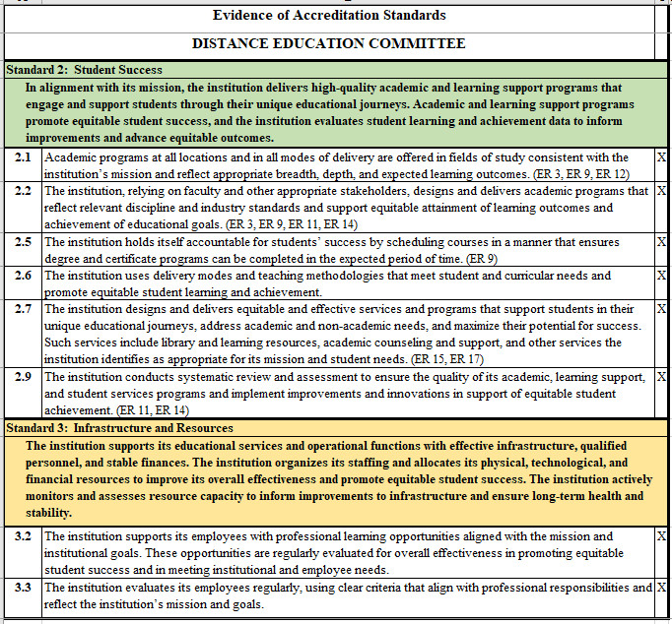

# Faculty Hiring Prioritization Committee (FHPC)

College Council Approved April 25, 2024

**Charge:**

Using the full-time Faculty Position Request Form, the committee will discuss and rank the faculty position requests by consensus and:

* Recommend faculty hiring priorities, by discipline, to the College President;
* Ensure that the College’s overarching planning documents are considered in all decisions;
* Coordinate with the Office of Institutional Research to ensure the faculty hiring is integrated with planning and research.

**Emergency Replacement**

"Emergency Replacement" refers to the situation where a full-time position is vacated unexpectedly and a new hire is recommended to the College President outside of the normal ranking process. Retirements, resignations, and deaths do not necessarily justify an emergency hire. The FHPC will determine whether or not a sudden, unexpected vacancy justifies an emergency hire by considering the following criteria:

1. External discipline accreditation requirements,

2. Health and Safety requirements,

3. Difficulty in recruiting and/or retaining part-time faculty,

4. Impact on student success and completion,

5. Impact on faculty non-teaching duties specific to the program (e.g. facilities and/or equipment coordination, travel, recruitment/outreach),

6. Classified support status (instructional assistants, lab technicians, etc.).

The process for requesting an Emergency Replacement is as follows:

A completed Faculty Position Request Form must be submitted to the FHPC through the appropriate division dean who must verify and approve the emergency nature of the request. The faculty Position Request Form will include an explanation about the need for continuation of the vacated position and the rationale for the emergency timing of the hiring action.

The FHPC will hold a special meeting after the dean forwards the request to the FHPC.

Based on the information provided in the form, the FHPC will decide by consensus whether to recommend immediate replacement of the position, to consider the position within the existing rankings*, or to request that the application be submitted through the regular process the following year. If multiple Emergency Replacement requests are reviewed at the same time, the FHPC will rank them in order of priority based upon the criteria listed above. Recommendations will go to the Academic Senate, along with a rationale. If there are any concerns formally raised by the Academic Senate, the FHPC will reconvene to review them. The FHPC will either reaffirm the recommendation(s) or make changes considering the Academic Senate’s concerns. In either case, the FHPC reports its decision to the Senate and forwards its final recommendation, along with a written description of Academic Senate concerns and the FHPC response, to the College President.

No meetings to consider an Emergency Replacement will be held outside the regular academic year. If an emergency request that meets criteria 1 or 2 is received outside the regular academic year, the dean will confer with the FHPC Chair, the other deans on the committee, and the Academic Senate President. If they decide by consensus that an emergency hire is necessary, they will make that recommendation to the College President.

*an unexpected vacancy meeting criteria 1 or 2 above will be recommended for emergency hire outside of the existing rankings; all other unexpected vacancies may be ranked alongside the existing rankings.

|  |  |
| --- | --- |
| COMMITTEE: | FACULTY HIRING PRIORITIZATION COMMITTEE (FHPC) |
| **Reporting Relationship:** | Academic Senate and College President |
| **Chairperson:** | Selected from faculty membership of committee by committee vote |
| **Voting Member:** | Yes |
| **Serves on College Council:** | No |
|  |  |
| **MEMBERS:** |  |
| **Voting:** | Dean, A&H |
|  | Dean, BSSL |
|  | Dean, PATH |
|  | Dean, STEM |
|  | Dean, Student Services |
|  | Faculty, A&H |
|  | Faculty, BSSL |
|  | Faculty, PATH |
|  | Faculty, STEM |
|  | Faculty, Student Services |
|  |  |
| **Non-Voting:** | President |
|  | Vice President of Academic Services |
|  | Vice President of Student Services |
|  | Director of Institutional Research, Planning and Effectiveness |
|  | Academic Senate President |
|  | Classified Senate President |
|  | LPCSG Representative |
|  |  |
|  | Designees are chosen to serve in lieu of the committee member for the semester or academic year, not on a meeting-by-meeting basis. In order to maximize attendance by committee members, all efforts will be made to schedule meeting days and times after Town Meeting or division meetings |
|  |  |
| **Term:** | 2 years for Faculty; Permanent for Deans |
|  |  |
| **Quorum:** | 10 Voting Members; Quorum = 6 |

# Program Review Committee (PRC)

College Council Approved April 25, 2024

**Mission Statement:**

The Program Review Committee promotes an effective and meaningful process with clear links to institutional planning and resource allocation.

**Charge:**

The Academic Senate and Institutional Planning and Effectiveness Committee of Las Positas College charge the Program Review Committee with:

* Creating, evaluating, and modifying (as needed) the forms and processes for Program Review;
* Communicating these processes and their outcomes to the campus;
* Posting materials on the Program Review website;
* Monitoring the Program Review process for inclusiveness, effectiveness, and transparency and making ongoing improvements;
* Mentoring program review writers through the writing process;
* Providing feedback to writers for improvements to strengthen their Program Reviews;
* Working collaboratively with administration, appropriate committees, and other College constituencies on the integration of program review into planning and resource allocation processes;
* Collaborating with Deans (or Vice Presidents) and other readers of program reviews (and updates) to create division summaries, which re submitted to IPEC.

|  |  |
| --- | --- |
| COMMITTEE: | PROGRAM REVIEW COMMITTEE (PRC) |
| **Reporting Relationship:** | Academic Senate and Institutional Planning & Effectiveness Committee |
| **Chairperson:** | Outreach to the campus as a whole, specifically to the Academic Senate and IPEC. Addition, there can be a co-chair model with Faculty and Classified Professional. The Chair attends IPEC and regularly reports to Academic Senate. |
| **Voting Member:** | Only in the event of a tie |
| **Serves on College Council:** | No |
|  |  |
| **MEMBERS:** |  |
| **Voting:** | Vice President of Academic Services or designee |
|  | Academic Dean |
|  | Faculty, A&H (2) |
|  | Faculty, PATH (2) |
|  | Faculty, BSSL (2) |
|  | Faculty, STEM (2) |
|  | Faculty, Student Services |
|  | Librarian |
|  | Classified Professional, at large (1) |
|  | Classified Professional, Student Services (1) |
|  | Faculty Association Representative |
|  | Student Government Representative |
|  | SLO Committee Member |
|  |  |
|  |  |
| **Voting Structure:** | All recommendations of the committee shall be referred to the Academic Senate for approval. Any recommendations made by the committee should be by consensus amongst the members. |
|  |  |
| **Term:** | New members are required to serve on the committee for a minimum of two years while returning members or members who have served previously are only required to serve for a year. (It takes about a year to learn the program review process and get through a program review cycle, so any new member that served on the committee would just get through learning the cycle and process and their term would end if kept to one year for everyone.) |
|  |  |
| **Quorum:** | 12 Voting Members; Quorum = 7 |

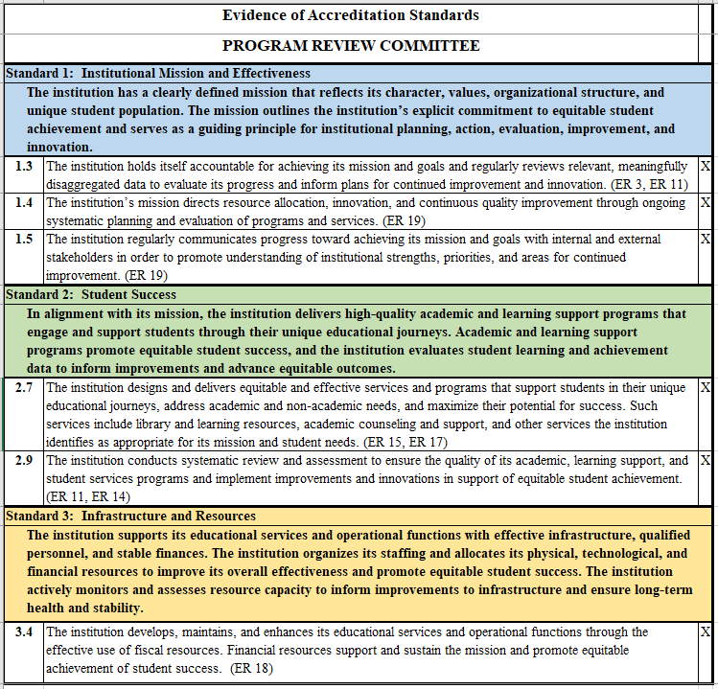

SECTION VII.

Committees Reporting to Academic Senate and College Council

# Career Technical Education (CTE)

College Council Approved April 25, 2024

**Charge:**

The Career Technical Education (CTE) Committee will help coordinate, lead, and support efforts and initiatives to increase and improve Career Education program outcomes. Using data and complying with applicable regulations, the CTE Committee will identify, prioritize, allocate, and report on funding for state (Strong Workforce), federal (Perkins), and CTE grants in alignment with college goals and plans and accreditation standards. The CTE Committee will assist with the implementation, make recommendations, and report out on outcomes for the Economic and Workforce Development Plan, relying on college and district data and plans and informed by applicable regulations, and will communicate the plan to the college.

|  |  |
| --- | --- |
| COMMITTEE: | CAREER TECHNICAL EDUCATION (CTE) |
| **Reporting Relationship:** | Academic Senate and College Council |
| **Chairperson:** | Co-Chairs – CTE Project Manager and CTE Liaison |
| **Voting Member:** | Only in the event of a tie |
| **Serves on College Council:** | No |
|  |  |
| **MEMBERS:** |  |
| **Voting:** | Administrator – Academic Services, At-large-1 |
|  | Administrator – Academic Services, At-large-2 |
|  | Administrator – VP of Academic Services |
|  | Administrator – Director of Research, Planning, and Institutional Effectiveness |
|  | Classified Professional, A&H |
|  | Classified Professional, BSSL |
|  | Classified Professional, STEM |
|  | Classified Professional, PATH |
|  | Classified Professional, Student Services |
|  | Faculty* - A&H |
|  | Faculty* - BSSL |
|  | Faculty* - STEM |
|  | Faculty* - PATH |
|  | Faculty – Counseling |
|  | *It is strongly recommended that faculty be from the CTE disciplines as defined by the California Community Colleges Chancellor’s Office |
|  |  |
| **Non-Voting:** | Academic Deans (4) |
|  | Co-Chairs/CTE Liaison and CTE Project Manager |
|  |  |
| **Term:** | 2 years |
|  |  |
| **Quorum:** | 14 Voting Members; Quorum = 8 |

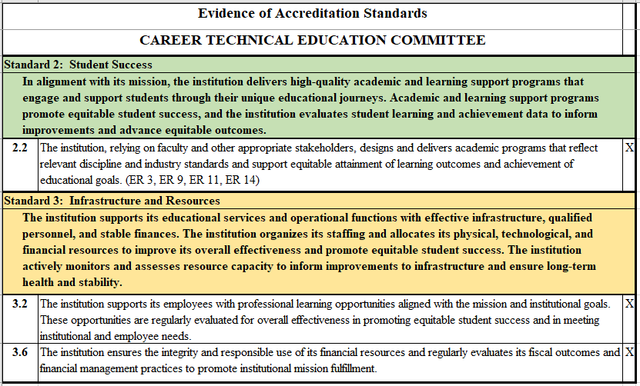

SECTION VIII.

Committees Reporting to Academic Senate and Classified Senate

# Professional Development Committee (PDC)

College Council Approved April 24, 2024

**Charge:**

Develop policies and processes for awarding of professional development funds; review and make recommendations for funding of staff proposals; plan and promote staff development activities.

|  |  |
| --- | --- |
| COMMITTEE: | PROFESSIONAL DEVELOPMENT COMMITTEE (PDC) |
| **Reporting Relationship:** | President, Academic Senate, Classified Senate, and Student Senate |
| **Chairperson:** | Tri-Chair: Administrator (selected by College President), Faculty (selected by Academic Senate), and Classified Professional (selected by Classified Senate). |
| **Voting Member:** | Only in the event of a tie |
| **Serves on College Council:** | No |
|  |  |
| **MEMBERS:** |  |
| **Voting:** | College President |
|  | Faculty, A&H |
|  | Faculty, BSSL |
|  | Faculty, PATH |
|  | Faculty, STEM |
|  | Faculty, Student Services |
|  | Faculty, Adjunct |
|  | Classified Professional, Teaching & Learning Center |
|  | Classified Professional, Administrative Services |
|  | Classified Professional (3) |
|  |  |
| **Non-Voting:** | LPCSG Representative |
|  | Administrator |
|  | Classified Chair |
|  | Faculty Chair |
|  |  |
| **Term:** | 2 years |
|  |  |
| **Quorum:** | 12 Voting Members; Quorum = 7 |

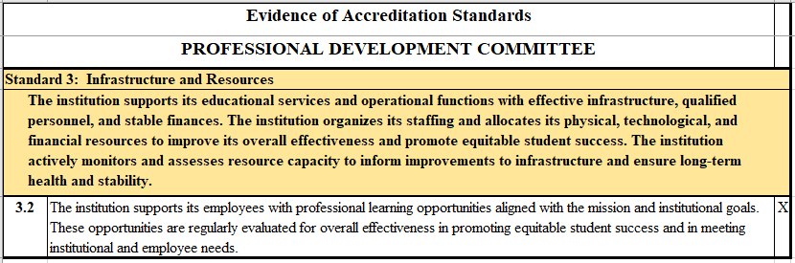

SECTION IX.

Committees Reporting to Academic Senate and College Council via VPSS

# Student Equity and Achievement Committee (SEA)

College Council Approved April 25, 2024

**Charge:**

The Student Equity & Achievement (SEA) Committee will help coordinate, lead, and support efforts and initiatives to boost achievement for all students with an emphasis on eliminating achievement gaps for disproportionally impacted students, as defined by the California Community Colleges Chancellor’s Office, and supporting language acquisition for language learners. The SEA Committee will help coordinate activities and practices pursuant to Guided Pathways; support students to complete their educational goals and a defined course of study; and support high-quality curriculum, instruction, and support services to students especially those who enter college requiring additional support learning English, ESL, and mathematics to ensure completion of a course of study in a timely manner.

|  |  |
| --- | --- |
| COMMITTEE: | STUDENT EQUITY AND ACHIEVEMENT COMMITTEE (SEA) |
| **Reporting Relationship:** | Academic Senate and College Council via the Vice President Student Services |
| **Chairperson:** | Director of Student Success and Equity |
| **Voting Member:** | Only in the event of a tie |
| **Serves on College Council:** | No |
|  |  |
| **MEMBERS:** |  |
| **Voting:** | Administrator, Academic Services, At Large (2) |
|  | Administrator, Student Services, At Large |
|  | Administrator, Vice President of Student Services |
|  | Classified Professional, Academic Services (2) |
|  | Classified Professional, Student Services (2) |
|  | Classified Professional, At Large |
|  | Faculty, A&H |
|  | Faculty, BSSL |
|  | Faculty, PATH |
|  | Faculty, STEM |
|  | Library Representative |
|  | Faculty, Counseling |
|  | LPCSG Representative (2) |
|  |  |
| **Non-Voting:** | Co-Chair, Director of Student Equity & Success |
|  | Co-Chair, Faculty from a discipline that offers Basic Skills courses |
|  | Administrator, Director of Research, Planning and Institutional Effectiveness |
|  |  |
| **Term:** | 2 years |
|  |  |
| **Quorum:** | 17 Voting Members; Quorum = 9 |

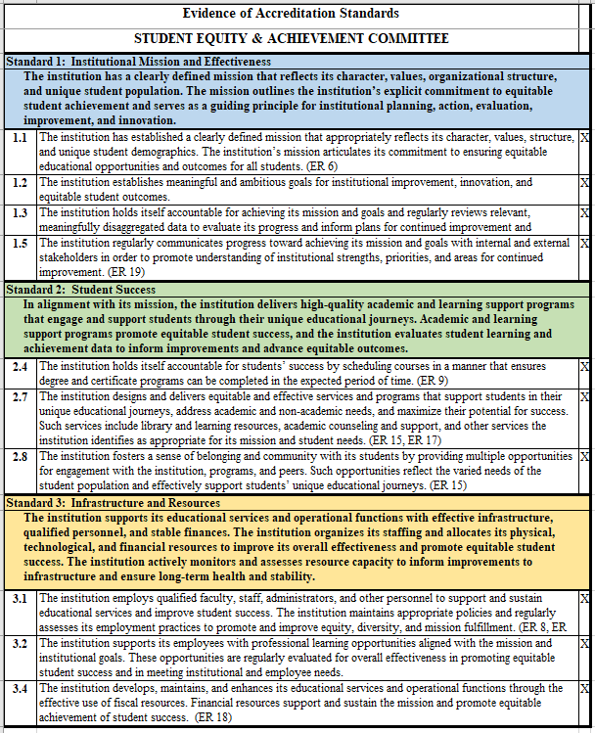

SECTION X.

Committees Reporting to Administrative Services

# 

# Health and Safety Committee

College Council Approved May 11, 2023

**Charge:**

The Health and Safety Committee is responsible for studying, reviewing, and recommending regulations and procedures relating to the health and safety (including environmental and physical hazards) of students, employees, and campus visitors.

|  |  |
| --- | --- |
| COMMITTEE: | HEALTH AND SAFETY COMMITTEE |
| **Reporting Relationship:** | Vice President of Administrative Services |
| **Chairperson:** | Safety Supervisor |
| **Voting Member:** | Only in the event of a tie |
| **Serves on College Council:** | No |
|  |  |
| **MEMBERS:** |  |
| **Voting:** | Director of Student Health Center |
|  | Faculty (2) (college-wide) |
|  | Classified Professional (2) |
|  | LPCSG Representative |
|  |  |
| **Non-Voting:** | n/a |
|  |  |
| **Term:** | 2 years |
|  |  |
| **Quorum:** | 6 Voting Members; Quorum = 4 |

|  |  |  |
| --- | --- | --- |
| **Standard 3: Infrastructure and Resources** | |  |
| **The institution supports its educational services and operational functions with effective infrastructure, qualified personnel, and stable finances. The institution organizes its staffing and allocates its physical, technological, and financial resources to improve its overall effectiveness and promote equitable student success. The institution actively monitors and assesses resource capacity to inform improvements to infrastructure and ensure long-term health and stability.** | |  |
| **3.8** | The institution constructs and maintains physical resources to support and sustain educational services and operational functions. The institution ensures safe and effective physical resources at all locations where it offers instruction, student services, and/or learning supports. |  |
| **3.10** | The institution has appropriate strategies for risk management and has policies and procedures in place to implement contingency plans in the event of financial, environmental, or technological emergencies and other unforeseen circumstances. |  |

SECTION XI.

Sub-Committee Reporting to Student Equity & Achievement Committee

# Math and Language Equity and Achievement (MLEA)

College Council Approved April 25, 2024

**Charge:**

In support of the Student Equity and Achievement Committee, the **Math and Language Equity and Achievement subcommittee** is responsible for an equity-minded approach to reviewing information and making recommendations related to entry and transfer-level Math, English, and ESL.

Tasks include but not limited to:

* Gathering, reviewing, and assessing data on student success and equity;
* Identifying, coordinating, and publicizing best practices for meeting students’ educational needs, including coordinating with SEA and Professional Development;
* Planning, creating, implementing, and publicizing strategies for removing barriers and addressing educational gaps;
* Supporting innovation in and institutionalization of self-placement, support, and instruction;
* Reviewing and supporting implementation of relevant legislation and best practices for placement and pedagogy.

|  |  |
| --- | --- |
| COMMITTEE: | MATH AND LANGUAGE EQUITY AND ACHIEVEMENT (MLEA) |
| **Reporting Relationship:** | Student Equity & Achievement Committee |
| **Chairperson:** | Selected by Academic Senate: Faculty from Math/English/ESL; same as co-chair of SEA |
| **Voting Member:** | Only in the event of a tie |
| **Serves on College Council:** | No |
|  |  |
| **MEMBERS:** |  |
| **Voting:** | Faculty, Instructional Faculty (3) |
|  | Faculty, Counseling Faculty |
|  | Dean (2) |
|  | Tutoring Center Director or designee |
|  | LPCSG Representative |
|  |  |
| **Non-Voting:** | Director of Student Equity and Achievement |
|  | Director of DSPS |
|  | Classified Professional, Academic Services |
|  | Assessment Specialist |
|  |  |
|  |  |
| **Term:** | 2 years |
|  |  |
| **Quorum:** | 8 Voting Members; Quorum = 5 |

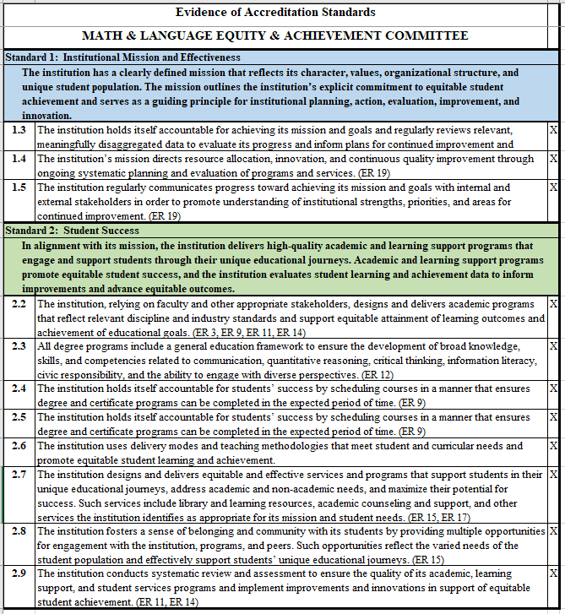

SECTION XII.

Task Forces and User Groups

## Art on Campus Task Force

**Overseen by the Dean of Arts and Humanities**

**Mission & Values Statement**

The Las Positas College Art on Campus Taskforce researches, identifies, and acquires artwork to enhance campus life. We value artwork that:

* Showcases the unique skill and talent of LPC students and campus community through both exhibitions and acquisitions.
* Celebrates the local region through images, themes, and artists of the Bay Area, “fostering a climate of discovery, creativity, personal development, and physical and mental health” as outlined in the LPC Values Statement.
* Demonstrates a fierce commitment to the tenets of equity, anti-racism, diversity, social and environmental justice, and personal expression.
* Engages viewers through different senses, variety of media, and subject matter.

## Student (Grade) Grievance Task Force

**Overseen by the Vice President of Academic Services**

**Charge:**

In accordance with CLPCCD Board Policy 5530, adjudicate student grievance dealing with prejudiced or capricious decisions regarding the academic evaluation of a student’s performance.

All student grievances follow these steps:

1. Student discusses situation with instructor.
2. If not resolved, student discusses situation with Dean of area (makes an appointment).
3. If not resolved, student makes appointment with Vice President of Student Services.
4. If not resolved, and the matter involves a question of prejudice or capricious decisions regarding the academic evaluation of a student’s performance, the Vice President of Student Services will refer the matter to the Vice President of Academic Services.
5. If the Vice President of Academic Services cannot resolve the matter for the student, he/she shall refer the grievance to the Academic Fairness Task Force.

## Student Grievance Task Force

**Overseen by the Vice President of Student Services**

**Charge:**

In accordance with CLPCCD Board Policy 5530 Student Rights and Grievances, the Student Grievance Task Force is formed when a student grievance is received by the Office of the Vice President of Student Services. All non-academic grievances are coordinated by the Vice President of Student Services. All academic grievances are coordinated by the Vice President of Academic Services.

All student grievances follow these steps:

1. Student discusses situation with instructor or department manager of area at issue.
2. If not resolved, student discusses situation with Dean of area by making an appointment.
3. If not resolved, student makes an appointment with the Vice President of Student Services or designee.
4. If unable to resolve, the Vice President of Student Services convenes the Student Grievance Task Force.

## UndocuAlly Task Force

**Charge:**

The mission is to support undocumented students reach their educational goals.

The overarching goal is to develop a campus-wide “UndocuAlly Action Plan” as a result of accomplishing the following objective by:

* Identifying resources, research, and best practices that support undocumented students reach their educational goals, and share this information with the campus community;
* Creating and maintaining a list of allies and supporters to serve our undocumented students;
* Advocating for the development and support of a *Dreamer Resource Center*; and
* Identifying and providing opportunities for on-going training for staff, faculty and administrators related to the support of undocumented students’ success.

## Global Engagement Task Force

**Charge:**

The mission is to explore the development of a study abroad program at LPC. Based on the college vision statement: “support[ing] and empower[ing] students to develop the knowledge, skills, values, and abilities needed to become engaged participants and leaders in their local and global communities.”

Activities and objectives include:

* Applying for a grant to get passports to Pell grant recipients
* Providing opportunities for virtual exchange
* Exposing students to study abroad trips and global internships sponsored by other colleges and providers
* Exploring the relationship between intercultural competencies and DEI goals
* Connecting with the global in our local communities and with our own international students
* Establishing partnerships with colleges and universities in other countries
* Inviting faculty from abroad here as scholars in residence
* Getting more faculty and students involved in travel opportunities through Community Ed.

## Climate Action Plan Task Force

**Charge:**

The mission is to advance the activities and objectives in the 2024-2029 Climate Action Plan

Activities and objectives include:

* Increase participation of faculty, staff, and admin in sustainability
* Advance the implementation of sustainability projects and practices on campus
* Recommend an infrastructure needed to establish support and increase cross-campus collaboration and participation
* Encourage support for climatizing curriculum, making climate-related decisions impacting the campus, and creating and maintaining relationships with campus affinity groups
* Identifying other activities and efforts to advance within the Climate Action Plan

SECTION XIII.

Forms and Templates

Forms and Templates

# Description of Forms

## Meeting Agenda

The meeting agenda is intended to inform committee representatives of the items to be discussed and also serves as a mechanism by which the campus community is made aware of issues being addressed by governance groups. The agenda is typically sent out campus-wide via email ideally at least 48 hours in advance of the meeting. It should include: the date, time, and location of the meeting; discussion topics separated into the categories of “Old Business” and “New Business” (for evidentiary purposes and to assist with tracking items); “Next Steps” (or a standing item on the agenda that provides an opportunity for the Chair to summarize the committee’s actions during the meeting as well as any follow-up assignments); “Good of the Order”; and the date, time, and location of the next committee meeting.

It is recommended that the Chair work with the Administrative Liaison and Support/Resource Staff in developing the agenda to ensure that relevant issues are addressed by the committee.

A sample is available in the “Forms/Templates” section. The College’s mission statement and planning priorities are included on meeting agendas, minutes, and other commonly used documents. This will serve to remind everyone of the main emphases for the year which may further hone discussions and decisions.

## Meeting Minutes

The intent of minutes is to accurately reflect the meeting attendees, to document any action taken by the governance group, to provide a summary of issues discussed, and to capture next steps/follow-up items. There is a “minutes” template in the “Forms/Templates” section.

**The minutes should not be a word-for-word transcript of the meeting**. For evidentiary purposes, meeting minutes should also include information such as: the date, time, and location of the meeting, the details of any motions made/approved, and a footer to assist with referencing documents.

Draft minutes should be sent to the committee within 5 working days of the meeting so that they can be reviewed while the details are still fresh in participant’s minds and as a helpful reminder for those tasked with items for the following meeting. If no Support/Resource Staff is available for the committee, the Chair is responsible for taking the minutes (or designating/rotating members of the committee to take minutes). Minutes should be approved at the following committee meeting. In the event there is no quorum present, approval of the minutes can be done via email (with a quorum) or postponed to the next meeting.

# Templates

## 

## Meeting Agenda Template

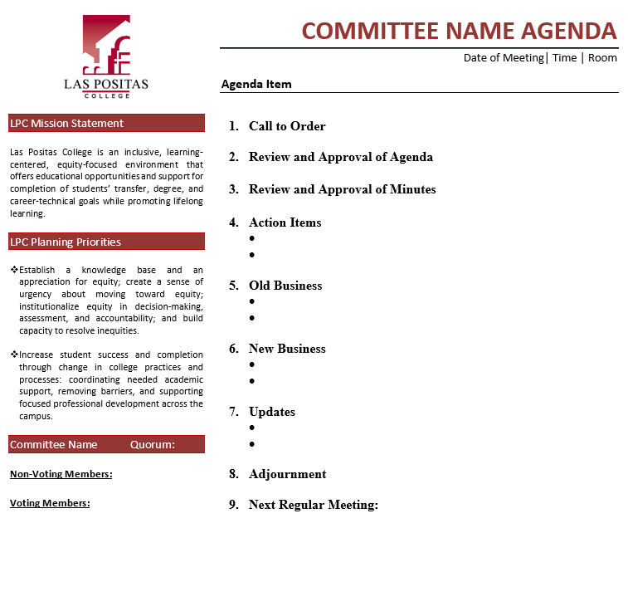

**Need to ADD new Planning Priority**

## Meeting Minutes Template

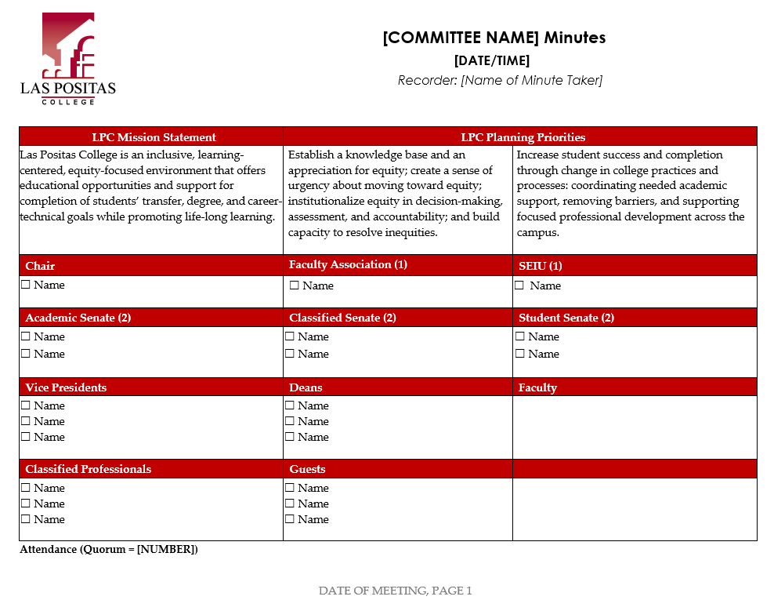

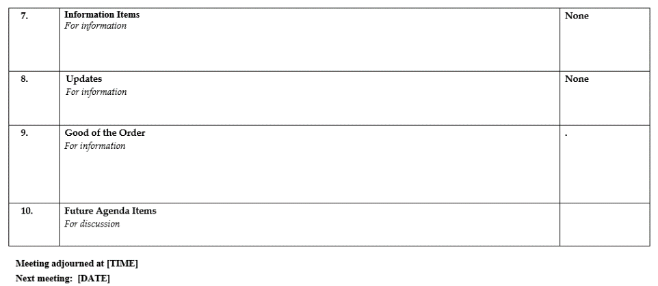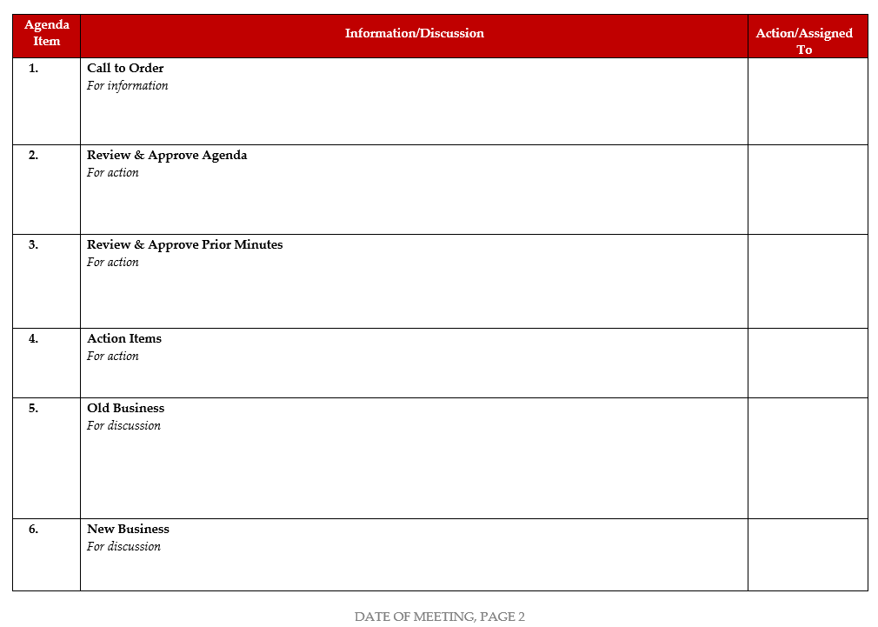

## Shared Governance Worksheet Template

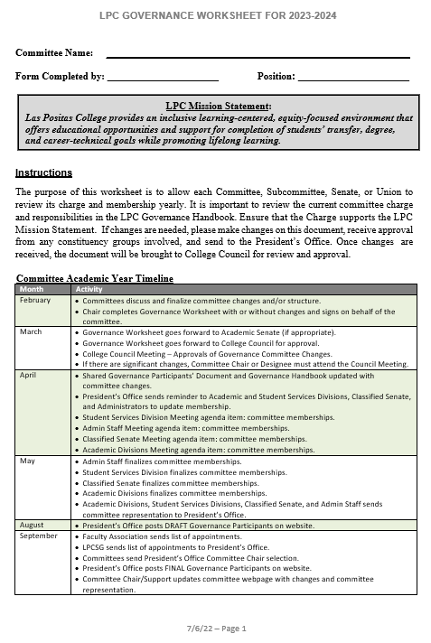

**Shared Governance Worksheet Template (contd)**

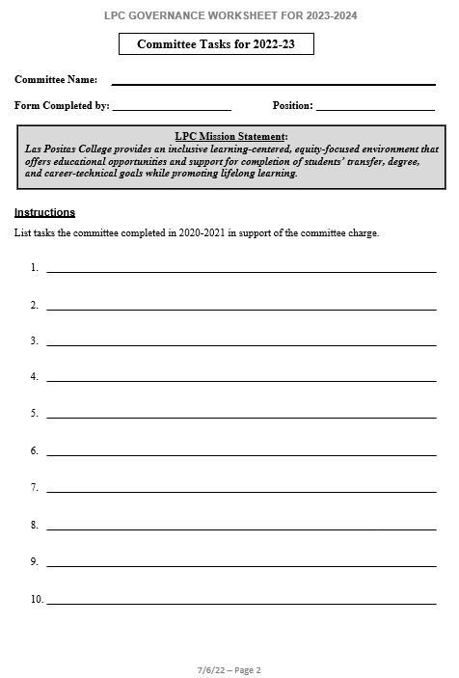

**Shared Governance Worksheet Template (contd)**

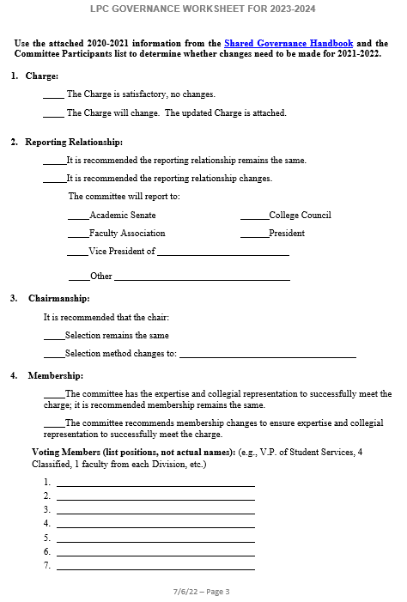

**Shared Governance Worksheet Template (contd)**

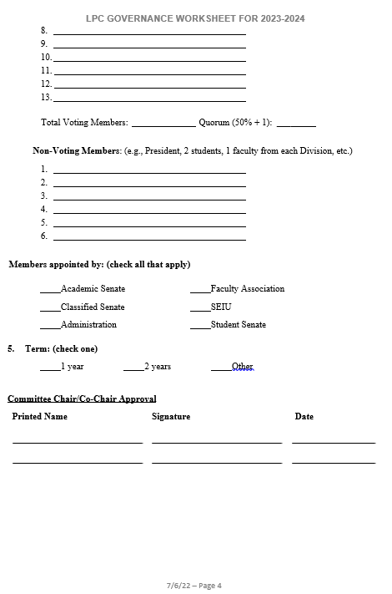

SECTION XIV.

Appendices

# Appendix A. Constituency Groups (Alphabetical)

The essential constituency groups that make up the Las Positas College consultation process are identified below:

## Academic Senate

The Academic Senate represents the faculty on all non-collective bargaining matters, in collegial consultation related to certain academic and professional matters as defined in Title V of the California Education Code. On these selected matters, the Board of Trustees will “rely primarily” upon the advice and judgment of the Academic Senate in the following areas listed in Ed Code Section 53201, which is consistent with Board Policy 2015:

* Curriculum, including establishing pre-requisites and placing courses in disciplines
* Degree and certificate requirements
* Grading policies
* Standards or policies regarding student preparation and success
* Faculty roles and involvement in the accreditation process, including the self-study and annual reports

The Academic Senate’s Constitution and Bylaws are available on the LPC website.

The Academic Senate will also participate through “mutual agreement”* in the following areas:

* District and College governance structures, as related to faculty roles
* Policies for faculty professional development activities
* Processes for institutional planning and budget development
* Regulations and procedures relating to health and safety
* Educational program development
* Processes for program review

Should there be recommendations developed by the Las Positas College Academic Senate that are in conflict with the Chabot College Academic Senate and need joint resolution, these issues shall be referred to the District Governance Council.

Senate representation from each Division is determined by a ration formula determined by the Senate and identified within the Las Positas College Senate Operating Rules. Senators from each Division are elected by a majority of the members of that Division. Senators from the part-time faculty are elected by a majority of votes cast by the part-time faculty. Senate terms are for one year, with a maximum of three consecutive years.

*In consulting collegially, the definitions that apply are:

“*Rely primarily” means that recommendations will be forwarded to the Board by the Academic Senate, after consultation with the President and Chancellor, and will be accepted by the Board in most cases. In instances where a recommendation is not accepted, the Board’s decision shall be based on a clear and substantive rationale that puts the explanation for the decision in an accurate, appropriate, and relevant context. If a recommendation is not approved, the Board or its designee shall promptly communicate its reason(s) in writing to the Senate. If such recommendations are not accepted, existing policies and procedures will remain in force.*

*“Mutually agree” means: Agreeing that the District governing board or such representatives as it may designate (Chancellor, President) and the representatives of the Academic Senate shall have the obligation to reach mutual agreement by written resolution, regulation, or policy of the governing board effectuating such recommendations.*

## Administrative Team

The Administrative Team reviews all Board policies and Administrative procedures and recommends and develops college policies and procedures to ensure their timely implementation. The administration will exercise leadership and assume appropriate levels of shared decision-making responsibility in coordination with other governance groups in the formulation and development of policies and procedures which include the following areas:

* Curriculum
* Degree and certificate requirements
* Grading policies
* Administrative roles and involvement in accreditation processes, including the self-study and annual reports
* Student preparation and success
* College/district governance structures
* Professional development activities
* Institutional planning processes
* Budget development processes
* Program planning and staffing
* Regulations and procedures relating to health and safety
* Program review
* Administrator and classified hiring recommendations

Report to: College President

Chair: College President

## Classified Senate

The Classified Senate represents classified professionals on all non-collective-bargaining matters. Classified staff members that serve in instructional areas will be included in discussions and will have input regarding academic programs, delivery of services, and other academic issues that affect their professional duties. The Classified Senate is recognized based upon California Assembly Bill 1725 and incorporated into the California Education Code, Title III.

In addition, classified professionals, jointly with other constituency groups, will also be given the opportunity to participate actively in the formulation and development of policies and procedures in the following areas:

* Classified roles and involvement in accreditation processes including the self-study and annual reports
* Student preparation and success
* College/District governance structures
* Professional development activities
* Institutional planning processes
* Budget development processes
* Program planning and staffing
* Regulations and procedures relating to health and safety

Classified representatives are elected by majority vote from among all voting classified members. The Governing Council of the Classified Senate includes the President, 3 Vice Presidents, Treasurer, Secretary, and Ambassadors. The Past-President and the highest-ranking union officer at Las Positas College shall serve as non-voting advisory members. The term of office of Governing Council members is one year (July 1 – June 30) and may serve more than 1 term. Refer to the current Constitution and Bylaws posted on the LPC website for Senate representation of LPC buildings. Invited and encouraged to participate in this Senate are District I.T. and M&O staff based at LPC. The Classified Senate Constitution and Bylaws are available on the LPC website.

## Faculty Association (FA)

Updated per College Council December 12, 2019

The Faculty Association retains the right to appoint unit members to District and College level committees that are in direct association with the faculty contract (Faculty Association Contract, Article 4J). The Faculty Association consists of the following Faculty in the Bargaining Unit:

* Contract Faculty
* Regular Faculty
* Temporary Faculty
* Part-time (Adjunct) Faculty
* Unit Members
* Unit Members – Full-time

See the most current Agreement posted on the District Human Resources website for full descriptions and details. Current committees that fall within the framework include but are not limited to CEMC, Curriculum, Distance Ed, Staff Development, Health and Safety, Technology, Faculty Hiring and Prioritization, Program Review, Calendar, DEMC, PBC, District Educational Support Committee, District Facilities, and the District Funding Formula Committee.

## SEIU Local 21 (Classified Union)

Updated Fall 2013

SEIU Local 21 represents classified staff members (non-confidential, non-supervisory) on collective bargaining matters. The SEIU has been offered the right to appoint unit members to District and College committees by this Shared Governance document.

The employees of CLPCCD, working as free and responsible individuals, recognize the labor movement in general, and SEIU Local 1021, can be instrumental in improving our status and resolving the social and health problems of our community; therefore, we enter into a union and agree to adopt bylaws, as an instrument for concerted action and collective bargaining in the interest of our members.

See the most current Agreement posted on the District H.R. website for full descriptions and details.

## Student Government

The Las Positas College Student Government (LPCSG) represents the student body. Students, jointly with other governance groups, will be given the opportunity to actively participate in the formulation and development of policies and procedures in the following areas:

* Curriculum
* Degree and certificate requirements
* Grading policies
* Student roles and involvement in accreditation processes, including the self-study and annual reports
* Student preparation and success
* College/District governance structures
* Institutional planning processes
* Budget development processes
* Regulations and procedures relating to health and safety

Students are assigned to committees by the LPCSG. All LPCSG members serve on committees. Appointments are made based on interest, schedule, and mutual agreement of the LPCSG. LPCSG also provides representation on hiring committees for administrative positions. Committee members are required to give written reports to the LPCSG at their weekly meetings throughout the academic year. The Student Governments’ Constitution and Bylaws are available on the college website.

# Appendix B. LPC’s Integrated Planning and Budget Cycle

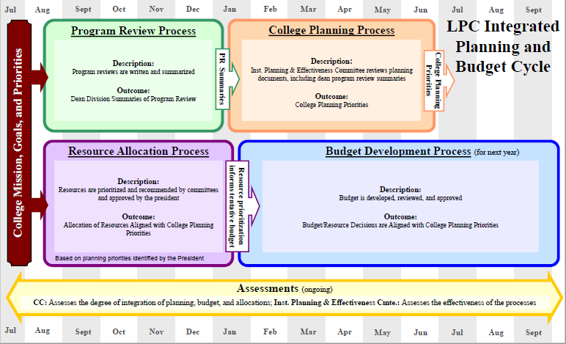

# Appendix C. Sample Shared Governance Master Calendar

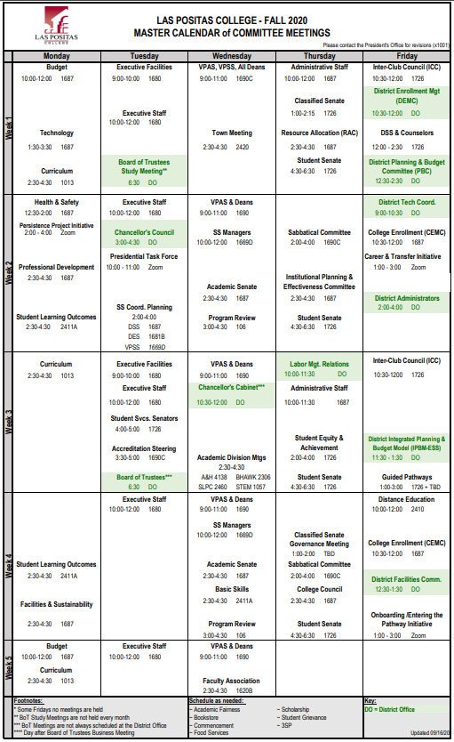

# Appendix D. LPC Planning Documents

Below is a table of Las Positas College planning and institutional process documents, along with the timeline for which the document is updated.

|  |  |  |  |
| --- | --- | --- | --- |
|  | **Agency** | **Document** | **Update** |
| **External** | Accrediting Commission for Community and Junior Colleges (ACCJC) | Mid-term Report | Fall 2019 |
| Institutional Self Evaluation Report | Fall 2022 |
| California Community Colleges Chancellor’s Office (CCCCO) | Strong Workforce Plan | Yearly |
| Guided Pathways | 2018-2022 |
| Unified Plan: Basic Skills Initiative, Student Equity, and Student Success and Support Program | 2017-2019 |
| Chabot-Las Positas Community College District | Security Master Plan | 2018 |
| Emergency Preparedness Plan |  |
| Revenue Allocation Model |  |
| Information Technology Plan - Total Cost of Ownership | 2017 |
| **Internal** | Las Positas College | Education Master Plan | 2021-2026 |
| Facilities Master Plan | 2018 |
| Program Review | Yearly |
| Institutional Effectiveness Report | Yearly |
| College Planning Priorities | Yearly |
| Faculty Hiring Prioritization | Yearly |
| Non-instructional Position Prioritization | Yearly |
| Instructional Equipment Prioritization | Yearly |
| LPC Technology Plan | Yearly |

# Appendix E. CLPCCD Board Policy

Chabot-Las Positas Community College District

Adopted: January 16, 1996

Renumbered: September 27, 2018

## Administration

BP 1300 Collegial Consultation

**Rely Primarily**

The Board of Trustees shall "rely primarily" upon the advice and judgment of each Academic Senate independently on selected college matters and the two senates jointly on selected District matters. College and District matters will be distinguished as described in the section below on the Chancellor's Council.

"Rely primarily" means that all recommendations in the areas specified below will be forwarded to the Board through the Chancellor by the Academic Senate(s) and will be accepted by the Board in most cases. In instances where a recommendation is not accepted, the Board's decision must be based on a clear and substantive rationale which puts the explanation for the decision in an accurate, appropriate, and relevant context. If a recommendation is not approved, the Board or its designee shall promptly communicate its reason in writing to the respective senate(s). If such recommendations are not accepted, existing policies and procedures will remain in force.

The Board will "rely primarily" on the Academic Senates in these "academic and professional" matters:

* 1. Curriculum, including establishing prerequisites and placing courses in disciplines;
  2. Degree and certificate requirements;
  3. Grading policies;
  4. Faculty roles and involvement in accreditation processes including self-study and annual reports.

**Mutual Agreement**

"Mutual agreement" shall be reached between the Board of Trustees or its designee and the Academic Senates on items specified below. On college matters, mutual agreement will be reached by a process agreed to by the college president and senate as defined in separate Board policies for each college. On District matters, mutual agreement will be reached between the

Chancellor and the senates as defined in the section on the Chancellor's Council. "Mutual agreement" means that the Board of Trustees and the Academic Senate(s) shall each ratify such policies or procedures before they are put into effect. If such agreements are not ratified by both parties, existing policies and procedures will remain in force.

The Board will reach "mutual agreement" with the Academic Senates in these "academic and professional" matters:

1. Educational program development
2. Standards and policies regarding student success
3. District and college governance structures as related to faculty roles
4. Policies for faculty professional development activities
5. Process for program review
6. Process for institutional planning and budget development

## District Councils and Committees

**District Curriculum Committee**

Curriculum, including establishing prerequisites and placing courses in disciplines

Degree and certificate requirements

Grading policies

Educational program development

**District Matriculation Council**

Standards or policies regarding student success

**District Institutional Planning Council**

Process for program review Process for institutional planning

**District Budget Study Group**

Process for budget development

**College Governance Process (See College Policies)**

Faculty roles and involvement in accreditation processes including self-study and annual reports;

College governance structures as related to faculty roles; Policies for faculty professional development activities.

**Chancellor's Council** (Exclusively District Issues)

District governance issues;

1. To provide a means for the colleges to communicate, with one another and to their constituents, the district- and college-developed recommendations in the above ten areas of collegial consultation.
2. To serve as a vehicle for identifying and resolving District matters. Should there be issues on which college-developed recommendations are in conflict or require a joint effort, such issues shall be identified as district matters. Prior to Board presentation, such District matters will be referred to the Chancellor's Council for resolution. District matters should be of sufficient import that the policies of one college result in a significant impact on the ability of the other college to carry out its own policies. The Chancellor's Council will develop a recommended resolution which will be ratified by the Chancellor and by each college President and senate following the processes established in the separate college governance policies. Typically, such a recommendation will be developed by the appropriate council. The administrative procedures for the council are located in the Administrative Rules and Procedures.
3. To serve as a vehicle for the Chancellor to identify the need for policies and procedures in any of the ten areas of academic and professional matters, the Council will be asked for direction on the development of these policies and refer such issues to the colleges or district councils for creation of such policies.
4. The composition of the Council shall be jointly agreed upon by the Chancellor and Academic Senates.
5. The membership for the District Curricular Committee, the District Matriculation Council, the District Institutional Planning Council, the District Budget Study Group, and the Chancellor's Council is located in the Administrative Rules and Procedures.

Chabot-Las Positas Community College District

Adopted: January 16, 1996

Renumbered: September 27, 2018

**Appendix F: Glossary of Acronyms and Terms**

|  |  |
| --- | --- |
| **Acronym** | **Description** |
| ACCJC | Accrediting Commission for Community & Junior Colleges |
| A Hours | One lecture hour. “A” is a unit value of one, equal to one lecture hours. (Related to CAH, Calculated A Hours.) |
| AUOs | Administrative Unit Outcomes |
|  |  |
| BaSK | Basic Skills Committee |
| BoT | Board of Trustees |
|  |  |
| CAH | Calculate A Hours. For example: 3 lecture hours = 3 CAH |
| CAP | The apportionment level to which the state will fund a district’s FTES. |
| CC | College Council |
| CEMC | College Enrollment Management Committee |
|  |  |
| DBSG | District Budget Study Group |
| DCC | District Curriculum Council |
| DE | Distance Education |
| DEMC | District Enrollment Management Committee |
| DES | Dean of Enrollment Services |
| DSS | Dean, Student Services |
|  |  |
| EMP | Educational Master Plan |
| ESS | District Educational Services Support Committee |
|  |  |
| FHPC | Faculty Hiring Prioritization Committee |
| FMP | Facilities Master Plan, District |
| FPP | Faculty Prioritization Process |
| FTEF | Full Time Equivalent Faculty. |
| FTES | Full Time Equivalent Student. The method by which the District receives state apportionment.  To calculate the FTES apportionment using the Art 1 class example:  Multiply the number of resident students in the Class x the contact hours per week x the number of weeks per semester; Divide the sum by 515  (35 students x 3 contact hrs/wk x 17.5 wks/sem., Divide by 525 = 3.5 FTES) |
| FTES/FTE | Full Time Equivalent Student per Full Time Equivalent Faculty.  Determining how many FTES a full-time faculty member generates.  Using the Art 1 example, each class of 35 students produces 3.5 FTES.  Since a full teaching load requires 5 classes, this full time faculty member would produce 17.5 FTES in one semester (5 classes x 3.5 FTES/class = 17.5 FTES). |
|  |  |
| PBC | District Planning & Budget Committee |
| PR | Program Review |
| PRC | Program Review Committee |
|  |  |
| RAC | Resource Allocation Committee |
|  |  |
| SLO | Student Learning Outcomes |
| SS | Student Services |
|  |  |
| VPAS | Vice President of Academic Services |
| VP Ad.S. | Vice President of Administrative Services |
| VPSS | Vice President of Student Services |
|  |  |
| WASC | Western Association of Schools and Colleges |
| WSCH | Multiply the number of students x the number of scheduled hours per week. No distinction between lecture, lab, studio, etc., hours – an hour of student contact is an hour of contact.  Example: Art 1, 3 hrs/week with 35 students = 105 WSCH |
| WSCH/FTEF | Weekly Student Contact Hour/Full Time Equivalent Faculty.  Using the Art 1 example under WSCH definition: This class generates 105 WSCH. A FT load of 15 CAH would require teaching 5 of these classes. Therefore, a faculty member teaching 5 classes with 35 students would generate 525. WSCH/FTE (5 classes x 125 WSCH = 525 WSCH/FTE). |
|  |  |

**Appendix G: Shared Governance Committees Providing Evidence to ACCJC Accreditation Standards, January, 2024**

**Standard 1**

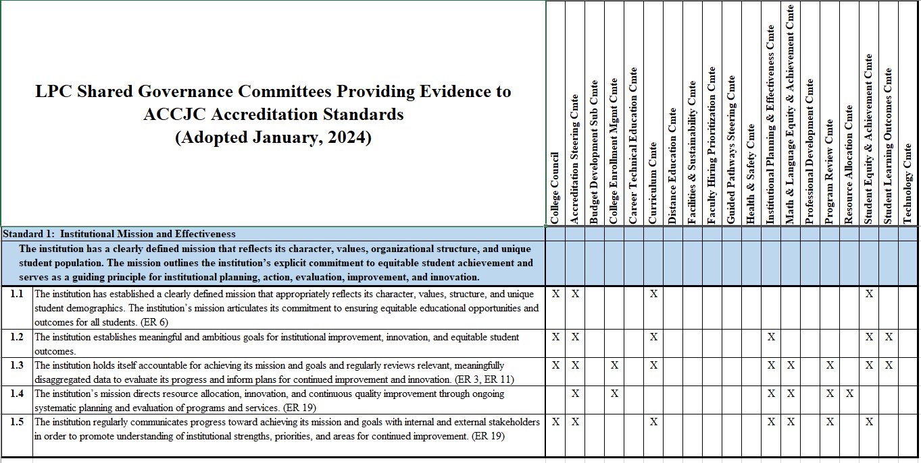

**Appendix G: Shared Governance Committees Providing Evidence to ACCJC Accreditation Standards, January, 2024**

**Standard 2**

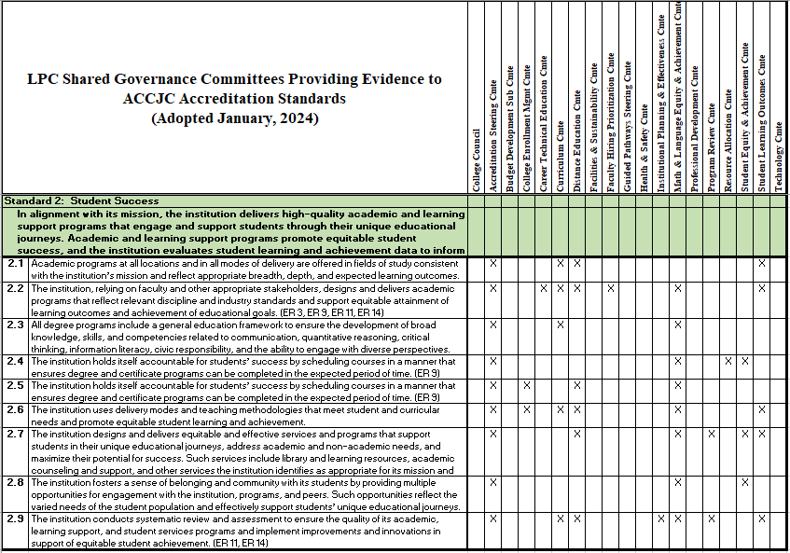

**Appendix G: Shared Governance Committees Providing Evidence to ACCJC Accreditation Standards, January, 2024**

**Standard 3**

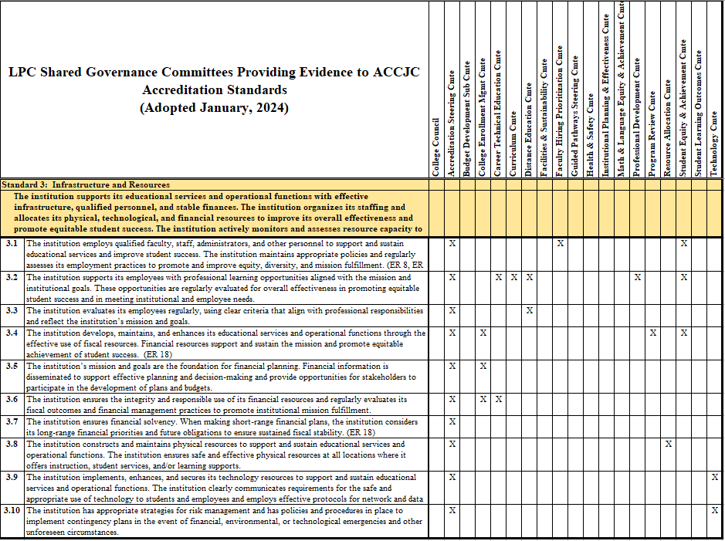

**Appendix G: Shared Governance Committees Providing Evidence to ACCJC Accreditation Standards, January, 2024**

**Standard 4**

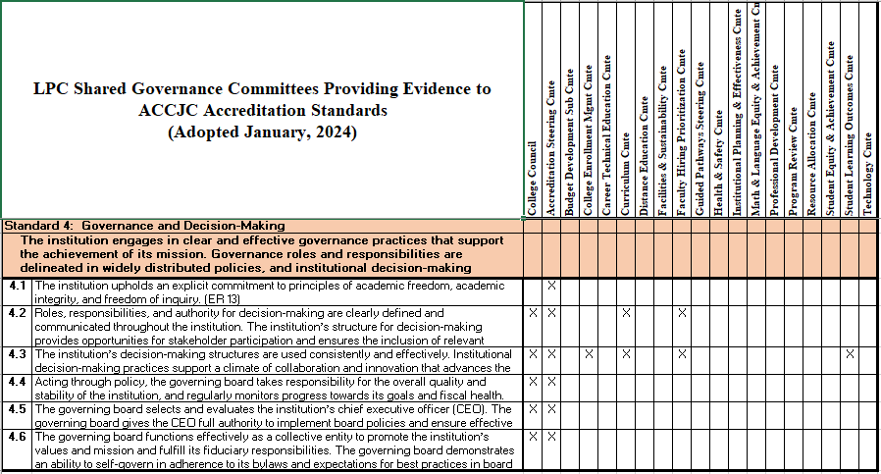

**LPC Shared Governance Handbook**

**Accepted by Board: January 20, 2015**

**Updated/Approved by College Council: October 25, 2018**

**Accepted by Board: December 4, 2018**

**Updated for 2019-2020: September 10, 2019**

**Updated for 2019-2020: December 12, 2019**

**Updated for 2020-2021: January 6, 2021**

**Updated for 2021-2022: June 16, 2021**

**Accepted by Board: July 20, 2021**

**Accepted by Board: September 13, 2022**

**Updated/Approved by College Council: May 11, 2023**

**Updated/Approved by College Council: THIS VERSION NEEDS TO BE UPDATED AND APPROVED**

End of Shared Governance Handbook