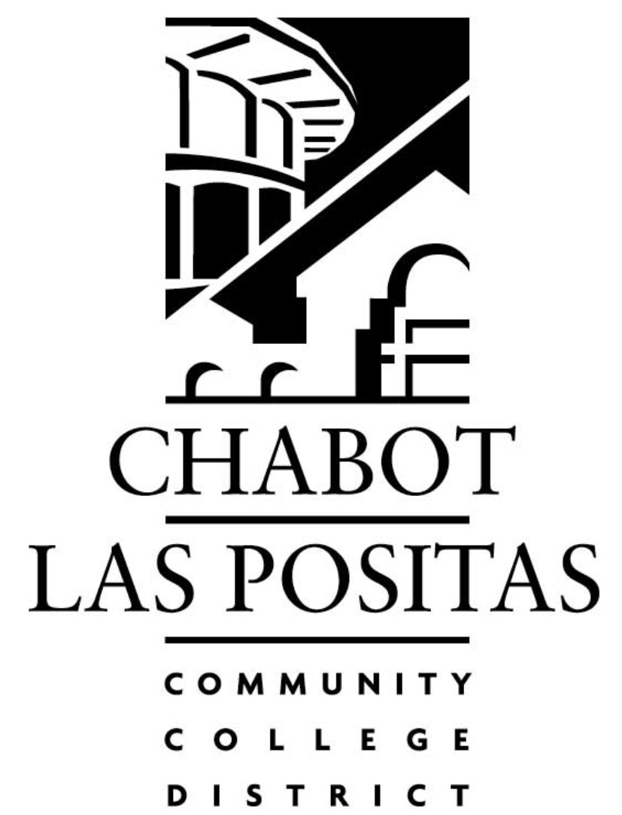
LIABILITY

CERTIFICATE OF COVERAGE REQUEST

Today’s Date:
JPA: Keenan & Associates
District: Chabot-Las Positas Community College District
Contact: [REQUESTOR] |  |  | Phone: [REQUESTOR’S CONTACT PHONE #]
Certificate Holder Name & Address  Attn: |  | [THE VENDOR’S MAILING ADDRESS AND CONTACT PERSON]
Description of Operations |  | [PER CONTRACT, DESCRIBE THE ACTIVITIES OR SERVICES BEING RENDERED]
Is this a Special Event |  | Yes No [COMPLETE IF THIS IS A ONE-TIME EVENT]
 |  | Event Date(s) & Time
 |  | Location
 |  | Sponsor
 |  | Participants
 |  | Provide Details of Event
 |  | Special Requirements
Cross-Out Endeavor Clause Yes No [CHECK IF NEEDED IN CONTRACT]
Additional Insured / Additional Covered Party Yes No [THIRD PARTY]
Other Additional Insured / Covered Party Yes No
Name & Address | [COMPLETE IF A THIRD PARTY NEEDS PROOF OF COVERAGE]

