

Reserving
LPC Meeting Rooms

Reference for Booking All LPC Meeting Rooms
And Classrooms for Meetings

CONTENTS

I. Reference Chart of All Rooms & Classrooms 2
(One-page wall chart)

- Booking & Sending an Invitation to a
Meeting Room 3
(Including the Facilities Request Forms)

III. Handy One-Page Reference for GroupWise 6
(One-page wall chart)

IV. Booking a Classroom for a Meeting (CLASS-Web) 7
(Including the Facilities Request Forms)

V. GroupWise Calendar Tips 12
(Set “Tools > Options” for Maximum Success)

NOTE: We would like to continue improving and adding to this reference. Please send any new items or suggestions to Sharon Gach, X. 1001.

3/08; Rev. 10/26/10; Rev. 4/8/11
s.g.

- Reference Chart of all Rooms & Classrooms
LPC STAFF REFERENCE
Also posted at:
http://grapevine/administration/RoomsforMeetings.php
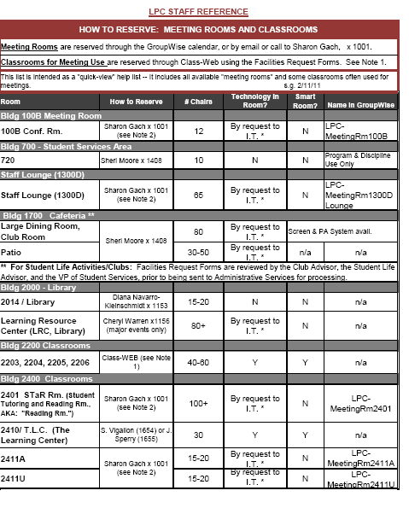

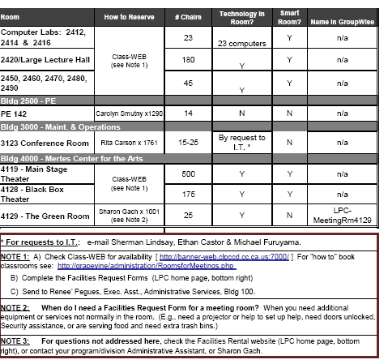

-- Please Post --
II. Booking & Sending an Invitation to a Meeting Room
(also known as a ‘Resource’)

The following rooms are available for reservation using your GroupWise calendar.
Other rooms are available from other sources (see Chart above, Section I).

Available for reservation through GroupWise calendars:

Meeting Room GroupWise Name
100B (Academic Services area) LPC-MeetingRm100B
1300D (Staff Lounge) LPC-MeetingRm1300DLounge
4129 – Green Room LPC-MeetingRm4129
2401 (Reading Room,
some limitations apply) LPC-MeetingRm2401ReadingRm
2411A (West end) LPC-MeetingRm2411A
2411U (East end) LPC-MeetingRm2411U

Step 1.
In your GroupWise calendar: Press New Appointment.

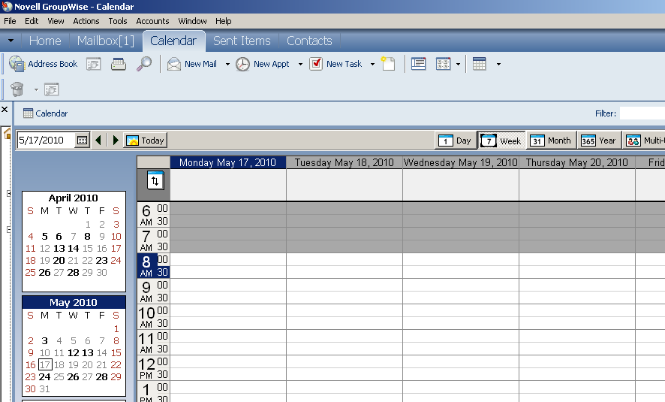

Step 2.
On the Address List type in/or search for resources(rooms) and people you wish to invite. You may include any notes in the box. Choose Date and Time. [Don’t press Send yet.]

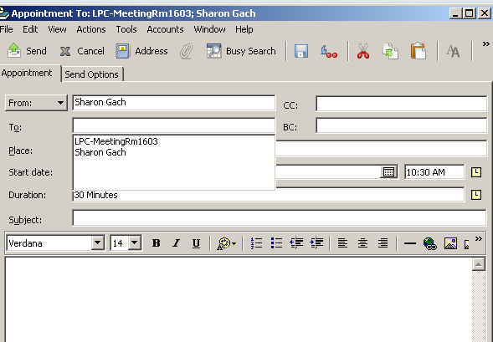
Note 1: Rooms (resources) are listed in the Address Book with an orange cube: 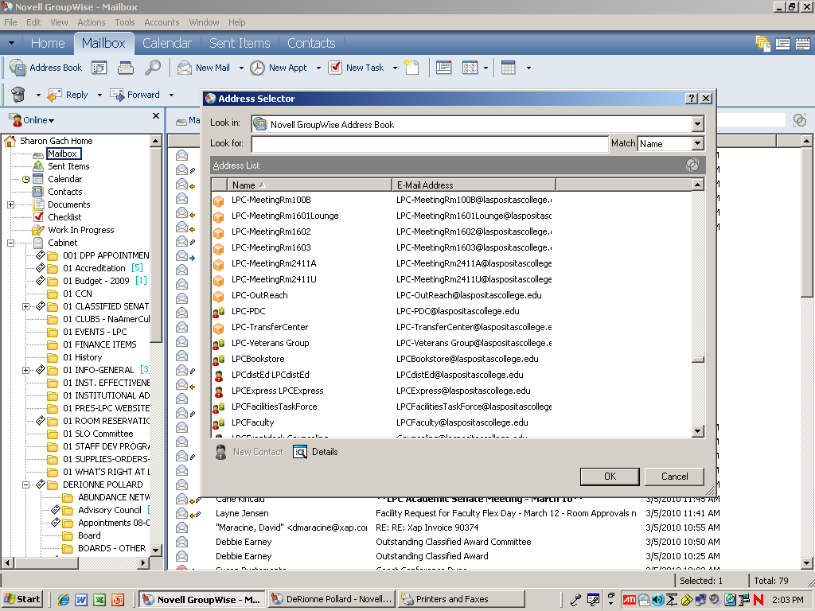

Note 2: Sample list of LPC meeting rooms in the GroupWise Address Book:
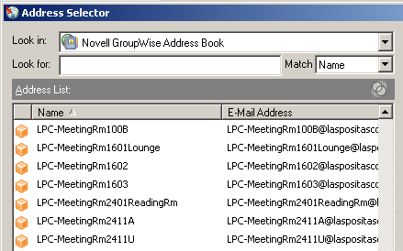

Step 3.
Check to see if the room is available before you Send, using Busy Search (on tool bar to right of the Paper Clip attachment icon).
If the room you wish is not free, please try another room,
or consider changing the meeting date/time.
When complete, Press Send.
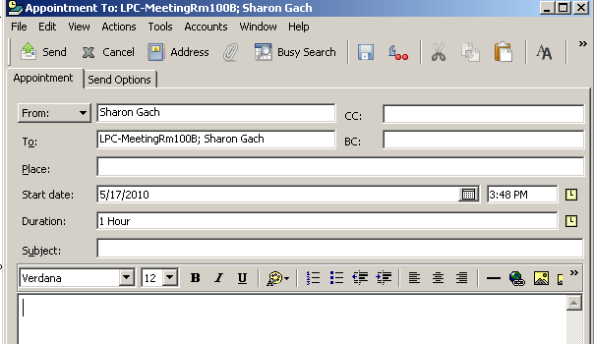

Busy Search example:
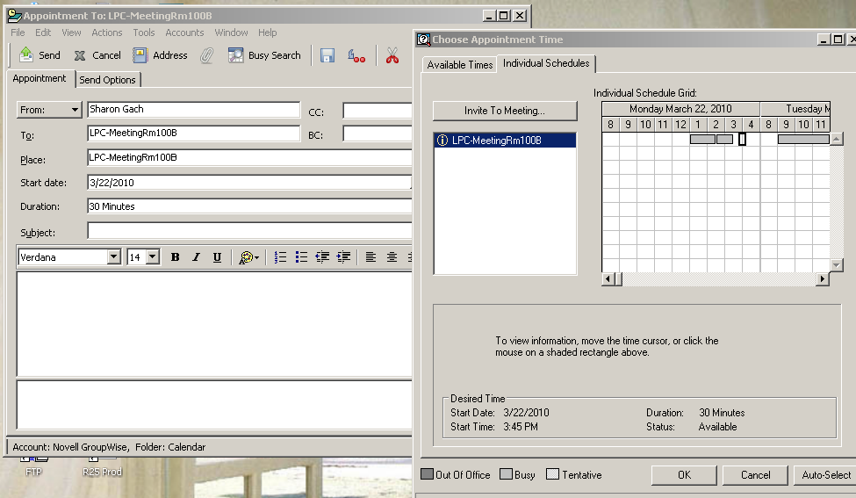
Hint: use the arrows or bar to scroll forward to other dates!

Step 4.
The “owner” or “proxy” of the calendar* will receive the meeting room invitation, check it for availability, and Accept or Decline. If the meeting is Declined the “owner” will write a short note of explanation, or suggest other rooms.

Step 5.
If you wish to check the status of an invitation later, Right Click on the appointment, press Properties. Information on all invitees is listed in a chart.

Step 6.
When do I need to complete the Facilities Request Forms?
- When you need additional:
  - Set up or Clean up
  - I.T. Assistance
  - Heating or A/C before or after hours (8 am – 5 pm)
  - Food being served (additional trash bins, tables, etc.)
  - Security to unlock/lock doors before or after hours (8 am – 5 pm)

How to find, complete, and submit the Facilities Request Forms:
- Go to the LPC home page, bottom, right: “About Las Positas”
- Click: Facilities Rental [http://www.laspositascollege.edu/facilities/index.php]
- Read the facilities information sheets and open the 2 Facilities Rental forms and complete them (can be completed online and saved to your computer drive).
- Have appropriate persons sign, and submit to Administrative Services Office, Layne Jensen.
- You will receive a confirmation via email when approved.



* The current GroupWise ‘owner’ for the above meeting rooms is Sharon Gach, with Layne Jensen and Jennifer Adams as proxies. These staff members can see all appointments and descriptions.

Questions? Call Sharon Gach, Ext. 1001.

III. Handy One Page Reference

LPC Meeting Rooms – How To Reserve

Available for reservation through GroupWise calendars:

Meeting Room GroupWise Name
100B (Academic Services area) LPC-MeetingRm100B
1300D (Staff Lounge) LPC-MeetingRm1300DLounge
4129 – Green Room LPC-MeetingRm4129
2401 (Reading Room,
some limitations apply) LPC-MeetingRm2401ReadingRm
2411A (West end) LPC-MeetingRm2411A
2411U (East end) LPC-MeetingRm2411U


Step 1.
In your GroupWise calendar: Press New Appointment.

Step 2.
On the Address List type in/or search for resources(rooms) and people you wish to invite. You may include any notes in the box. Choose Date and Time. [Don’t press Send yet.]
Note 1: Rooms (resources) are listed in the Address Book with an orange cube:

Step 3.
Check to see if the room is available before you Send, using Busy Search (on tool bar to right of the Paper Clip attachment icon). If the room you wish is not free, please try another room, or consider changing the meeting date/time.

When complete, Press Send.

Step 4.
The “owner” or “proxy” of the calendar* will receive the meeting room invitation, check it for availability, and Accept or Decline. If the meeting is Declined the “owner” will write a short note of explanation, or suggest other rooms.

Step 5.
If you wish to check the status of an invitation later, Right Click on the appointment, press Properties. Information on all invitees is listed in a chart.


* The current GroupWise ‘owner’ for the above meeting rooms is Sharon Gach, with Layne Jensen and Jennifer Adams as proxies. These staff members can see all appointments and descriptions.

Questions? Call Sharon Gach, Ext. 1001
IV. Booking a Classroom for a Meeting Using CLASS-Web
By Nicole Huber
There are 2 main reports in CLASS-Web to run in order to check that a classroom is available: “Room Schedule Report” and “Available Room Query Report.” Other possibilities to check are “Event Query Report” and “Scheduled Classrooms Report.”

A. Room Schedule Report
1. Log into Class-Web → Click on “Faculty & Staff Menu” Tab

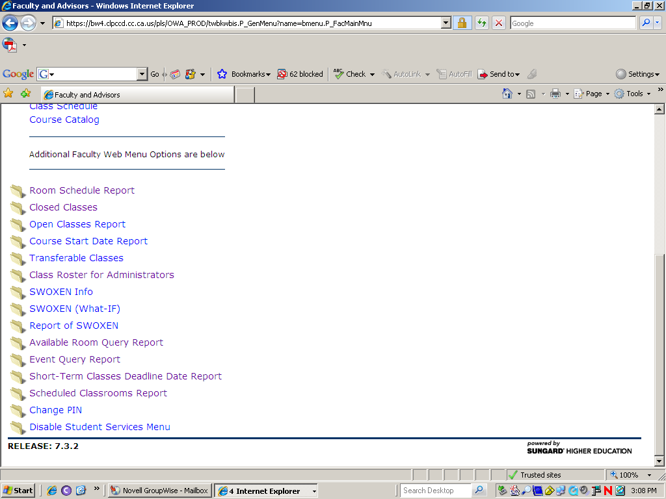
2.

Room Schedule Report - Choose this option if you know the particular room that you want to use.

3. Enter the: Building Number and Room Number, Select the Term → Hit Submit
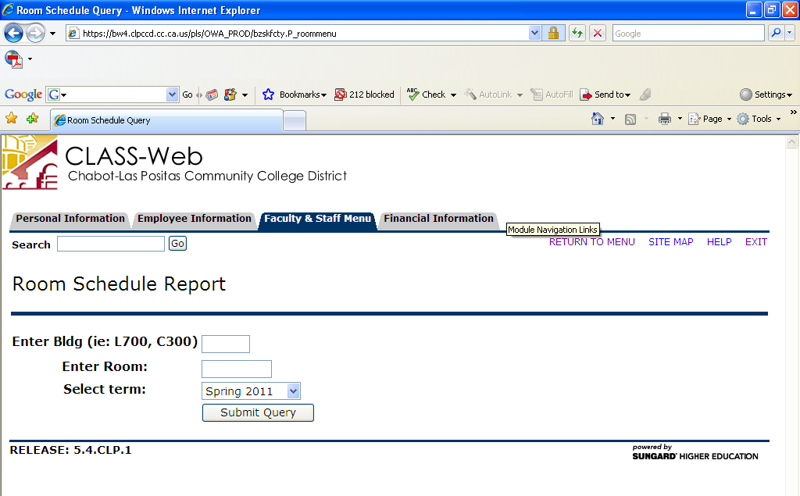
Use “L” for Las Positas (Ex. L1800 – Sci Bldg)
Enter the room you want to look at (ex. 1826)
Choose the correct term

4. Example

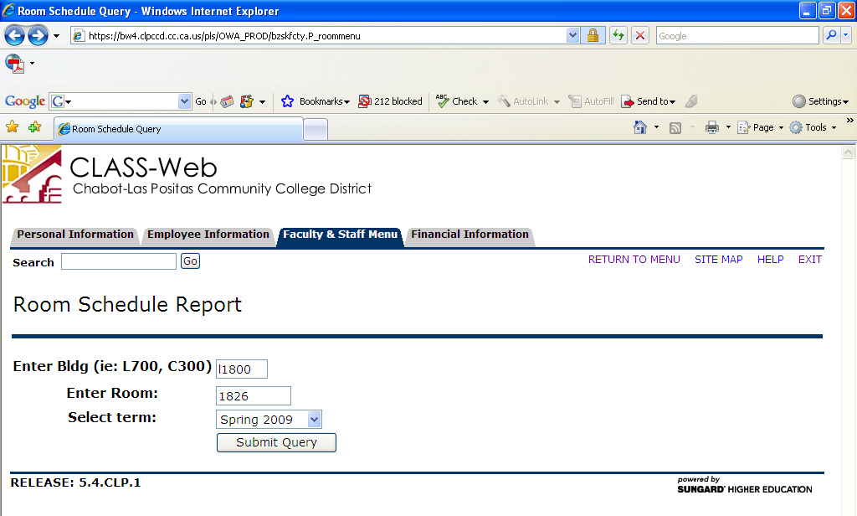

5. Example Report

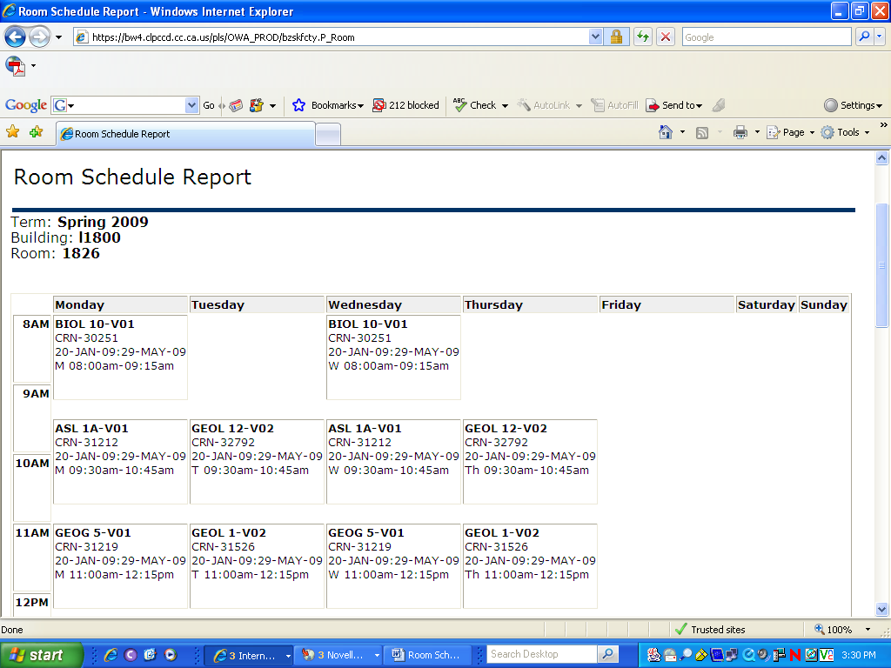
READ TO BOTTOM
READ TO BOTTOM
Remember to always look to the bottom of the room schedule for the scheduled Events. These will not show in the daily schedule view, where the classes show.
B. Available Room Query Report

1. Log into Class-Web → Click on “Faculty & Staff Menu” Tab

2.

Choose this option if you want to enter a particular date or date range and time. This will give you all rooms available at the terms you entered.

3.
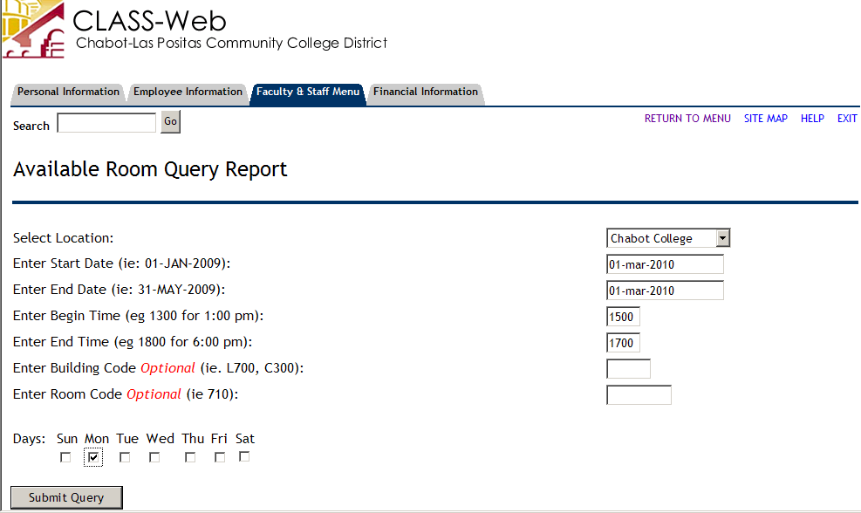
Choose: Las Positas College
Remember to click on the days of the week that you are interested in, in addition to entering the date range above.
Be sure to enter all fields, except Optional. Each field has an example below, of how to enter information in that particular field.
Date format:
date-month-year
Military Time: See Chart next page

4. Example
Military Time:
0100-1 AM
0200-2 AM
0300-3 AM
0400-4 AM
0500-5 AM
0600-6 AM
0700-7 AM
0800-8 AM
0900-9 AM
1000-10 AM
1100-11 AM
1200-12 AM
1300-1 PM
1400-2 PM
1500-3 PM
1600-4 PM
1700-5 PM
1800-6 PM
1900-7 PM
2000-8 PM
2100-9 PM
2200-10 PM
2300-11 PM
2400-12 PM
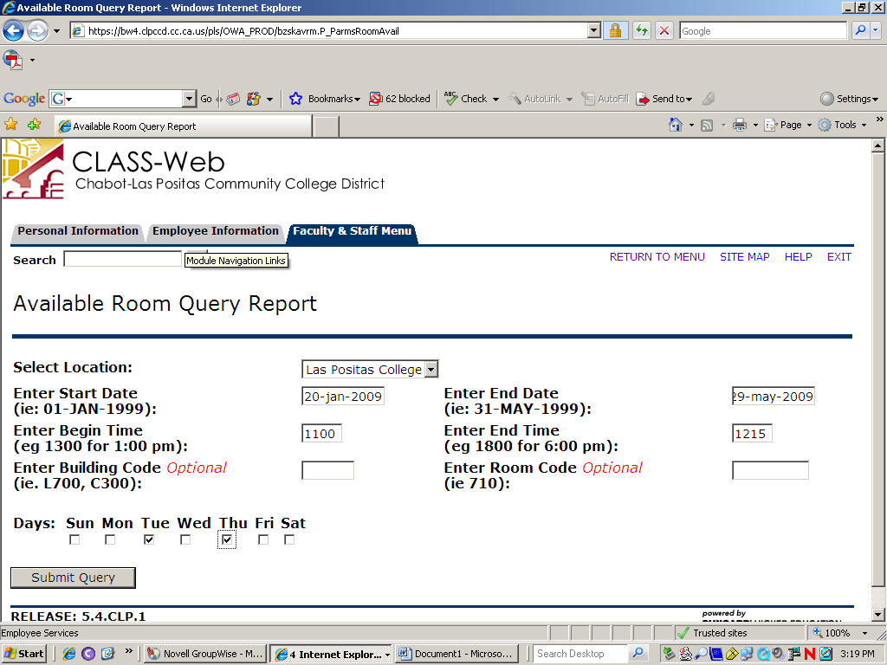

5. Example Report
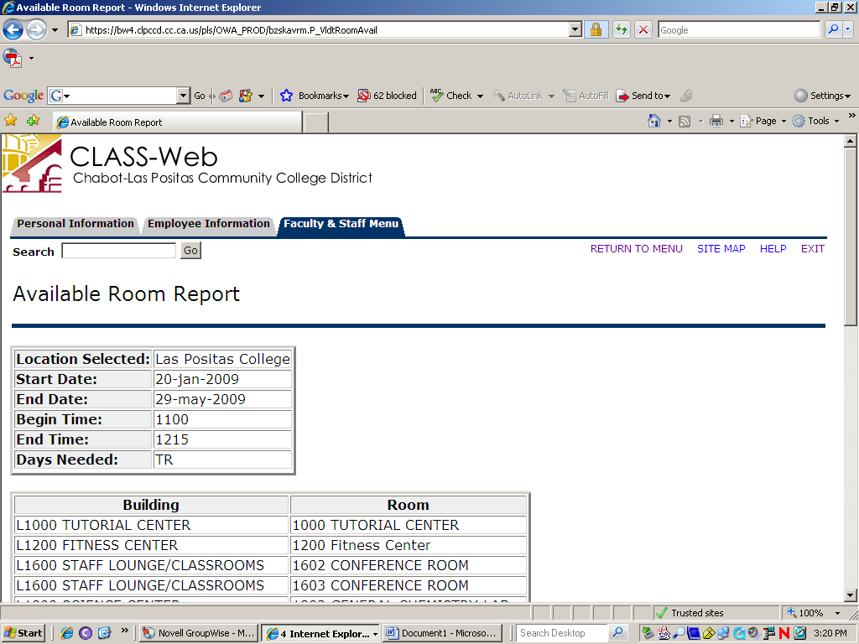

Notes:
1. Meeting Rooms are not scheduled via Banner. See procedure “Group Wise LPC Meeting Rooms…” from
S. Gach, x. 1001.

2. General Classrooms- Schedule using the Facilities Request Forms process. [LPC home page, bottom right, “Facilities Rental”]

(Facilities requests must be turned in for all general classroom requests).

C. To Reserve the Room : Facilities Request Forms

- Go to the LPC Home page, bottom, right: “About Las Positas”
- Click: Facilities Rental http://www.laspositascollege.edu/facilities/index.php
- Read the facilities information sheets and open the 2 Facilities Rental forms and complete them (can be completed online and saved to your computer drive).
- Have appropriate persons sign, and submit to Administrative Services Office, Executive Assistant to the Vice President.
- You will receive a confirmation via email when approved.

N. Huber, 12/08, Rev. S. Gach, 3/10
# # #

Also: See information from Administrative Services, Exec. Asst.

V. GroupWise Calendar Tips

A. To Book Appointments Before 8 am and After 5 pm: (Tools/ Options/ Date Time Options)
You need to allow your calendar to create appointments for any hour of any day, by pressing
“Set Always Available”.

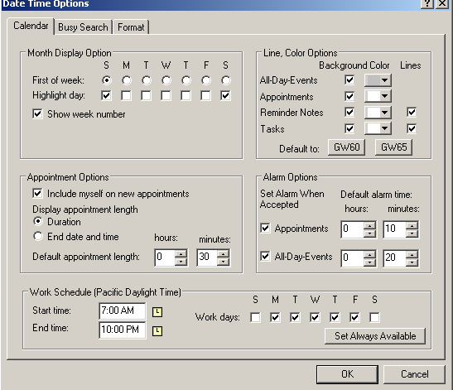

[If the settings stay at 8 am – 5 pm it will not allow you to book anything before or after those hours. Then if you try to set a meeting from 3 pm – 7 pm, for example, Groupwise will give you a 4 hour meeting, but will back it up to END at 5 pm -- your setting ‘tells’ Groupwise not to let you work past 5 pm.]

B. To see future days, use the bar or arrow to advance the dates/times.
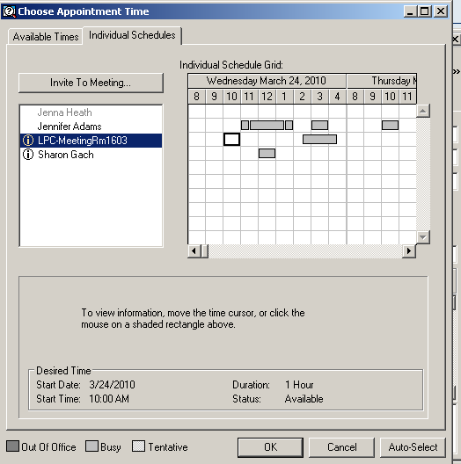

C. To Delete a scheduled appointment:

- Click on appt.
- Press delete button on keyboard
- You will see this message, check the box “Delete this item for all other recipient’s mailboxes.” And write a comment in the box as to why meeting cancelled, etc.

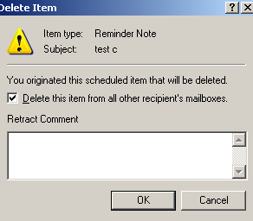
Can write a note as to why cancelled.
- Meeting will be deleted from other attendees’ calendars.

D. To send appt. to others, AFTER it has been created:
1. Open Appt, Press Delegate:

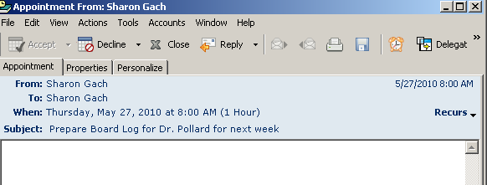

2. You see this screen. Fill it in for the others you wish to invite.
Press Send.

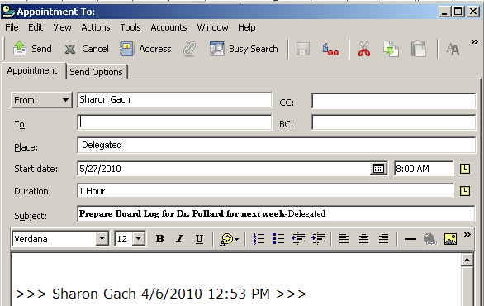

E. To get your name automatically added to every Appointment you create:

In Tools->Options->Date&Time , Check “Include myself on new appointments”.

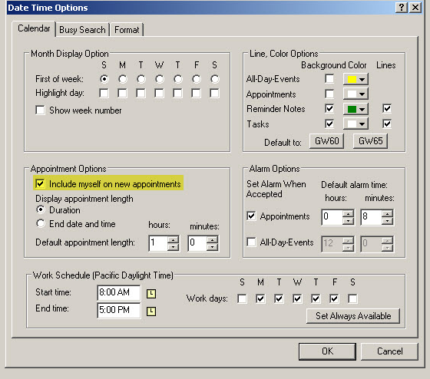

E. To get notification via email or flash message when people Accept/Decline meetings:
Check the options you wish in: Tools, Options, Send, Appointment.

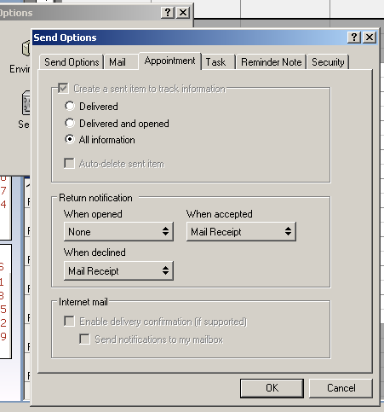
Click each boxes’ arrows to choose your options.

F. Set notify so you receive answers from Meeting Rooms (and other Invitees)

Tools> Options> Send> Appointment.
Check what you need from this area:
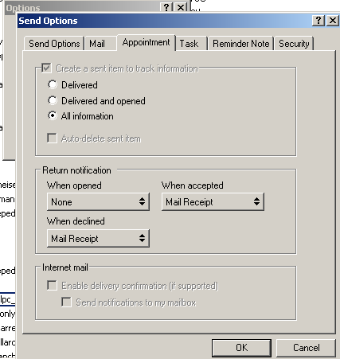
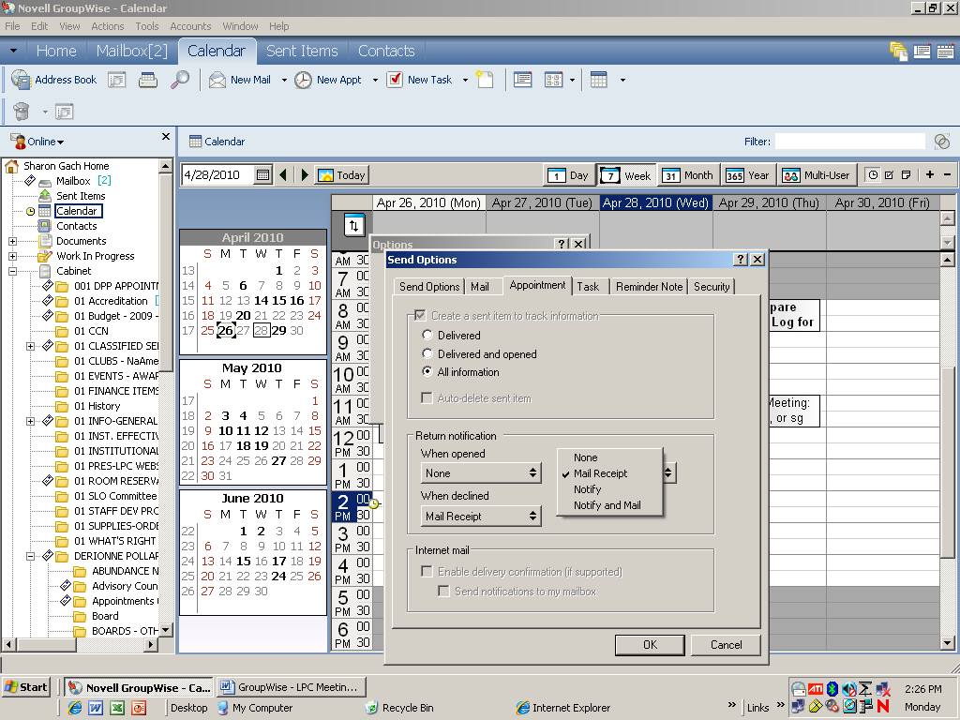
Choices:

[You may wish to only receive “When Declined”
if you don’t want a lot of additional mail.]

G. How to open several GroupWise Calendars (or In Boxes) at once:
1. Make sure the other person has given you Proxy to their Calendar/ In Box:
Tools, Options, Security, Proxy Access. They add User here:

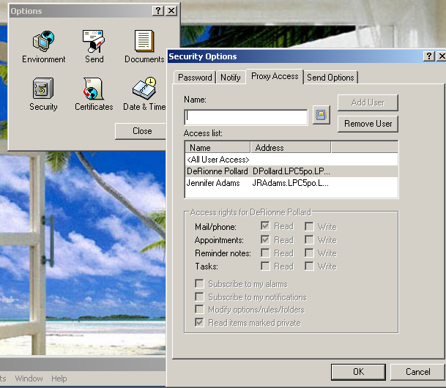
(continued next page)

2. Next, add their name to Your Online Proxy list:
a. Press Online

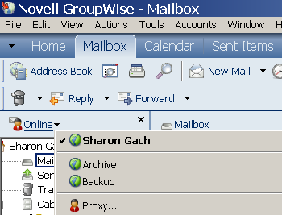

b. Press Proxy

c. Type Name in box, or use Address Book:

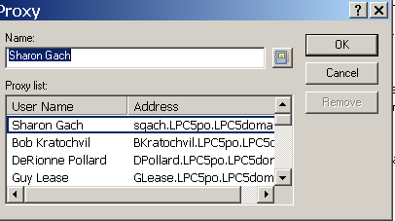

d. The new Groupwise account will open.

e. To change to any of your Proxies or back to your Account, press Online

then, desired account:

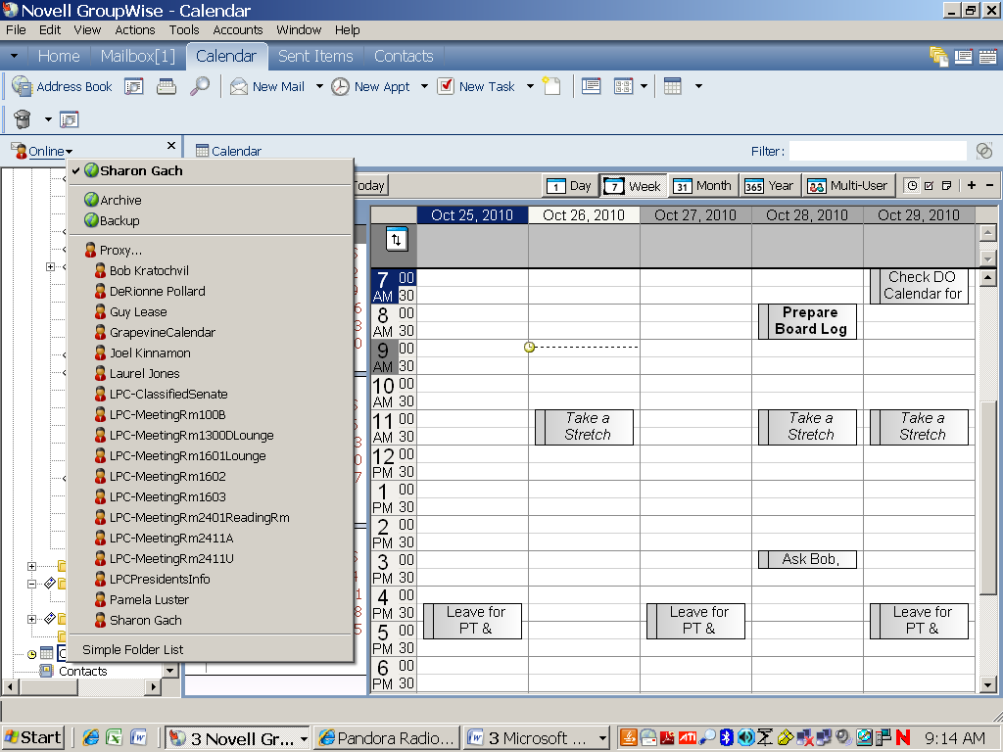

3. Next, to open as many calendars as you wish -- in your GroupWise, click:

Window, New Main Window.

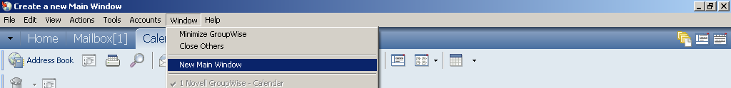

4. Then, from that open window, look on the left side and click Online. You will see all the Proxy calendars you have access to. Click the one you want.

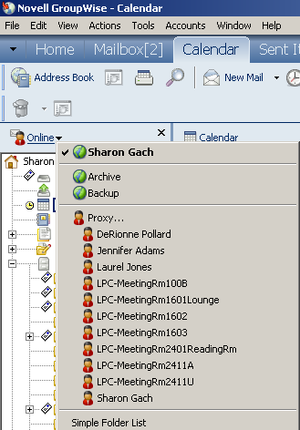

(If the calendar you want is not there, ask the person to give you proxy, as in Step 1 above.)

5. To change to a new Calendar, just press Proxy, and choose the new calendar.
(When you are in one of your Proxy calendars the word “Online” changes to “Proxy”.)

6. Leave as many windows open as long as you need them; shrink them to the bottom of your screen. They update in real time if other people book meetings.

# # #

NOTE: We would like to continue improving and adding to this reference. Please send any new items or suggestions to Sharon Gach, X. 1001.

