Handshake App Steps for Students
- Download the Handshake app on your phone.
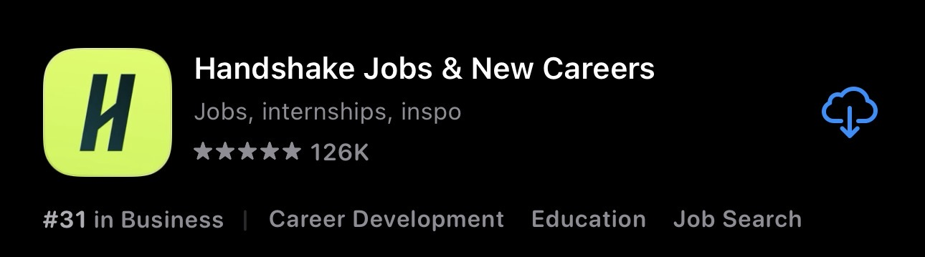

- Open the app and choose “Continue with school”.
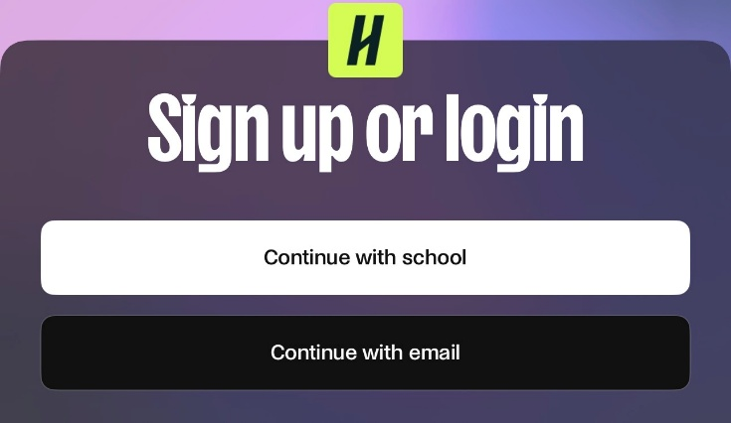

- Type “Las Positas College” and select it from the drop-down menu.
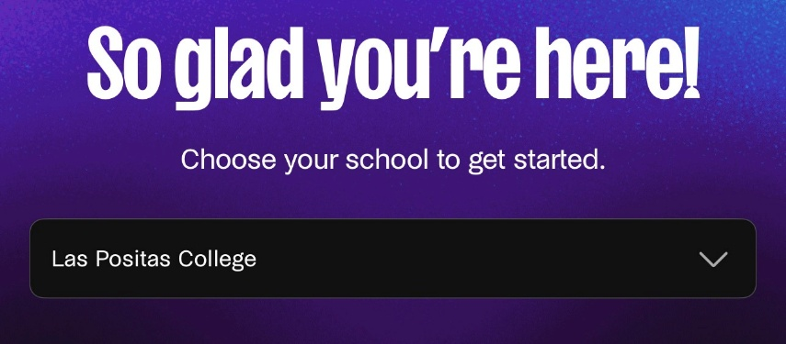

- Enter your Zonemail address and sign in.
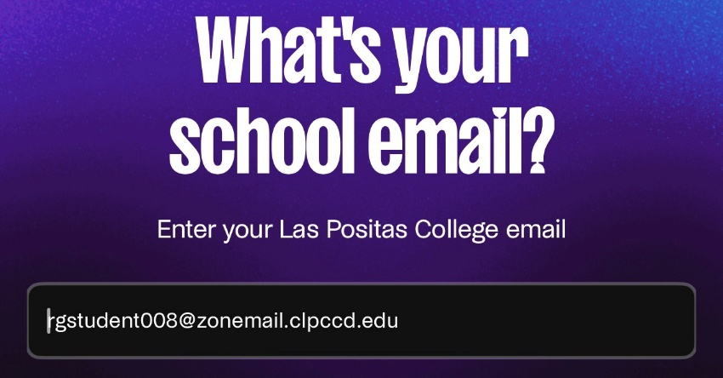
  - Don’t know your Zonemail address? Visit this Zonemail information page.

- Confirm your Zonemail address by signing in to Zonemail account. For best results, use the same device (phone) to confirm your email.

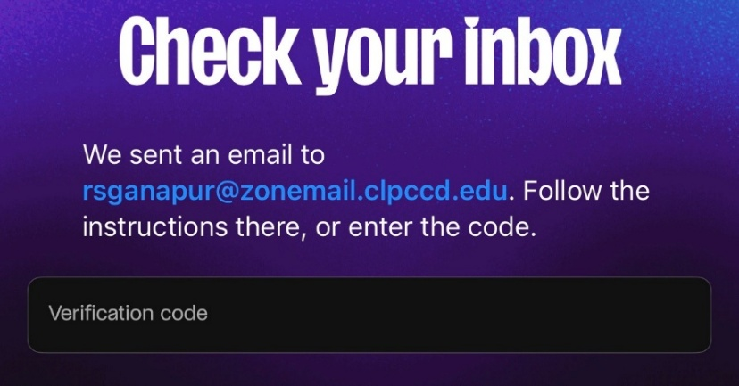

- Go back to the Handshake app. Turn on notifications to learn about job fairs, events, and jobs and internships.
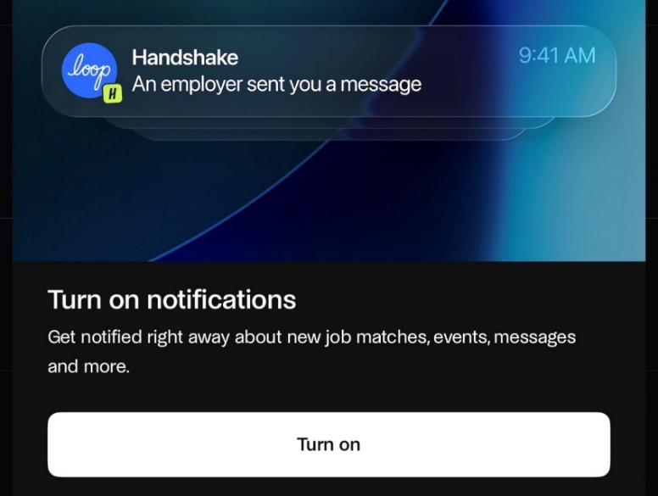

- Search for jobs, internships, and events.
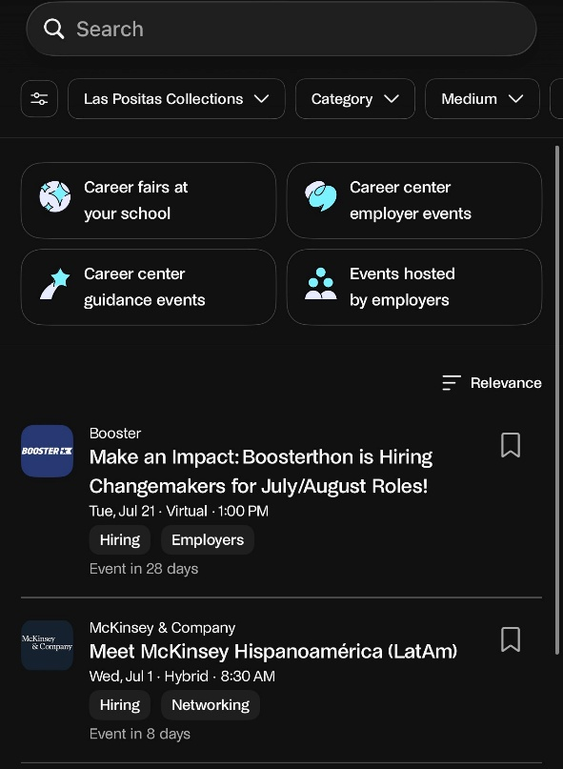

- On a computer or laptop, you can go to the Handshake website.
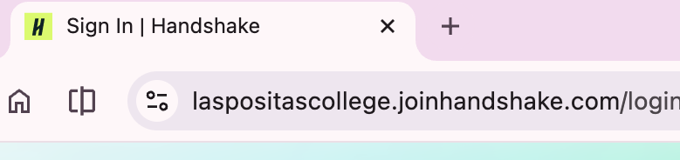

- Use your Zonemail address to sign in.
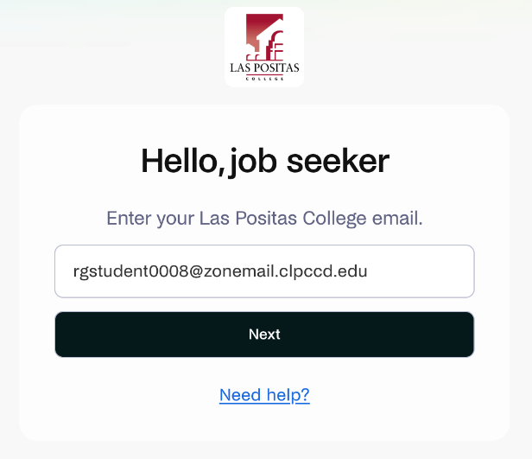

- Click on the profile button, the Profile button either has your photo or your initials on it. Edit your profile (hint: start by uploading your resume), fill out your profile, and apply for jobs and internships.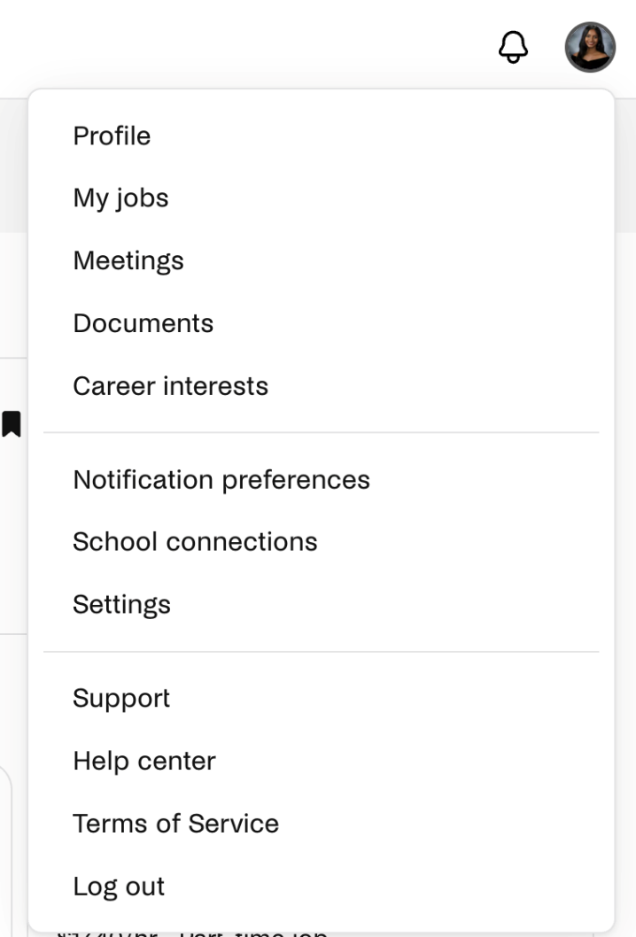

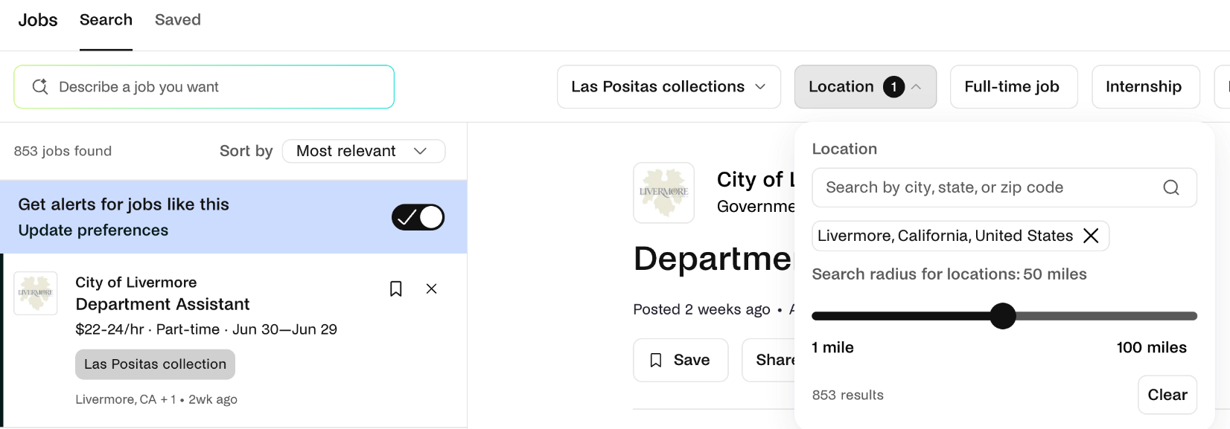

- Remember to forward Zonemail to your personal email.

