

**2021-22 Return to Campus Plan**

The college will take necessary precautions and will follow all orders in place by state and county public health departments. The college will also follow the COVID-19 Safe Practices: Return to Campus guidelines and safety plan established by CLPCCD facilities, in partnership with an environmental health & safety consulting company. The safety plan includes global, area and task-specific Safe Work Practices.

The college planning process also recognizes that the temporary Telecommuting Agreement between SEIU Local 1021 and the Chabot-Las Positas Community College District remains in place until further negotiations occur to further inform conditions to return to campus. This planning process will be further informed by the ongoing negotiations between the Faculty Association and the District.

Implementation of this plan is informed by the understanding that the 2021 summer and fall terms are a transition period. Supervisors will work with work with individual employees on an as needed basis during the transition. This plan is contingent upon the status of the pandemic in our local community, based upon California’s Blueprint for a Safer Economy COVID-19 color tiers and county risk levels. The Governor has outlined plans to move beyond the Blueprint to fully open the state economy on June 15, if vaccine supply is sufficient for Californians 16 years and older who wish to be inoculated; and if hospitalization rates are stable and low. If the state were to move beyond the Blueprint, there may be implications that could inform our college planning process.

As of May 6, 2021, **72% of Alameda County residents (over 900,000 people) have received at least one dose and 46% (over 600,000 people) are fully vaccinated.**

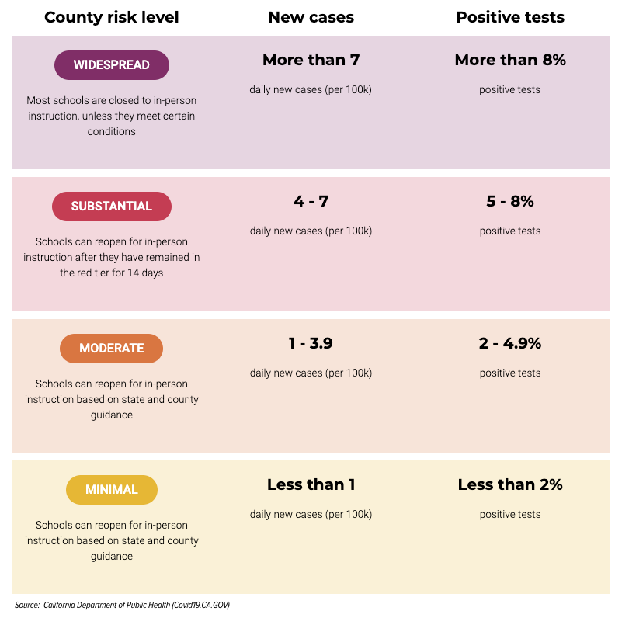

**Fall 2020 and Spring 2021**

**(Phase I)**

**College administrators are on a rotating shift to provide on-site campus support.**

**Campus Safety & Security**

Business Days and Hours: 24 hours per day / 7 days per week

**Admissions & Records**

Monday through Friday from 9:00 a.m. to 1:00 p.m.

**Disabled Student Programs & Services (DSPS)**

Monday through Friday from 9:00 a.m. to 1:00 p.m. – *Appointment Basis Only*

**Student Health & Wellness Center**

Monday, Wednesday, and Thursday from 9:00 a.m. to 5:00 p.m.; Tuesday from 11:00 a.m. to 7:00 p.m.; and Friday from 9:00 a.m. to 1:00 p.m.

**Child Development Center**

Monday through Friday from 7:30 a.m. to 5:00 p.m.

**Information Desk**

Monday through Friday from 9:00 a.m. to 1:00 p.m.

**Performing Arts**

* Stream live and pre-recorded events with small groups (14 performers and up to 2 staff)
* Drive-in Theater Performances and Productions
* Use of Music Practice Rooms and 1:1 lab use by appointment

**Intercollegiate Athletics**

* Implementing the Return to Play plan (county/district)
* Competition is based on availability of other teams to travel/compete

**Summer 2021**

**(Phase II)**

**ORANGE TIER OR BETTER**

Below is a summary of the proposed limited student support services that will be available on campus for summer 2021. The conversations and planning will begin regarding the logistics of a return to work for the following respective areas (i.e. Proper PPE, staffing considerations and days/hours will need to be confirmed. The summer 2021 term will be a transition period. Safety is the highest priority and telecommuting agreements remain in place. Supervisors will be flexible in working with classified professionals regarding the return to work.

**Effective June 1, 2021**

**College administrators will be on a rotating shift to ensure on-site campus support.**

**Financial Aid Office**

Monday through Thursday from 9:00 a.m. to 1:00 p.m.

Essential Services: Assist with the completion of the Free Application for Federal Student Aid

(FAFSA) and the California Dream Act Application (CADAA); assist with the completion and submission verification-related documentation; assist with the completion of the scholarship application for the 2021-2022 Academic Year.

**Counseling Center Front Desk**

Monday through Friday from 9:00 a.m. to 1:00 p.m.

Assist students with ~~sc~~hedulin~~g~~ appointments for the creation or updating of student educational plans; advising on fall course scheduling; prerequisite clearances; students who are or have been academically dismissed or who are or who have been on academic and/or progress probation; and academic, career, and personal counseling services to students. Schedule students into workshops, and respond to student inquires.

***All departments offering in-person student support services during spring 2021 will continue to offer in-person services during summer 2021.***

**Fall 2021**

**(Phase III)**

**ORANGE TIER OR BETTER**

**Effective August 2, 2021**

**College administrators will be on a rotating shift to ensure on-site campus support.**

**Assessment Center**

Monday through Friday from 9:00 a.m. to 1:00 p.m. *– Appointment Basis Only*

Essential Services: Facilitate assessment placement in subjects including English, English as a Second Language, French, Mathematics, and Spanish upon request or if required; assist with determining placement for second level transfer courses (e.g., Calculus, Chemistry, etc.); assign computer terminals for students to complete the online self-placement assessment; and assist students with the review of standardized test results and receipt of college transcripts for course placement determination.

**Community Education**

Monday through Friday from 9:00 a.m. to 1:00 p.m. *– Appointment Basis Only*

Essential Services: Provide in-person courses that align with Essential and Critical Infrastructure Workforce Sectors and to provide educational and personal enrichment opportunities to our community including, but not limited to, basic skills acquisition, career and technical training, and industry and professional retraining.

**International Student Program**

Monday through Friday from 9:00 a.m. to 1:00 p.m. – *Appointment Basis Only*

Essential Services: Assist international students with completing documentation related to student visas and help ensure compliance with U.S. Department of Homeland immigration regulations; assist with securing off-campus housing; and referral to student support services.

**Veterans Resource Center**

Monday through Thursday from 9:00 a.m. to 1:00 p.m. – *Appointment Basis Only*

Essential Services: Assist with the completion and submission of documentation required by the U.S. Department of Veterans Affairs to receive veteran educational benefits; provide certifications; issue instructional materials (e.g., textbooks, school supplies, etc.); issue personal items (e.g., infant diapers, etc.); and referral to academic and student support services.

**Extended Opportunity Programs & Services (EOPS), Cooperative Agencies Resources for Education (CARE), and California Work Opportunity and Responsibility to Kids (CalWORKs)**

Monday through Friday from 9:00 a.m. to 1:00 p.m. *– Appointment Basis Only*

Essential Services: Assist students with onboarding to state categorically funded programs; assist students with the matriculation process; issue direct aid including textbook assistance and school supplies; assist with maximizing support services from county resources; refer dependents of students to child care facilities in operation; refer students to employment opportunities; support students to solicit financial aid and scholarships.

**Bookstore (to provide in-person services; TBD)**

**Effective August 18, 2021**

**College administrators will return to campus at least 3 days per week, depending on office function and departmental need. Administrators will work with their direct administrative support staff regarding on-campus support based upon departmental needs.**

**Library**

The library will be open for circulation and reference help on Mondays 11am to 7 pm and on Thursdays 9am to 5 pm. On Tuesdays and Wednesdays students can pick up and drop off circulation materials outside of the library (curbside pickup/grab n go).

**Tutoring**

​The Tutoring Center will be open Tuesday and Wednesday from 10am - 5pm. The Tutoring Center will have limited space for individual study.  In-person scheduled and drop-in tutoring will be available.

**Food services (TBD)**

***All departments offering in-person student support services during summer 2021 will continue to offer in-person student support services during fall 2021.***

**Spring 2022**

**(Phase IV)**

**ORANGE TIER OR BETTER**

**Effective: January 3, 2022**

**All college administrators and direct administrative support staff will fully return to campus.**

All departments will fully return to campus and provide support services, including the departments offering in-person student support services during fall 2021 and the following departments:

* Outreach Services
* Career/Transfer Center
* Student Life Office/Welcome Center

With a full return to campus, the following activities will also be available:

* Campus Meetings
* Field trips
* Campus Events & Activities
* Commencement

***NOTES:***

*This document does not reflect instructional courses and the types and percentage of courses that will be offered in a face to face format.*

*This plan will be further informed by recommendations by the District-wide Reopening Task Force, the Senior Leadership Team, and the LPC Emergency Task Force.*

Revised: 5/6/21